Workbook

Planning your CPD Workbook

Workbook: Planning your CPD

Contents

Introduction | 3
The features of the CPD scheme | 4
What is CPD? | 6
What is professional practice?
Why plan your CPD? | 8
Unplanned or opportunistic learning
Planning your CPD to meet the requirements of the CPD scheme
Planning your CPD across the four themes
of the OPS | 11
Development plan template | 13
Year 1 CPD cycle
Year 2 CPD cycle
Year 3 CPD cycle
Completed example of development plan template | 16
Year 1 CPD cycle
Year 2 CPD cycle
Year 3 CPD cycle
Further information | 21

This workbook is published by the General Osteopathic Council (GOsC).

We welcome your comments and feedback to help us improve this workbook.

Please send any comments and/or suggestions to: newcpd@osteopathy.org.uk.

The GOsC is a charity registered in England and Wales (1172749). | 04/10/19

Workbook: Planning your CPD

Introduction

This workbook has been prepared to support osteopaths in planning their continuing professional development (CPD) as part of the GOsC’s CPD scheme. It explains why and how planning can be helpful and gives some practical tips as well as providing some useful templates.

You will find learning points throughout to help summarise the advice.

3

Workbook: Planning your CPD

The features
of the CPD scheme
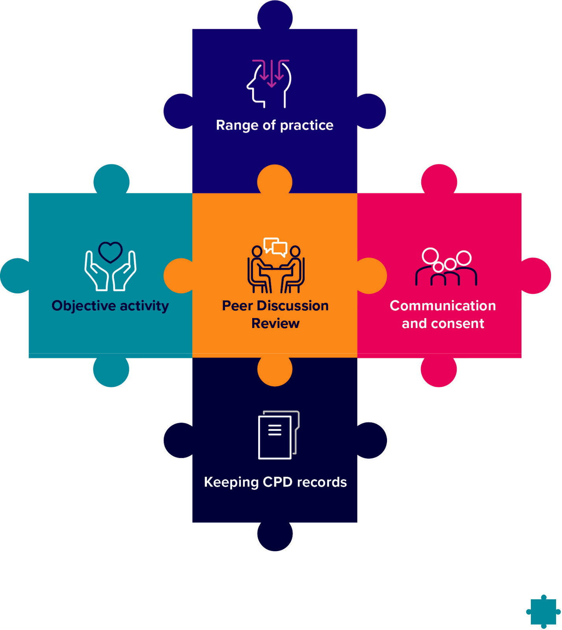

4

Workbook: Planning your CPD

Range of practice: the four Osteopathic Practice Standards themes and breadth of practice

You should do CPD activities in all four themes of the Osteopathic Practice Standards:

A. Communication and patient partnership

B. Knowledge, skills and performance

C. Safety and quality in practice

- Professionalism

Your CPD should also cover the breadth of your professional practice, which may include the clinical, education, research or management aspects of your roles.

Objective activity

Your CPD needs to include at least one objective activity that informs your practice and your CPD. An objective activity is where you seek external objective feedback about your practice and then analyse and reflect on this to show how it has informed your practice or CPD. This activity might include: case-based discussion, patient feedback, peer observation or a clinical audit. See page 21 for further information.

Communication and consent

You need to do at least one CPD activity in the area of communication and consent. This should include reviewing the relevant guidance in the Osteopathic Practice Standards and showing how this has informed your learning and how it has been applied in practice. Doing an activity in the area of communication and consent will help you to demonstrate how your CPD benefits patients.

Keeping CPD records

You need to keep a record of your CPD that shows you have completed a three-year cycle of a minimum of 90 hours. This must include a minimum of 45 hours of ‘learning with others’ and include all the required elements of the scheme.

Peer Discussion Review

You need to complete a Peer Discussion Review towards the end of the three-year cycle. A Peer Discussion Review is a structured conversation with an osteopath or other health professional in which you confirm, and discuss how, you have completed all the elements of the scheme.

5

Workbook: Planning your CPD

What is CPD?

The definition of continuing professional development (CPD) is very broad and can include any activity that maintains, enhances and develops osteopathic professional practice.

CPD can include any learning undertaken by an osteopath, for example:

- discussion of CPD and practice with a colleague

- courses, seminars or practical sessions

- e-learning

- reading, research or individual study

- Peer Discussion Review

- mentoring

- any other activities that can advance practice.

Doing CPD is an ongoing aspect of professional practice (see What is professional practice? on page 7. According to the Osteopathic Practice Standards:

Theme B: Knowledge, skills and performance

B3: You must keep your professional knowledge and skills up to date.

To achieve this, osteopaths must be professionally engaged, undertaking professional development activities and keeping up to date with factors relevant to ongoing practice including in relation to the wider healthcare environment.

For CPD to count as ‘learning with others’, it must also involve interaction with others to inform your learning – which means you will be both giving and receiving information. This can be carried out with osteopaths, other healthcare practitioners or other professionals.

You should reflect on the CPD you do, and you must keep a record of it.

6

Workbook: Planning your CPD

What is professional practice?

Professional practice can include clinical work (including safeguarding), education, research or management responsibilities (including leadership). Over the course of a CPD cycle, CPD should reflect the breadth of an individual’s practice. For example, an osteopath who only undertakes clinical work and holds no management or teaching responsibilities might confine all their CPD to clinical work. However, an osteopath who undertakes one day a week in education, should undertake an appropriate portion of their CPD in the area of education or teaching practice. Osteopaths with research or management responsibilities should be able to demonstrate balanced CPD in these areas.

Learning points:

- The definition of CPD is very broad and includes any learning or activities that advance practice.

- Professional practice can include clinical work, education, research or management responsibilities.

- CPD should be reflected on and recorded.

7

Workbook: Planning your CPD

Why plan your CPD?

There are many reasons why osteopaths undertake the CPD that they do – interest in a particular subject, availability, affordability, and flexibility when trying to fit this in with work and other demands.

It can help to have a plan and to give some thought to what areas of CPD you wish to focus on during a particular timeframe. If you can find the time to do some planning this can help you to feel confident about meeting the requirements of the CPD scheme. Planning your development proactively, rather than responding to events that happen to crop up from time to time, might also help you to identify different, more relevant or cheaper ways of meeting your CPD objectives. It could provide an opportunity for you to identify other people who are interested in the same areas or activities as you, so you might be able to work together.

A development plan template is included on page 13 of this workbook. The template provides a suggested format which you can adapt according to your needs. Here are some useful steps to take:

- Identify one or more learning need(s).

- Think about how you will you go about addressing the need.

- Decide what (if any) resources you will require.

- Think about how you will evaluate whether the learning need has been addressed.

- Decide when you want to have completed the relevant CPD.

Identifying your learning needs can be an ongoing process, and undertaking one activity might lead you to further activities as you reflect on what you have learned. You could decide to have one overarching plan to address these, or several plans related to different areas of practice.

You will find a completed example of the development plan template on page 17 of this workbook to give you an idea of what it could look like when someone has worked through it.

Whether or not you plan your CPD in this way is up to you, but you might find it helps to think through what you’ll aim to do and when, so that you can balance your activities evenly through the three-year cycle.

Learning points:

- Planning your CPD can have a number of advantages including, ensuring that it remains relevant to your particular interests and practice, is flexible, manageable and affordable over the three-year cycle.

- Planning can give you time to explore different, potentially helpful ways of undertaking CPD and allow you to identify relevant CPD events that fit with your schedule

8

Workbook: Planning your CPD

Unplanned or opportunistic learning

Not all CPD activities are planned in advance. For example, you might encounter a patient with an unusual medical condition which merits further research and this might prompt you to reflect on your communication approaches. If you work in education, perhaps a student asks a question which prompts you to talk to colleagues or carry out further research. However such opportunities arise, recording them in some way and considering their impact on your work as an osteopath, will mean they can be claimed as CPD.

Learning points:

- Unplanned CPD is valuable too.

- If you undertake unplanned CPD, do take time to record it so that it can count towards your CPD requirement.

9

Workbook: Planning your CPD

Planning your CPD to meet the requirements of the CPD scheme

The following sections can help you to plan your CPD to meet the requirements of the new CPD scheme.

There is flexibility within the new CPD scheme to spread the 90-hour requirement in a way that suits you. There may be some years when you do fewer CPD activities and then make up for this in the following year. That said, we would certainly recommend that you aim to carry out, reflect on and record at least 30 hours of CPD each year across the cycle. You should find this a reasonable and readily achievable amount.

Taking this approach will also help you to meet Standard B3 of the Osteopathic Practice Standards: ‘You must keep your professional knowledge and skills up to date’ and avoids leaving the bulk of activities until the final year, which might be hard to manage. You will also need sufficient time within the final year to complete your Peer Discussion Review, and make sure you’ve met all the requirements of the scheme by the end of the cycle.

When planning your CPD, remember to think about these requirements:

- 90 hours of CPD from the date that you enter your three-year CPD cycle. At least half of these hours must comprise ‘learning with others’.

- CPD activities must cover the range of your practice and the four themes of the Osteopathic Practice Standards (OPS). These are: Communication and patient partnership; Knowledge, skills and performance; Safety and quality in practice; and Professionalism.

- An objective activity must be carried out at least once within the three-year cycle.

- CPD must benefit patients and include an activity in the area of communication and consent at least once in the three-year cycle.

- A Peer Discussion Review must be completed towards the end of the three-year cycle.

Learning points:

- Planning CPD across the three-year cycle helps you to show you are meeting your professional obligation to keep your knowledge and skills up to date and avoids leaving the bulk of activities until the final year, which then might be hard to manage.

- Discussing your CPD and practice with a peer can count as CPD. This can be done throughout the CPD cycle but your Peer Discussion Review should be completed before the end of Year 3 of the CPD cycle.

10

Workbook: Planning your CPD

Planning your CPD
across the four themes of the OPS

The Osteopathic Practice Standards (OPS) are available to read on our dedicated mobile-friendly website at: standards.osteopathy.org.uk. The CPD scheme requires osteopaths to undertake activities across the four themes of the Osteopathic Practice Standards. Some activities might cover more than one of the themes. Remember, there is no requirement regards how much time should be spent on each theme. You don’t need to allocate the number of minutes spent on each theme in an activity which might encompass more than one of the themes.

The table below provides a summary of the areas broadly covered by each of the four

OPS themes and gives examples of relevant CPD activities:

Theme of the | Areas include | Relevant CPD activities may cover:
OPS
A | Listening, respecting | • | communicating with patients – different
Communication | patient’s concerns and |  | questions and approaches to identify patient
and patient | preferences, dignity | • | ideas, concerns and expectations
partnership | and modesty, effective |  | exploring non-verbal communication
 | communication, providing | • | mechanisms
 | information, consent, |  | communicating benefits and risks of treatment
 | patient partnership | • | options to particular patients
 |  |  | supporting patients to make decisions about
 |  |  | treatment
B | Having sufficient | • | reflection on current knowledge and skills and
Knowledge, skills | knowledge and skills, |  | learning new knowledge and skills including
and performance | working within training |  | techniques for patient feedback, any reflection
 | and competence, keeping |  | on the results of the feedback, for example,
 | up to date, analysing and |  | re-reading aspects of the OPS, reading around
 | reflecting on information |  | communication and consent will cover this
 | to enhance patient care | • | theme
 |  |  | analysing feedback about your practice and
 |  | • | implementing improvements
 |  |  | analysing data and report writing
C | Case history taking and | • | taking a case history and developing a clear
Safety and quality | record keeping, patient | • | narrative for treatment options
in practice | evaluation, management, |  | learning knowledge and skills about
 | safeguarding, wider role in |  | vulnerable patients, including safeguarding or
 | enhancing patients’ health | • | how to report female genital mutilation
 | and wellbeing |  | signposting patients to resources about diet,
 |  | • | exercise, and smoking cessation
 |  |  | all of these areas could feature as part of your
 |  | • | patient feedback
 |  |  | dealing with health and safety issues

11

Workbook: Planning your CPD

Theme of the | Areas include | Relevant CPD activities may cover:
OPS
D | Ethics, integrity, honesty, | • | enhancing your understanding of the
Professionalism | duty of candour, |  | contributions of other healthcare professionals
 | confidentiality, working | • | to patient care
 | with others, complying |  | establishing clear boundaries with patients
 | with regulatory | • | (through case studies or group discussions)
 | requirements |  | reviewing equality and diversity issues
 |  |  | considering confidentiality and data protection
 |  | • | (eg GDPR)
 |  |  | keeping up to date with legal requirements on
 |  | • | advertising your practice
 |  |  | supporting colleagues to enhance patient
 |  |  | care (eg mentoring activities)

Many activities which you already undertake will relate to these themes, without any specific extra CPD being required. It’s not necessary to link to individual standards but it is worth familiarising yourself with these and seeing where there might be gaps in your knowledge, understanding or skills.

Learning points:

- Review the themes of the Osteopathic Practice Standards and the table above to help you identify where the CPD you are already doing covers the four themes, or to help you identify new, interesting areas of CPD that could support your practice.

12

Workbook: Planning your CPD

Development plan template

Development Plan

Name: Annie Osteopath

Covering the period from: | To:

Year 1 CPD cycle

Ask: Where do I want to be by the end of this period? What do I want to be doing? Which aspects of the CPD scheme requirements might I meet? For example, I could undertake an objective activity.

What is my | What will I do to | What resources | What will be my | Target dates
learning/ | achieve this? | or support will I | success criteria? | for review and
development |  | need? |  | completion
need?

13

Workbook: Planning your CPD

Year 2 CPD cycle

Ask: Where do I want to be by the end of this period? What do I want to be doing? Which aspects of the CPD scheme requirements might I meet? For example, I could undertake an objective activity.

What is my | What will I do to | What resources | What will be my | Target dates
learning/ | achieve this? | or support will I | success criteria? | for review and
development |  | need? |  | completion
need?

14

Workbook: Planning your CPD

Year 3 CPD cycle

Ask: Where do I want to be by the end of this period? What do I want to be doing? Which aspects of the CPD scheme requirements might I meet? For example, I could undertake an objective activity.

What is my | What will I do to | What resources | What will be my | Target dates
learning/ | achieve this? | or support will I | success criteria? | for review and
development |  | need? |  | completion
need?

15

Workbook: Planning your CPD

Completed example
of development plan template

This is an example of what a completed development plan might look like. It isn’t intended to be prescriptive but illustrates how someone might plan activities over the cycle to make sure they meet the requirements of the scheme. Even if you have planned out your CPD, you can still do additional CPD as the opportunity arises.

If you choose to use this template, remember you can adapt it to fit your specific requirements, but you might find it helpful to use the structure suggested here to help you consider activities. For example, considering success criteria helps you to take things a step beyond ‘attending an event’, and helps you to think what you actually want to get out of doing the activity.

16

Workbook: Planning your CPD

Development Plan

Name: Annie Osteopath

Covering the period from: 1 March 2019 | To: 28 February 2022

Year 1 CPD cycle

Ask: Where do I want to be by the end of this period? Which aspects of the CPD scheme requirements might I meet? For example, I could undertake an objective activity.

What is my | What will I do to | What resources | What will be my | Target dates
learning/ | achieve this? | or support will I | success criteria? | for review and
development |  | need? |  | completion
need?
To seek feedback | Undertake a | Need to find or | Generating | September 2019
on my practice | questionnaire | adapt a suitable | sufficient | and February
from patients | survey of patients | questionnaire | feedback over a | 2020
 |  |  | defined period
 |  | Check resources | to enable me to
 |  | on cpd.osteopathy. | reflect on this
 |  | org.uk | and to consider
 |  |  | the impact on my
 |  | Talk to colleagues | practice
 |  | who have done this
 |  | already
To ensure that CPD | Consider each | OPS: I will put | Generate sense | September 2019
reflects breadth of | recorded activity | standards. | of how my CPD
my practice and | against the OPS | osteopathy.org.uk | reflects the OPS
the OPS themes | themes | onto home screen | themes, and use
 |  | of my phone so I | this to further plan
 |  | can access it any | activities for next
 |  | time | year
Improve my | Undertake | Journal access via | Completion of | February 2020
understanding | specific CPD | o zone | all activities and
of management | event |  | to be able to
of patients with |  | Purchase book on | consider how I
chronic pain. | Read around the | chronic pain | might enhance
 | subject (source |  | my management
 | recent journal | Discuss cases with | of patients with
 | articles) |  | chronic pain
 |  |  | and implement
 | Discuss cases |  | changes
 | with colleagues at
 | local group
Identify a peer to | Discuss with |  | Agreeing to work | December 2019
discuss CPD issues | colleagues at |  | with someone
with and who will | local group
carry out my Peer |  |  | Undertake a
Discussion Review |  |  | practice Peer
in Year 3 of the |  |  | Discussion
cycle and seek |  |  | Review | 17
their agreement to
working with me

Workbook: Planning your CPD

Year 2 CPD cycle

Ask: Where do I want to be by the end of this period? Which aspects of the CPD scheme requirements might I meet? For example, I could undertake an objective activity.

What is my | What will I do to | What resources | What will be my | Target dates
learning/ | achieve this? | or support will I | success criteria? | for review and
development |  | need? |  | completion
need?
Undertake CPD in | Attend specific | Access to journals | Completion of | September 2020
communication and | CPD event in this | which I can get via | planned activities,
consent | subject | the o zone | enabling me to
 |  |  | reflect on my
 | Consider recent | Local group | practice and
 | journal articles | meetings | consider how
 |  |  | this might be
 | Discuss case |  | enhanced as a
 | scenarios with |  | result
 | colleagues
Focus on some | Boundaries – | Access to | Completion of | September 2020
key aspects of | read around the | GOsC CPD site | planned activities
professionalism | subject – consider | and o zone | and reflection on
theme of the OPS | resources provided | and the online | practice
 | on CPD website | Osteopathic
 |  | Practice
 |  | Standards
 |  | standards.
 |  | osteopathy.org.uk
Boundaries with | Case-based | Attend local group | Completion of | February 2021
patients | discussions with | meetings | planned activities
 | colleagues |  | and reflection on
 |  |  | practice
Data protection | Data protection | iO website | Completion of | February 2021
 | – review data | ICO website | planned activities
 | storage and |  | and reflection on
 | policies to ensure |  | practice
 | best practice and
 | GDPR compliance. |  | Implement any
 | Review iO |  | indicated changes
 | resources and ICO |  | to processes
 | website

18

Workbook: Planning your CPD

Year 2 CPD cycle

What is my | What will I do to | What resources | What will be my | Target dates
learning/ | achieve this? | or support will I | success criteria? | for review and
development |  | need? |  | completion
need?
Supporting | I plan to take on | Access mentoring | Recruit a suitable | February 2021
colleagues | an associate this | support guidance | associate and
 | year, I am keen | on Osteopathic | devise and
 | to devise an | Development | implement a
 | effective mentoring | Group website | mentoring plan
 | programme to
 | support their | Attend group
 | development | meetings
 | and ensure they
 | have the support
 | they need at this
 | early stage in their
 | career
 | I will talk to
 | colleagues to see
 | what they do in
 | their practices, and
 | review iO guidance
 | on mentoring

19

Workbook: Planning your CPD

Year 3 CPD cycle

Ask: Where do I want to be by the end of this period? Which aspects of the CPD scheme requirements might I meet? For example, I could undertake an objective activity.

What is my | What will I do to | What resources | What will be my | Target dates
learning/ | achieve this? | or support will I | success criteria? | for review and
development |  | need? |  | completion
need?
Enhance my | Undertake specific | Access to CPD | Completing | December 2021
knowledge and | CPD event in this | event | activities and
skill in rehabilitation | area |  | being able to
techniques |  | Attend local group | confidently
 | Discuss | meetings | include enhanced
 | approaches with |  | rehab and
 | colleagues | Access research | exercise advice in
 |  | journals on | the management
 | Research journal | o zone | of patients
 | articles to review
 | latest thinking
Review | Consider how | N/A | To develop | January 2022
development | my practice is |  | a broad
needs leading in to | developing, and |  | development to
the next three year | reflect on the |  | discuss during my
CPD cycle. | current cycle to |  | Peer Discussion
 | consider where |  | Review
 | there may be gaps
 | in learning and
 | areas where I may
 | wish to develop
 | my skills and
 | knowledge further
Peer Discussion | Arrange Peer | PDR guidance | Complete Peer | November 2021
Review | Discussion Review | and resources on | Discussion | and
 | with colleague to | GOsC CPD site | Review and get | January 2022
 | demonstrate how | cpd.osteopathy. | sign off by my
 | I’ve met the CPD | org.uk | peer
 | requirements over
 | the past three
 | years and prepare
 | a draft peer review
 | so that I can work
 | out if I have met the
 | requirements

20

Workbook: Planning your CPD

Further information

Read the Osteopathic Practice Standards online: standards.osteopathy.org.uk

Visit the CPD microsite: cpd.osteopathy.org.uk

A range of workbooks is available on our CPD microsite which cover various aspects of the CPD scheme. They have been designed to help you plan your CPD and support you in meeting the requirements of the scheme.

The full range of workbooks are available at: cpd.osteopathy.org.uk/workbooks

Titles include:

•

•

•

•

•

Patient feedback

Keeping CPD records

Communication and consent

Case-based discussion

Peer observation

Contact us

newcpd@osteopathy.org.uk

+44 (0)20 7357 6655

21

