Workbook: Patient Feedback

Patient feedback
Analysis template

Aims

Method

Results

Areas of strength

Areas for development

Conclusions, action plan and next steps

31

Workbook: Patient Feedback

Patient feedback analysis template – completed example

Aims

I am interested to understand how patients feel about their treatment and their experience of treatment with me. I have never provided my patients with the opportunity to feedback anonymously before and I am interested to understand whether I can improve their experience with me.

Method

I gave out a questionnaire to every patient seen from 7 to 21 November 2018 and asked them to complete it and put it in the box by reception. I also emailed the questionnaire to patients and asked them to email it back to me or to post it in the stamped addressed envelope enclosed.

Results

Did the osteopath ...?
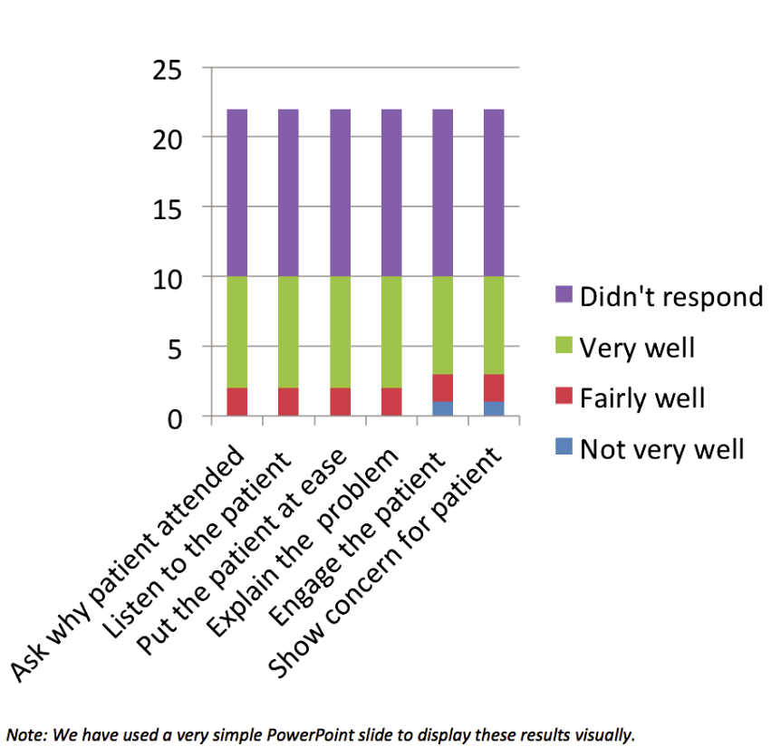

Areas of strength

Areas of strength included:

- How thoroughly I asked about why the patient had attended.

- Listening to what the patient had to say.

- Putting the patient at ease during their physical assessment and examination.

- Explaining the patient’s problem.

32

Workbook: Patient Feedback

Areas for development

Areas for development included:

In two of the questionnaires for patients coming in on a Tuesday I noticed that scores were slightly lower for ‘engaging the patient in consultation’ and ‘demonstrating concern for your welfare’.

Conclusions, action plan and next steps

Action Plan

I realise that I am always keen to finish on time on Tuesday as I have to pick up my daughter from after school club. I have now ensured that I schedule the last appointment on Tuesday at an earlier time.

I recognise that my responses are not ‘significant’ of the population of patients that I see yet. However, I am interested to explore further patients to see if I can gather any other information about my practice that I wasn’t previously aware of.

I am not an expert in statistics and I feel that I may benefit from learning more about how to analyse my patient feedback. I intend to explore this with some of my colleagues to see if they can recommend some useful CPD in this area for next year.

I intend to repeat the questionnaires early next year to see whether there have been any changes. OPS theme

The patient questionnaires have helped me identify evidence that I appear to be meeting the requirements in Theme A: Communication and Patient Partnership.

OPS theme | Areas include | Relevant CPD activities may cover:
A: Communication | Being conscious about | During the consultation and before starting
and patient | ensuring that I have | treatment, I may try asking some patients to let
partnership | sufficient time to focus | me know what they feel has happened in the
 | on the patient and really | consultation (rather than telling them) so that I can
 | listening to them. | be sure that my understanding of their needs and
 |  | my response to them has been fully understood.
 |  | I may see if this makes a difference to the
 |  | responses.
B: Knowledge, | Further work on data | Additional reading on data analysis and use of
skills and | analysis needed. | spreadsheets.
performance
C: Safety and | Not applicable. | Not applicable.
quality in practice
D: Professionalism | Not applicable. | Not applicable.

