Workbook

Case-based
Discussion

Workbook

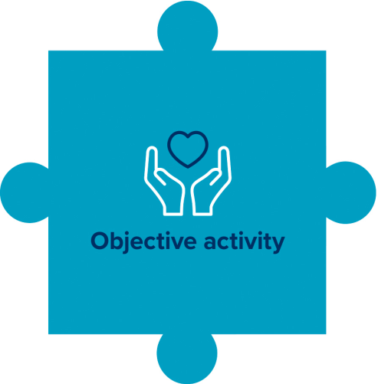

Workbook: Case-based discussion

Contents

Introduction | 3
The features of the CPD scheme\ | 4
What is CPD? | 6
What is professional practice?
What is a case-based discussion? | 8
Getting started on a case-based discussion | 9

Choosing who to discuss a case with

Choosing a case to discuss

Duties of patient confidentiality when discussing cases

Useful tips for giving and receiving feedback | 11

Reflecting on and recording a case-based discussion 12

Linking to the four themes of the Osteopathic
Practice Standards | 13
Templates | 15
Further information | 18

This workbook is published by the General Osteopathic Council (GOsC).
We welcome your comments and feedback to help us improve this workbook. |  | 2
Please send any comments and/or suggestions to: newcpd@osteopathy.org.uk
The GOsC is a charity registered in England and Wales (1172749). | 20/03/19

Workbook: Case-based discussion

Introduction

This workbook has been prepared to support osteopaths taking part in a case-based discussion, which is an objective activity, one of the requirements of the GOsC’s CPD scheme.

Case-based discussions are a useful way to explore practice and gain reassurance and feedback. Case-based discussions can also cover communication and consent and the four themes of the Osteopathic Practice Standards depending on the nature of the discussion.

3

Workbook: Case-based discussion

The features
of the CPD scheme
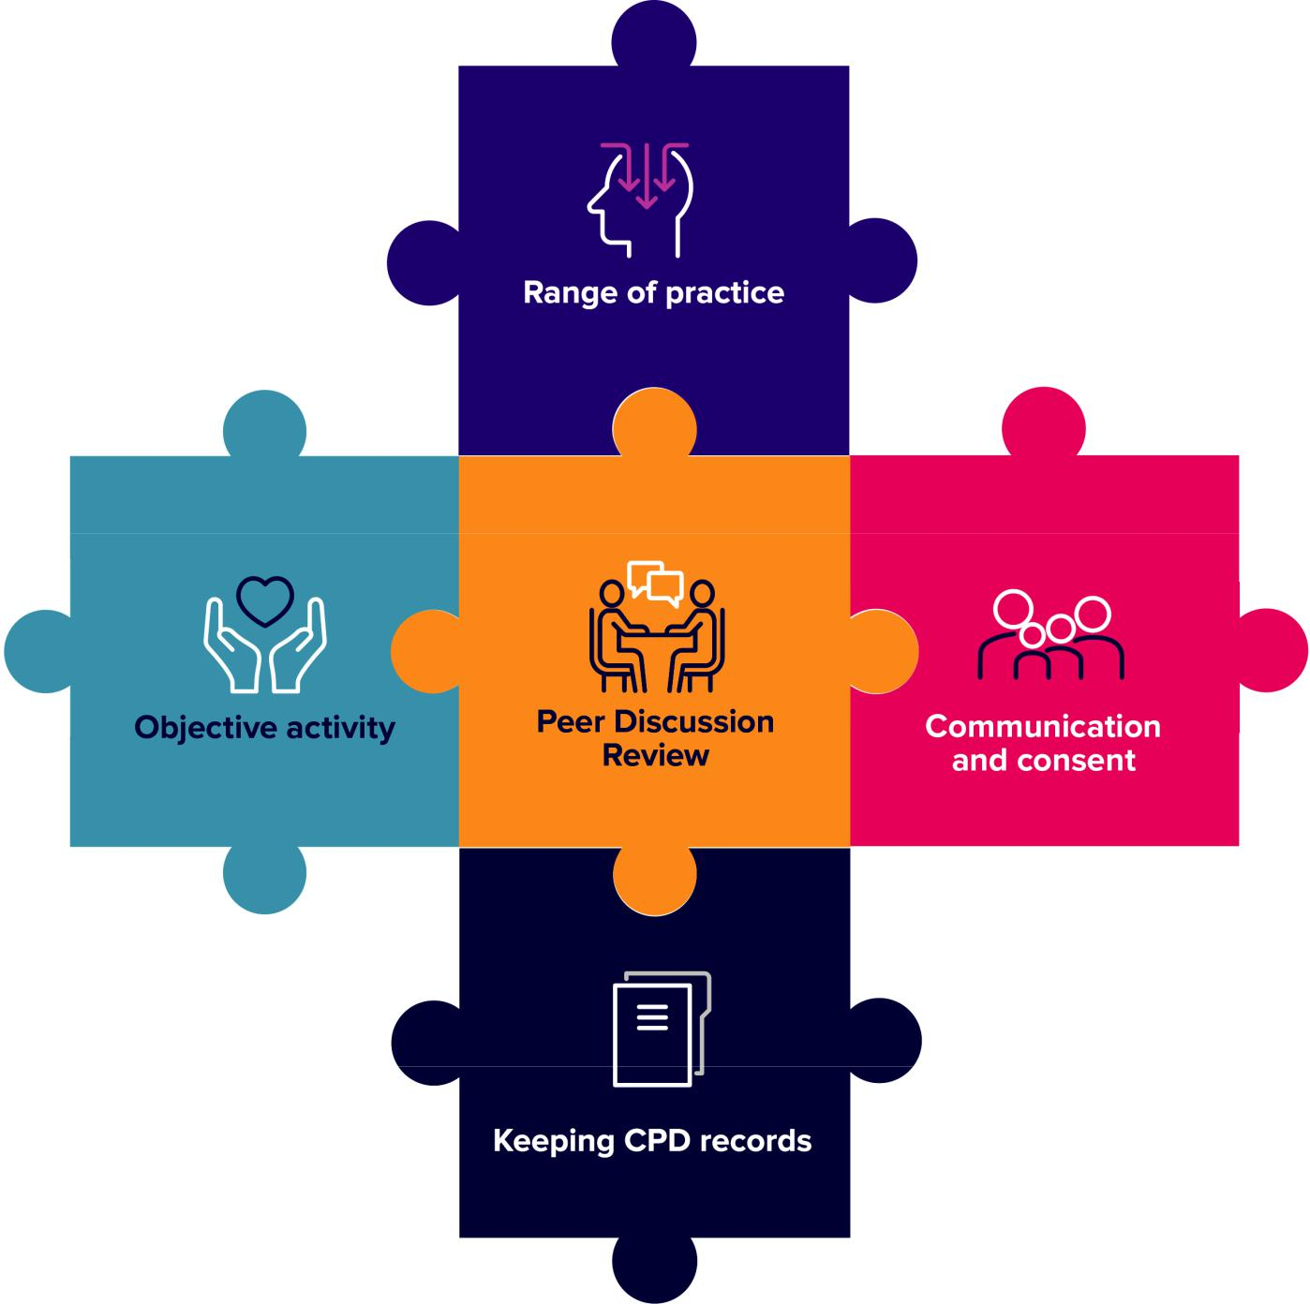

4

Workbook: Case-based discussion

Range of practice: the four Osteopathic Practice Standards themes and breadth of practice.

You should do CPD activities in all four themes of the Osteopathic Practice Standards:

A. Communication and patient partnership

B. Knowledge, skills and performance

C. Safety and quality in practice

- Professionalism

Your CPD should also cover the breadth of your professional practice, which may include the clinical, education, research or management aspects of your roles.

Objective activity

Your CPD needs to include at least one objective activity that informs your practice and your CPD. An objective activity is where you seek external objective feedback about your practice and then analyse and reflect on this to show how it has informed your practice or CPD. This activity might include: case-based discussion, patient feedback, peer observation, clinical audit or a peer observation. See page 18 for further information. This workbook gives guidance on carrying out a case-based discussion.

Communication and consent

You need to do at least one CPD activity in the area of communication and consent. This should include reviewing the relevant guidance in the Osteopathic Practice Standards and showing how this has informed your learning and how it has been applied in practice. Doing an activity in the area of communication and consent will help you to demonstrate how your CPD benefits patients. Case-based discussions can also cover communication and consent depending on the nature of the discussion.

Keeping CPD records

You need to keep a record of your CPD that shows you have completed a three-year cycle of a minimum of 90 hours. This must include a minimum of 45 hours of ‘learning with others’ and include all the required elements of the scheme.

Peer Discussion Review

You need to complete a structured conversation towards the end of your three-year cycle with an osteopath or other health professional to confirm that you have completed all the scheme’s elements.

5

Workbook: Case-based discussion

What is CPD?

The definition of CPD is very broad and can include any activity that maintains, enhances and develops osteopathic professional practice. CPD can include any learning undertaken by an osteopath, for example:

- discussion of CPD and practice with a colleague

- courses, seminars or practical sessions

- e-learning

- reading, research or individual study

- Peer Discussion Review

- mentoring

- any other activities that can advance practice.

Doing CPD is an on-going aspect of professional practice. Standard B3 of the Osteopathic Practice Standards (2018) states that osteopaths ‘must keep… professional knowledge and skills up to date’. To achieve this, osteopaths must be professionally engaged, undertaking professional development activities and keeping up-to-date with factors relevant to on-going practice including in relation to the wider healthcare environment.

For CPD to be ‘learning with others’, it must also involve interaction with others to inform your learning – which means you will be both giving and receiving information. This can be carried out with osteopaths or other healthcare professional.

6

Workbook: Case-based discussion

What is professional practice?

Professional practice can include clinical work (including safeguarding), education, research or management responsibilities. Over the course of a CPD cycle, CPD should reflect the breadth of an individual’s practice. So, for example, an osteopath who only undertakes clinical work and holds no management or teaching responsibilities might confine all their CPD to clinical work. However, an osteopath who undertakes one day a week in education, should undertake an appropriate portion of their CPD in the area of education or teaching practice. Osteopaths with research or management responsibilities should be able to demonstrate balanced CPD in these areas.

Learning points:

- The definition of CPD is very broad and includes any learning or activities that advance practice.

- Professional practice can include clinical work, education, research or management responsibilities.

- CPD should be reflected on and recorded.

7

Workbook: Case-based discussion

What is a
case-based discussion?

A case-based discussion is an example of ‘an objective activity’ – it’s a means of getting objective feedback on your practice from a colleague, enabling you to reflect on what you do and to consider how you might develop your practice. Discussing a case with another osteopath or healthcare professional is an excellent way of seeking feedback on your practice and it builds on what many osteopaths are already doing. Osteopaths have told us that they can find it an enjoyable exercise because they enjoy talking about osteopathy with other osteopaths and professionals.

Case-based discussions can help you to reflect on, and raise questions about, cases that you have found challenging in some way. It can provide reassurance that you have acted appropriately, and give you ideas about how you might develop your practice.

Many osteopaths will already discuss cases with colleagues, although perhaps in a more informal context, without keeping a record. Having a more structured conversation with a colleague or other health professional, reflecting on and recording this activity, together with any outcomes, takes this activity a step further and can really support the development of new insights about practice.

Reflecting on your practice and undertaking CPD in how you communicate with patients in response to patient feedback is often (but not always) a core part of a case-based discussion. Therefore case-based discussion will often meet the communication and consent requirements of the CPD scheme.

8

Workbook: Case-based discussion

Getting started
on a case-based discussion

There are a few things to consider before arranging a case-based discussion with a colleague. You need to consider who to meet with, what case or cases to discuss, where to meet (remember you don’t necessarily need to meet face-to-face if that is difficult for you), also how long you’ll meet for. If working with a colleague, do you bring a case each, for example? What, if anything, will you need to prepare in advance? We look at these questions below.

Choosing who to discuss a case with

The choice is yours – it could be someone that you know well, who you already work with, or you might decide to choose someone that is less well known to you. You might want to discuss a case with just one other person, or to do it in a group setting.

Osteopaths have told us that the following factors may be important to them when choosing who to discuss a case with:

- being comfortable with the other person and the process (feeling safe)

- finding someone you trust – people often trust their peers to give helpful, critical feedback on the questions they raise, and the doubts and uncertainties they have

- creating an environment where uncertainty and mistakes are viewed by everyone as an opportunity for learning and development

- remembering that you don’t necessarily need to meet face-to-face if that is difficult for you as this can widen the pool of people to work with. Case-based discussions can take place face-to-face, on the phone or using Skype or other online platforms.

Choosing a case to discuss

Osteopaths have told us that they find it most useful discuss cases that have affected them in some way, raising questions or uncertainties in their mind. Discussing these cases can often lead to reassurance, or development of practice in the future.

You could also use an example case study to practise case-based discussion and reflect on practice. There may be particular issues that you are keen to explore within a case-based discussion, and you could construct your own scenario accordingly. For example, something around effective communication or gaining consent or a particularly challenging case from a clinical perspective.

Think about these questions:

- Are there any areas which you would like to explore in a case-based discussion?

- Do you have a particular case in mind?

9

Workbook: Case-based discussion

Planning the discussion

There are no definitive rules about how to structure the discussion, it’s about finding an approach that works best for you and everyone involved. You also need to think about how you will record and structure your reflections, decide if you would prefer to do this during or following the discussion.

If working in a group, consider whether you’ll ask the whole group for feedback, or split into twos or threes.

Consider whether you or anyone else has any concerns or worries about taking part in a case-based discussion. Discuss how you might address these.

Duties of patient confidentiality when discussing cases

The process of discussing a case should be confidential between colleagues, and it would be helpful to discuss and agree this in advance. For osteopaths, there is an overriding duty to act in the interests of patients, standard C4 of the Osteopathic Practice Standards says, ‘you must take action to keep patients from harm’. If an osteopath were to hear something during a case-based discussion session that made them concerned for the safety of patients, then there is a duty on them to take action. The guidance to standard C4 gives examples of this, depending on the severity of the concern.

If discussing an actual patient, then you should ensure that they remain anonymous, and that the patient’s confidentiality is preserved at all times. Even if not mentioning a patient’s name, you should remember that other details might enable them to be identified, particularly if you work in a relatively small community.

10

Workbook: Case-based discussion

Useful tips
for giving and receiving feedback

The giving, and receiving, of feedback is a skill that may be more familiar to some osteopaths than others. Those who work in osteopathic education, who mentor colleagues, or who work in an NHS context, might be used to professional discussions with an element of giving or receiving feedback. For those who work in a more isolated setting, this may be less familiar and potentially daunting.

There are some useful resources available on feedback published by the London Deanery (faculty.londondeanery.ac.uk/e-learning/feedback.). This is aimed at an educational setting, but many of the principles will apply in the case of peer feedback as well.

When giving feedback, there are some useful tips to bear in mind:

- use open questions to encourage reflection – for example, ‘did that go as planned?’, ‘how do you think the patient felt?’, ‘would you do anything differently next time?’

- focus on the positive – it may be helpful, of course, to highlight areas where things could be done better, but don’t be unnecessarily negative

- be sensitive about the impact of what you say – feedback should be for the recipient’s benefit

- be supportive

- don’t overload – focus on two or three key messages.

When receiving feedback, you will find it very helpful if you can try to:

- assume it’s constructive

- accept it positively

- not be defensive.

If all this sounds overly formal and intimidating, please don’t worry. Remember that this is centred around a case-based discussion. In many cases, it will be a two-way activity, so you’ll both be giving and receiving feedback at some point.

Above all, be honest, respectful and kind.

11

Workbook: Case-based discussion

Reflecting on
and recording a case-based discussion

Keeping records of your discussions will allow you to count the activity towards your CPD requirement. We have included an objective activity reflection sheet on page 15, this is offered as an example. Feel free to adapt these or use something else if that works better for you. Some osteopaths might prefer a more structured form, or you might prefer to record your discussions in a bespoke way.

In the objective activity reflection sheet, you’ll see that this is focused on identifying learning points and any actions to be taken as well as highlighting the themes of the Osteopathic Practice Standards you covered in your discussion. The reflection sheet aims to help you to focus on what went well in the case, what could have been done differently, and is based on a ‘What? So what? Now what?’ model of reflection.

Broadly speaking, this model of reflection involves asking:

What?, that is, what happened?

So what?, that is, what was the impact of this?

Now what?, that is, will anything change or action be taken as a result of the experience?

Don’t feel that you need to record pages of information. Ultimately you will be talking this through with a colleague when you come to do a Peer Discussion Review. So you just need to record sufficient information to allow you to give a brief summary of the key points, the key impact they had, and any identified learning/action plans you made as a result.

12

Workbook: Case-based discussion

Linking to the four themes
of the Osteopathic Practice Standards

The Osteopathic Practice Standards (OPS) are available at: standards.osteopathy.org.uk. Undertaking a case-based discussion activity is likely to impact on more than one theme of the Osteopathic Practice Standards. The table below provides a summary of the areas covered by each theme of the Osteopathic Practice Standards (2018). All areas could be featured within a case-based discussion exercise depending on the areas that you choose to explore.

Theme of the | Areas include | Relevant CPD activities may cover:
OPS
Communication | Listening, respecting | • Communicating with patients – different
and patient | patient’s concerns and |  | questions and approaches to identify patient
partnership | preferences, dignity | • | ideas, concerns and expectations
 | and modesty, effective |  | Exploring non-verbal communication
 | communication, providing | • | mechanisms
 | information, consent, |  | Ways of communicating benefits and risks of
 | patient partnership | • | treatment options to particular patients
 |  |  | Ways of supporting patients to make decisions
 |  |  | about treatment
Knowledge, | Having sufficient | • Reflection on current knowledge and skills
skills and | knowledge and skills, |  | and learning new knowledge and skills
performance | working within training |  | including techniques (for patient feedback,
 | and competence, keeping |  | any reflection on the results of the feedback,
 | up to date, analysing and |  | for example, re-reading aspects of the OPS,
 | reflecting on information |  | reading around communication and consent
 | to enhance patient care |  | will cover this theme.)
Safety and | Case history taking and | • Case history taking and developing a clear
quality in | record keeping, patient | • | narrative for treatment options
practice | evaluation, management, |  | Learning knowledge and skills about
 | safeguarding, wider role in |  | vulnerable patients, including safeguarding or
 | enhancing patients’ health | • | how to report female genital mutilation
 | and well being |  | Signposting patients to resources about diet,
 |  |  | exercise, and smoking cessation

13

Workbook: Case-based discussion

Theme of the | Areas include | Relevant CPD activities may cover:
OPS
Professionalism | Ethics, integrity, honesty, | • | Enhancing your understanding of the
 | duty of candour, |  | contributions of other healthcare professionals
 | confidentiality, working | • | to patient care
 | with others, complying |  | Establishing clear boundaries with patients
 | with regulatory | • | (through case studies or group discussions)
 | requirements |  | Data analysis and report writing
 |  | • | Equality and diversity issues
 |  | • | Confidentiality and data protection (eg GDPR)
 |  | • | Keeping up to date with legal requirements on
 |  | • | advertising your practice
 |  |  | Analysing feedback about your practice and
 |  | • | implementing improvements
 |  |  | Supporting colleagues to enhance patient
 |  | • | care (eg mentoring activities)
 |  |  | Health and safety issues

Learning point:

- Case-based discussions can cover many of the key requirements of the CPD scheme including: objective activity, communication and consent and the four themes of the

Osteopathic Practice Standards.

14

Workbook: Case-based discussion

Objective Activity
Reflection Sheet

(Please jot down notes related to the case that you are discussing with someone else)

1. Which case did you use?

Your own case | Other - Please state

2. What went well in the case?

3. What went less well in the case?

15

Workbook: Case-based discussion

4. What would you/should the osteopath in the case study do differently next time?

What happened? For example, there was a miscommunication between the patient and the osteopath.

So what? What was the impact of this? For example, in order to avoid future miscommunications, I discussed this case with another osteopath to get a different perspective. The feedback provided was … And I reviewed the OPS standards in theme A in relation to communication and consent.

Now what? For example, instead of using the phrase ‘is that ok?’. I try to use an open question ‘how would you like to proceed?’

5. Which themes of the Osteopathic Practice Standards have you discussed today?

Communication and |  |  | Knowledge, skills and |  |  | Safety and quality in |  |  | Professionalism
patient partnership |  |  | performance |  |  | practice

16

Workbook: Case-based discussion

Template: Linking your case-based discussion to the Osteopathic Practice Standards

Date:

Title of case:

Names of osteopaths discussing the case:

Brief description of case (all identifying factors to be removed):

OPS theme | Points discussed | Actions to be taken/ learning
 |  | points to record

Communication

and patient

partnership

Knowledge, skills

and performance

Safety and quality

in practice

Professionalism

17

Workbook: Case-based discussion

Further information

Read the Osteopathic Practice Standards online: standards.osteopathy.org.uk

Visit the CPD microsite: cpd.osteopathy.org.uk

Read our examples of case-based discussions: cpd.osteopathy.org.uk/CBDexamples

Read stories from other osteopaths who have taken part in case-based discussions:

cpd.osteopathy.org.uk/learn-from-others/stories

The National Council for Osteopathic Research (NCOR) Patient Incident Learning and Reporting System (PILARS) is a website for UK registered and student osteopaths to use as a learning resource: ncor.org.uk/practitioners/pilar

The full range of workbooks are available at: cpd.osteopathy.org.uk/workbooks

Titles include:

•

•

•

•

•

Planning your CPD

Keeping CPD records

Patient feedback

Peer observation

Communication and consent

If you have any queries about this workbook or CPD in general, please feel free to get in touch:

Tel: +44 (0) 20 7357 6655

Email: newcpd@osteopathy.org.uk

18

