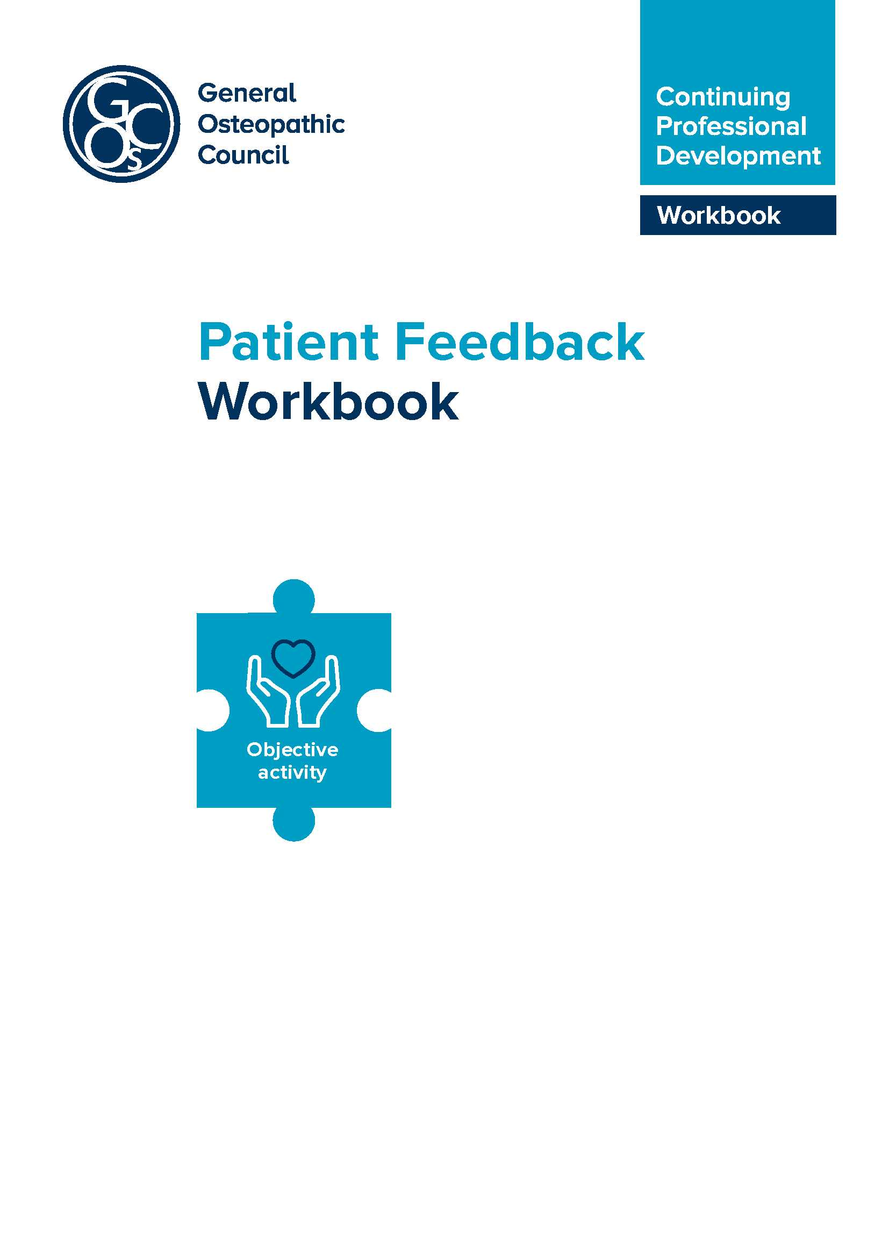
Introduction to patient feedback
This workbook has been prepared to support osteopaths in undertaking patient feedback within a group of supportive colleagues or by themselves.
The new CPD scheme
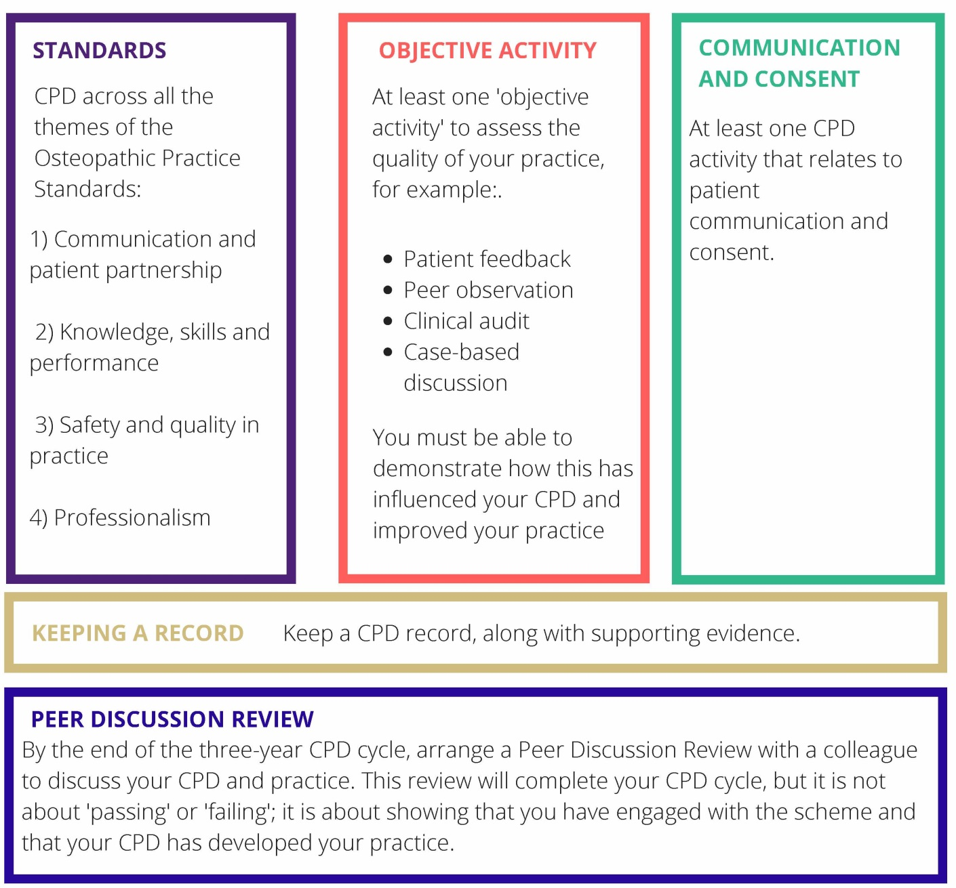
What is patient feedback?
Patient feedback is about obtaining feedback from patients (using questionnaires or other methods) about aspects of your practice.
It is an example of ‘an objective activity’ – it’s a means of getting objective feedback on your practice from patients, in areas that you choose. This enables you to reflect on what you do (with colleagues if you choose) and to consider how you might enhance your CPD and practice as a result.

Communication and consent
Reflecting on how you communicate with patients in response to their feedback is a core part of the patient feedback analysis and process. Therefore, patient feedback can also meet the communication and consent requirements of the CPD scheme.
Patient feedback in relation to the Osteopathic Practice Standards (OPS)
Undertaking patient feedback is likely to impact on more than one theme of the OPS, which are available at standards.osteopathy.org.uk
The table below provides a summary of the areas covered by each theme of the OPS (2018). All areas could be featured within a patient feedback exercise depending on the CPD activities that you choose to cover.
Theme of the OPS | Areas include | Relevant CPD activities may cover:
- Communication and patient partnership | Listening, respecting patient’s concerns and preferences, dignity and modesty, effective communication, providing information, consent, patient partnership. | - communicating with patients – different questions and approaches to identify patient ideas, concerns and expectations  - exploring non-verbal communication mechanisms  - ways of communicating benefits and risks of treatment options to particular patients  - ways of supporting patients to make decisions about treatment.
- Knowledge, skills and performance | Having sufficient knowledge and skills, working within training and competence, keeping up to date, analysing and reflecting on information to enhance patient care. | - reflection on current knowledge and skills and learning new knowledge and skills including techniques (for patient feedback, any reflection on the results of the feedback, for example, re-reading aspects of the OPS, reading around communication and consent will cover this theme.)  - analysing feedback about your practice and implementing improvements.
- Safety and quality in practice | Case history taking and record keeping, patient evaluation, management, safeguarding, wider role in enhancing patients’ health and well being. | - case history taking and developing a clear narrative for treatment options  - learning knowledge and skills about vulnerable patients, including safeguarding or how to report female genital mutilation  - signposting patients to resources about diet, exercise, and smoking cessation  - all of these areas could feature as part of your patient feedback.  - health and safety issues.
- Professionalism | Ethics, integrity, honesty, duty of candour, confidentiality, working with others, complying with regulatory requirements. | • enhancing your understanding of the contributions of other healthcare professionals to patient care  • establishing clear boundaries with patients (through case studies or group discussions)  • data analysis and report writing  • equality and diversity issues  • confidentiality and data protection  (eg GDPR)  • keeping up to date with legal requirements on advertising your practice  • supporting colleagues to enhance patient care (eg mentoring activities).
The guidance to Standard B1 (You must have and be able to apply sufficient and appropriate knowledge and skills to support your work as an osteopath) says that this knowledge should include ‘the ability to the ability to critically appraise your own osteopathic practice. For example, this could be achieved through: feedback from patients’
Patient feedback can provide feedback on many aspects of your practice, as well as covering themes B and D , it is also likely to provide feedback in:
- themes A – through thinking around how you communicate with the patient and seek consent
- theme C – on how you gather and record information, and how you devise and implement a treatment plan.
Undertaking this type of activity is an excellent way of gaining support from colleagues, and developing a community of practice by comparing and sharing methods and results. Although, if you choose, the patient feedback activity can be undertaken without a colleague.
Why should I consider gathering patient feedback?
There is some evidence that patient experience is correlated with patient outcomes. For example, the systematic review from Doyle C et al which found that ‘The data presented display that patient experience is positively associated with clinical effectiveness and patient safety, and support the case for the inclusion of patient experience as one of the central pillars of quality in healthcare.’
Although there is evidence that patient satisfaction within osteopathy is very high
(in the region of 96%) there are areas which can be improved , for example:
- lack of communication between osteopath and GPs
- information about risk and benefit of treatment
- details about what happens during consultation
- lack of appropriate onward referral
- assurances about confidentiality.
Patients say that the knowledge and competence of the osteopath is very important. Trust is also important to them in a healthcare environment. These two quotes from patients in some more recent patient research illustrate this:
‘Trust … it’s hard to sum up, it’s a feeling, it’s the whole package that when you go to see them you think ‘do I want to go back and see this person again?’
‘… you might go into a practice and see one osteopath and think ‘yeah, I’m happy with this person’ and another time you’ll get put to another one and you’ll think
‘no, I don’t like you, I don’t feel comfortable’.
Patients contributing to the development of our CPD scheme also felt that it was important to be given the opportunity to feedback to their osteopath about their experience.
If you decide that patient feedback is for you, the remainder of this booklet will help you to undertake a patient feedback exercise and to record it using a simple
Patient Feedback Analysis Template, which can be found, at the Annex.

Getting started with Patient Feedback, analysis and reflection
SECTION 1: AIMS
How can patient feedback inform my practice , what do I want to achieve?
As with all feedback, consider what’s important for you to know about your practice? For example are you interested in exploring:
- Patient outcomes – how does my treatment contribute to patients’ improved health outcomes – in their words?
- Patient experience – what is my patient’s experience of my practice and treatment, from the moment that they contact my practice for the first time
to the moment that they are discharged from my care? (This is often a more objective measure, for example, how quickly was I able to offer you an appointment?) It is possible to have a positive patient experience but a negative outcome (and vice versa).
- Patient satisfaction? – how satisfied is the patient with my care. This is often a more subjective measure.
In our webinar series during 2017 and 2018, osteopaths have explored:
- Patient experiences of getting an appointment from first point of contact.
- How often patient’s had to wait for their appointment because the osteopath
was running late with a previous patient?
- Patient experiences of following up an appointment:
  - did they know how to contact the osteopath if there were any questions?
  - do they prefer follow up contact by phone, by email, by text?
- Patient outcomes – some osteopaths decided to use the Patient Reported Outcomes Measure (PROM) questionnaires developed by the National Council for Osteopathic Research as a way of getting independent and objective feedback without having to analyse it themselves. This also provides an opportunity for osteopaths to contribute to the collective evidence base for osteopathy. Further information is available at: ncor.org.uk/practitioners/patient-reported-outcomes.
- Patient experience/satisfaction – understanding what is important to the patient by exploring their values, for example, whether they felt listened to, or part of the decision making process.
Aims: What area of patient feedback am I interested in exploring?
Use the information in this box to complete the ‘aims’ section of the patient feedback analysis template at the Annex.

SECTION 2: METHOD
Methods of collecting patient feedback
Having decided what area of practice you are interested in gathering feedback on, the next step is to consider the best method of collecting that feedback.
Involving others
Are there others involved in your practice – either principals, associates, patients other health professionals, or receptionists who may be interested or involved in you collection of patient feedback? It is good practice to involve these people at an early stage to broaden your perspective, but also make them feel involved. A collaborative environment could contribute to a more successful exercise.
You could choose:
- Online patient questionnaires
(either one that you design yourself or you could choose a ready-made template). Some examples are provided at the Annex to this work book.
Advantages include:
- unprompted feedback from a large number of people
- an indication of what respondents feel most passionate about
- a range of ratings and the ability to compare and correlate ratings.
Disadvantages include:
- only certain people may be able to comment online
- more prone to negative feedback
- simplistic ratings may not be sufficient to identify the real issues and may be limited to particular matters.
- Hard copy patient questionnaires
(again, either one that you design yourself or you could choose a ready-made template).
Advantages include:
- easy to analyse
- tools in place already
- can be anonymous (depends on information provided)
- people can feel more comfortable/honest if not speaking to a clinician inexpensive
- higher numbers of feedback
- multiple methods of administration (people can take away, send back by post or complete them before leaving and posting in a secure box).

Disadvantages include:
- surface perspective not in-depth
- may not cover sensitive issues well
- non-response or selection bias
- can exclude groups
- can exclude carers
- close ended questions may be more likely to get positive feedback.
- A mystery shopper
  - advantages can include a good overview of the whole patient experience
  - disadvantages might include the practicality of recruiting an appropriate person.
- Patient focus groups
(a group of volunteer patients meet to share their experience of your practice in particular areas. Focus groups are often facilitated by an independent person)
Advantages include:
- in depth information
- putting a human face on issues
- helping to focus on what’s most important to patients and carers
- providing an immediate opportunity to resolve issues.
Disadvantages include:
- selection bias (only particular people will be available to speak with you)
- difficulties in generalising the findings to your whole patient population, it may be better to get a focus group facilitated by someone independently.
- Recording feedback received verbally from a patient
Advantages include:
- immediate feedback and the ability to resolve any issues.
Disadvantages include:
- the inability of the patient to feel that they can raise issues if they feel it may compromise their treatment or the therapeutic relationship. Sometimes, feedback given a couple of days later can be more reflective and insightful.

To improve the quality of the feedback so that it is useful to you, you may wish to consider:
- anonymous feedback (perhaps an online questionnaire, or a self-addressed envelope, or a post box in reception emptied every 2 weeks or so?)
- thinking about ways to enhance response rates?, for example, making clear to patients that you are doing this because you want their genuine feedback so that you can make their experience even better (osteopaths have told us that when they say ‘I have to get feedback to show to my regulator….’ that patients are very supportive but provide little developmental feedback).
What method is best for you to collect patient feedback and why? (consider feedback from your patients, or people that you work with). If you choose a questionnaire will you design it yourself or use one already developed?
Use the information in this box to complete the ‘method’ section of the patient feedback analysis template at the Annex.
SECTION 3: SAMPLE
How will I selector find patients to provide their feedback?
In part, this will depend on your aims and what you would like to find out from your feedback. You could:
- Embed a link to an online questionnaire on your website which would be available to all patients for a specified period of time, promoted via your communication channels. This might be appropriate if you want general feedback about experiences or outcomes from a wide variety of patients (although this mechanism may exclude patients who are not IT literate).
- Give every patient that you see within a two week window a questionnaire to post back to you. This will allow for a good cross-section of your patient population.
- Only select new patients – this might be appropriate if you are interested to explore the information that they receive before treatment.
- Advertise for patients interested in participating in a focus group. Time of day, location, whether or not expenses are paid may all affect the types of patients who are able to participate.
Things to consider when selecting patients
This is not a research project, therefore there are no specified minimum numbers. However, you may like to think about how many patients will give you a good cross section analysis of your practice. It might be 50, 25 or a week’s worth of patients. Think about the Equality Act – how can you ensure that everyone can participate and that you collect feedback from a wide range of patients.
How will you select the patients to provide feedback and why?
Use the information in the box to complete the ‘method’ section of the patient feedback analysis template at the Annex.

SECTION 4: DEVELOPING CONTENT
How do I pick the right questions to ask patients?
The next stage is to think about the actual questions that you are going to ask. Again, involving others, associates, principals, other health professionals and patients is a good opportunity to develop questions which meet the aims of the project. (People will interpret questions in different ways, so seeking the views of others can help to make sure that the wording that you choose is right).
Overarching topics which could help you determine the types of questions you might ask might ask include the characteristics of interactions:
- patient-professional relationship
- professional care
- information and advice
- communication skills
- trust?
You could think about the organisational aspects of care, for example, accessibility, facilities or waiting time, Or you might look at overarching assessments including the success of the outcome, general satisfaction, the willingness of the patient to recommend your services to their friends or relatives?
Have a look at the example template questionnaires at the Annexes and consider which one best suits your purposes, or consider whether you might like to design your own questionnaire.
If you are interested in exploring PROMs, rather than any of the other approaches to obtaining patient feedback described above, we do recommend that you contact the national PROMs project run by the National Council for Osteopathic Research. Further information is available at: ncor.org.uk/practitioners/patient-reported-outcomes.
Explaining your feedback aims to respondents
Now that you have almost finalised your patient feedback form, it is important to include further explanation to your patients so that they understand why you are collecting feedback, how it will be used and any implications for them. Your patient participation form should include the following information::
- why you are collecting feedback?
- are patient views anonymous and confidential?
- how will the feedback be used and reported?
- what will be the outcome of the patient feedback?
- who should patients contact if they have any concerns or worries?
- information about data protection (including compliance with the GDPR)
- is their participation voluntary?
Data protection
Personal data is data which relates to a living individual who can be identified
(a) from those data, or
(b) from those data and other information which is in the possession of, or is likely to come into the possession of, the data controller.
This includes any expression of opinion about the individual, any indication of the intentions of the data controller or any other person in respect of the individual.
It is important to have a privacy notice which explains:
- what personal data you are holding – e.g. names, address, email addresses etc.
- how you are using it, how you will store it and how you will destroy it.
Data is not classed as personal data provided that patients cannot be identified from it. But even in these cases, it is good practice that your patient participation information should explain how you are using the data they provide, how it will be reported and how long it will be kept for. An example patient participation information form is attached at the Annex. You can adapt this to take fit your particular context.
Administering your questions
Do you work in a practice with other osteopaths or receptionists? How will they be involved in your patient feedback? What information do they need from you and do you need from them in order to make this a successful exercise? (For example, will you put a poster on the wall in reception to encourage patients to give you feedback? Will there be a sealed box to collect patient feedback forms, do you need to design an electronic survey?)
Collecting patient feedback
You will now be in a position to start gathering feedback, you should hope to get a reasonable response rate from your patients.
Regularly reflect through this period and consider how you might improve your response rate if you find responses to be less than you hoped.

SECTION 5: ANALYSIS
How to analyse the patient feedback you have collected and decide what this indicates
The aim of the analysis is to total up your responses to each question, allowing you to identify strengths and areas that can be improved even further to help inform a future action plan.
Here is a completed example of a patient feedback analysis template, you can a blank version in the Annex, resource D.
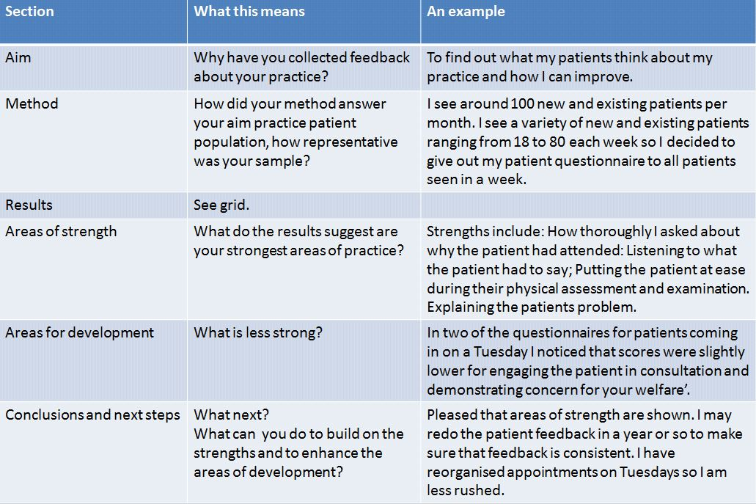
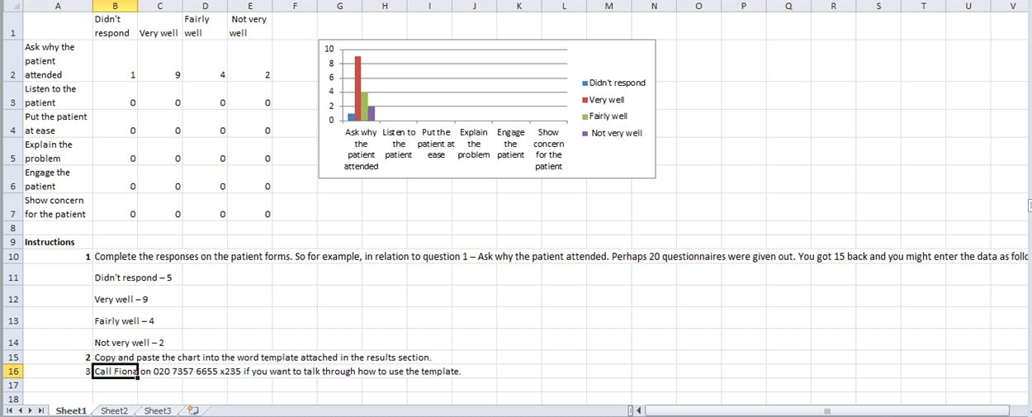
Heres is a simple example of an excel spreadsheet used for analysing patient feedback. Excel sheets enable the results to be displayed in an automated graph allowing for a simpler analysis .
There are two excel sheets available to support a very simple analysis of the patient feedback templates at the Annex.
Alternative ways of analysis include a simple pen and paper. Perhaps tallying the results as illustrated in the example below.
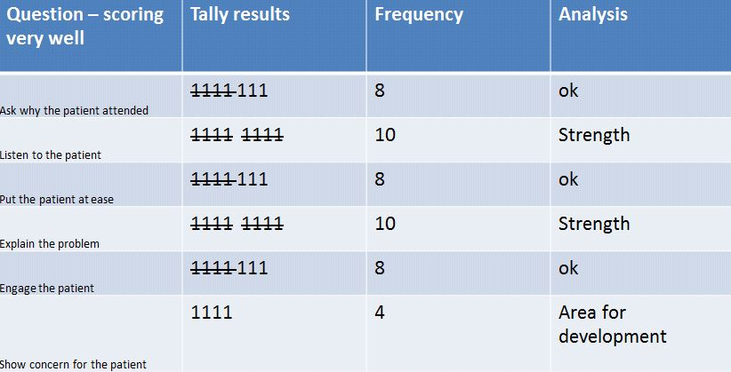
How to analyse the comments you have collected
If you have decided to collect some free text comments, consider the following in relation to identifying strengths or areas of development:
- are the comments one off or do they appear more than once?
- how do you connect two comments using different language making the
same point?
- why not discuss the comments with a colleague to gain a different perspective
or to explore different insights into your results.
Recording your results: What were your results? What are the areas of strength? Are there any areas less strong?
Use the information in this box to complete the ‘results’ section of the patient feedback analysis template at the Annex.

SECTION 6: CONCLUSIONS AND NEXT STEPS
You have now identified your strengths to provide assurance about your practice! Take the opportunity to celebrate what you do well and record this for sharing with your peer. You may also like to consider sharing these findings with your patients. You may also have identified some areas where you would like to improve your results even further. What actions might you take to change your practice and enhance your scores next time? You could discuss the findings with a colleague, read the Osteopathic Practice Standards, or explore the resources around communication and consent available on our website at cpd.osteopathy.org.uk. You will also find case studies demonstrating how osteopaths have responded to the findings in their patient feedback and enhanced practice even further.
If you decide to discuss your findings with a colleague, you may find the resources about giving and receiving constructive feedback at the Annex helpful.
What next? What can you do to build on the strengths and to enhance the areas of development? Would you do it differently next time?
Will you repeat this patient feedback exercise? If so, when and why?
Use the information in this box to complete the ‘conclusions and next steps’ section of the patient feedback analysis template at the Annex.

- Care and Relational Empathy Measure (CARE) 1
- Patient feedback template for adaptation 2
- Example Patient Participation Information Sheet
- Patient Feedback Analysis Template Form
- Patient Feedback Analysis Template – completed example
- Giving and receiving feedback

Note – these templates are suggestions, and can be modified, amended and adapted to meet your needs.

Resource A – Care and Relational Empathy Measure
Further information about the CARE measure is available at: caremeasure.org/about.php.
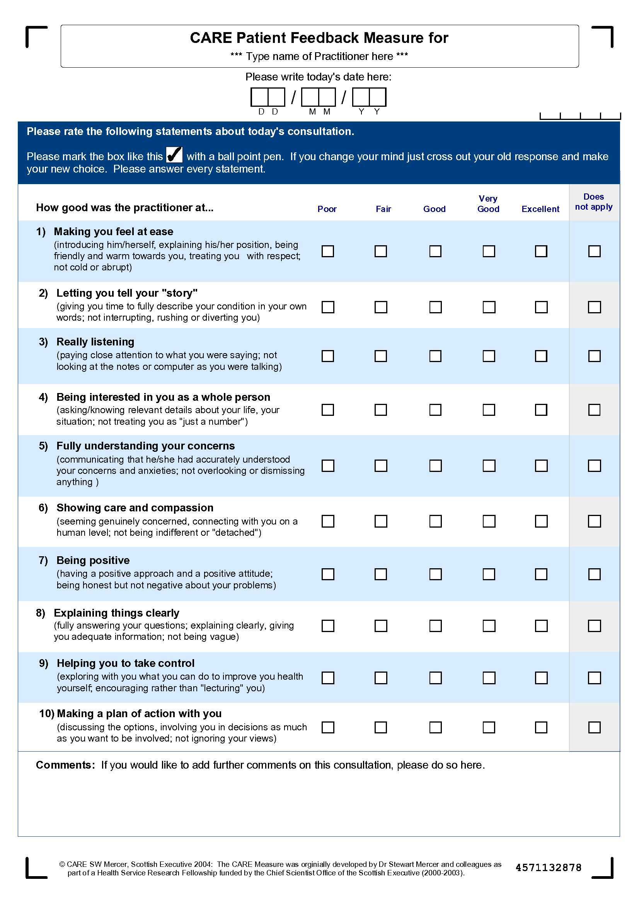
Resource B – Patient feedback template for adaptation instructions
What is this patient feedback template?
This template enables osteopaths to explore patients’ views about their experience of the osteopathic appointment.
This generic template can be adapted by the osteopath to ensure that the information fits the osteopath circumstances. Please check that the following sections all reflect the correct information:
- about this questionnaire
- questions 1 to 9
- next steps.
Patient feedback template
Name of osteopath: …………………………………………………………………………………………
Date of appointment: …………………………………………………………………………………………
About this Questionnaire
It is important to us to ensure that we continually review and enhance the experience that patients have with us. Please tell us about your honest experience with your osteopath.
The information that you provide will be anonymous (you will not be identified) and will be used to enhance practice.
The collective responses may be shared with my peer (another health professional) or my regulator to help me to reflect upon and improve my practice. We will retain data from these questionnaires for up to five years.
Questions
- How thoroughly did the osteopath ask you about why you had attended?
Not very well | Fairly well | Very well
- Did you feel the osteopath listened to what you had to say?
Not very well | Fairly well | Very well
- How well did the osteopath put you at ease during your physical assessment and examination?
Not very well | Fairly well | Very well
- How well did the osteopath explain your problem?
Not very well | Fairly well | Very well
- How well did the osteopath engage you in your consultation?
Not very well | Fairly well | Very well
- Did you feel the osteopath demonstrated concern for your welfare?
Not very well | Fairly well | Very well
- What did you like about your osteopathy appointment?

- What could make your osteopathy appointment even better?

- Do you have any other comments?

Next steps [osteopath to adapt as appropriate]
Returning the questionnaire: Please return this questionnaire to the feedback box in reception. (This feedback box is emptied weekly). [Adapt as appropriate]
Further information: If you have any questions about completing this form, please contact:

Resource C - Example Patient Participation Information Form
[Please adapt this for your own purposes]
I am collecting feedback from patients to help me to provide better care for my patients. This anonymous questionnaire asks about your experience of my practice – both areas that are going well and areas where I can improve.
Any views that you provide are entirely voluntary and anonymous and you can withdraw from the survey at any time.
Your response to the survey will be taken as consent to participate. The survey will take about five minutes to complete.
The results of the surveys will only ever be published in forms that can not identify you as an individual. The collective results may be shared with my peer or with my regulator in order to help me discuss my practice and Continuing Professional Development (CPD).
Further information
If you have any questions about your participation, please contact:
Name, address, contact details
Data Protection
All data collected in this survey will be held securely and will be destroyed as soon as it is no longer required for analytical purposes and after no more than three years.

Resource D – Patient Feedback Analysis Template
Aims

Method
Results
Strengths
Areas for Development
Action Plan and next steps

Resource E – Patient Feedback Analysis Template – completed example
Aim
I am interested to understand how patients feel about their treatment and their experience of treatment with me. I have never provided my patients with the opportunity to feedback anonymously before and I am interested to understand whether I can improve their experience with me.
Method
I gave out a questionnaire to every patient seen from 7 to 21 November 2011 and asked them to complete it and put it in the box by reception. I also emailed the questionnaire to patients and asked them to email to me or to post in the stamped addressed envelope enclosed.
I decided to use consecutive patients so that I had a good balance of new and ongoing patients.
I gave out a total of 22 surveys to 22 patients who attended during this time. Three of the patients were children. I gave the questionnaire for the children to the parents.
I received 10 responses.
Results
Did the Osteopath

Note: We have used a very simple PowerPoint slide to display these results visually.

Strengths
Areas of strength included:
- how thoroughly I asked about why the patient had attended
- listening to what the patient had to say.
- putting the patient at ease during their physical assessment and examination.
- explaining the patient’s problem.
Areas for Development
Areas for development included:
‘In two of the questionnaires for patients coming in on a Tuesday I noticed that scores were slightly lower for engaging the patient in consultation and demonstrating concern for your welfare’.
Action Plan and next steps
Action Plan
I realise that I am always keen to finish on time on Tuesday as I have to pick up my daughter from after school club. I have now ensured that I schedule the last appointment on Tuesday at an earlier time.
I recognise that my responses are not ‘significant’ of the population of patients that I see yet. However, I am interested to explore further patients to see if I can gather any other information about my practice that I wasn’t previously aware of.
I am not an expert in statistics and I feel that I may benefit from learning more about how to analyse my patient feedback. I intend to explore this with some of my colleagues to see if they can recommend some useful CPD in this area for next year.
I intend to repeat the questionnaires early next year to see whether there have been any changes.
Mapping Grid
The patient questionnaires have helped me identify evidence that I appear to be meeting the requirements in Theme 1 – Communication and Patient Partnership.

Resource F - Giving and receiving feedback
The giving, and receiving, of feedback is a skill that may be more familiar to some osteopaths than others. Those who work in osteopathic education, who mentor colleagues, or who work in an NHS context, might be used to undergoing some form of peer observation process. For those who work in a more isolated setting, giving and/or receiving feedback may be less familiar and potentially daunting.
There are some useful resources available on feedback published by the London Deanery (faculty.londondeanery.ac.uk/e-learning/feedback). This is aimed at an educational setting, but many of the principles will apply in the case of peer feedback as well.
When giving feedback, there are some useful tips to bear in mind:
- use open questions to encourage reflection, for example, ‘Did that go as planned?, ‘how do you think the patient felt, ‘would you do anything differently next time?’
- focus on the positive – it may be helpful, of course, to help highlight areas where things could be done better, but don’t be unnecessarily negative
- be sensitive about the impact of what you say – feedback is for the recipient’s benefit, not the giver’s
- be supportive
- don’t overload – focus on two or three key messages
- if you met resistance when giving feedback, perhaps you need to rephrase it.
When receiving feedback:
- assume it’s constructive
- accept it positively
- don’t be defensive.
If all this sounds overly formal and intimidating, please don’t worry. Remember that you’ll be undertaking this activity with someone that you’ve asked and agreed to work with because you trust their judgement. In most cases, it will be a two way activity as well, so you’ll be both giving and receiving feedback at some point. Be honest, respectful and kind.

If you have any queries on the workbook or CPD in general, please feel free to get in touch:
General Osteopathic Council
Osteopathy House
176 Tower Bridge Road
London SE1 3LU

Email: newcpd@osteopathy.org.uk
osteopathy.org.uk
cpd.osteopathy.org.uk

The GOsC is a charity registered in England and Wales (1172749)

We welcome your comments and feedback. We are keen to hear your feedback to help us to improve this workbook. Please send any comments and/or suggestions to newcpd@osteopathy.org.uk

osteopathy.org.uk/news-and-resources/document-library/osteopathic-practice-standards/osteopathic-practice-standards.
See Osteopathic Practice Standards (2018) available at standards.osteopathy.org.uk.
See A systematic review of evidence on the links between patient experience and clinical safety and effectiveness, Doyle C , Lennox L and Bell D (2013) available at: bmjopen.bmj.com/content/3/1/ e001570.
See Leach J et al, Osteopathic Patient Expectations Study available at: osteopathy.org.uk/news-and-resources/research-surveys/gosc-research/osteopathic-patient-expectations-study.
See report of Community Research, Public and patient perceptions of Osteopath Study (2015) at osteopathy.org.uk/news-and-resources/document-library/research-and-surveys/public-and-patient-perceptions-of-osteopaths-and-osteopathy.
See ncor.org.uk/practitioners/patient-reported-outcomes (a report coming directly from patients about how they feel or function in relation to a health condition and its therapy without interpretation by healthcare professionals or anyone else (Patrick et al, 2008).
See health.org.uk/sites/health/files/MeasuringPatientExperience.pdf.
See Heakth Foundation: Measuring patient experience, 2013 available at: health.org.uk/sites/ health/files/MeasuringPatientExperience.pdf.
As above.
See ico.org.uk/for-organisations/guide-to-data-protection/key-definitions.

