Workbook

Keeping CPD records Workbook

Keeping CPD records

Workbook: Keeping CPD records

Contents

Introduction | 3
The features of the CPD scheme | 4
What is CPD? | 6
What is professional practice? | 7
Recording your CPD activity | 8
Options for recording your CPD | 9
Linking to the four themes of the
Osteopathic Practice Standards | 12
Keeping records to help you prepare
for a Peer Discussion Review | 13
Templates: activity record and record summary | 14
Further information | 20

This workbook is published by the General Osteopathic Council (GOsC).
We welcome your comments and feedback to help us improve this workbook. |  | 2
Please send any comments and/or suggestions to: newcpd@osteopathy.org.uk.
The GOsC is a charity registered in England and Wales (1172749). | 22/01/19

Workbook: Keeping CPD records

Introduction

This workbook has been prepared to support osteopaths in keeping their continuing professional development (CPD) records as part of the GOsC CPD scheme.

You will find learning points throughout to help summarise the advice.

3

Workbook: Keeping CPD records

The features
of the CPD scheme
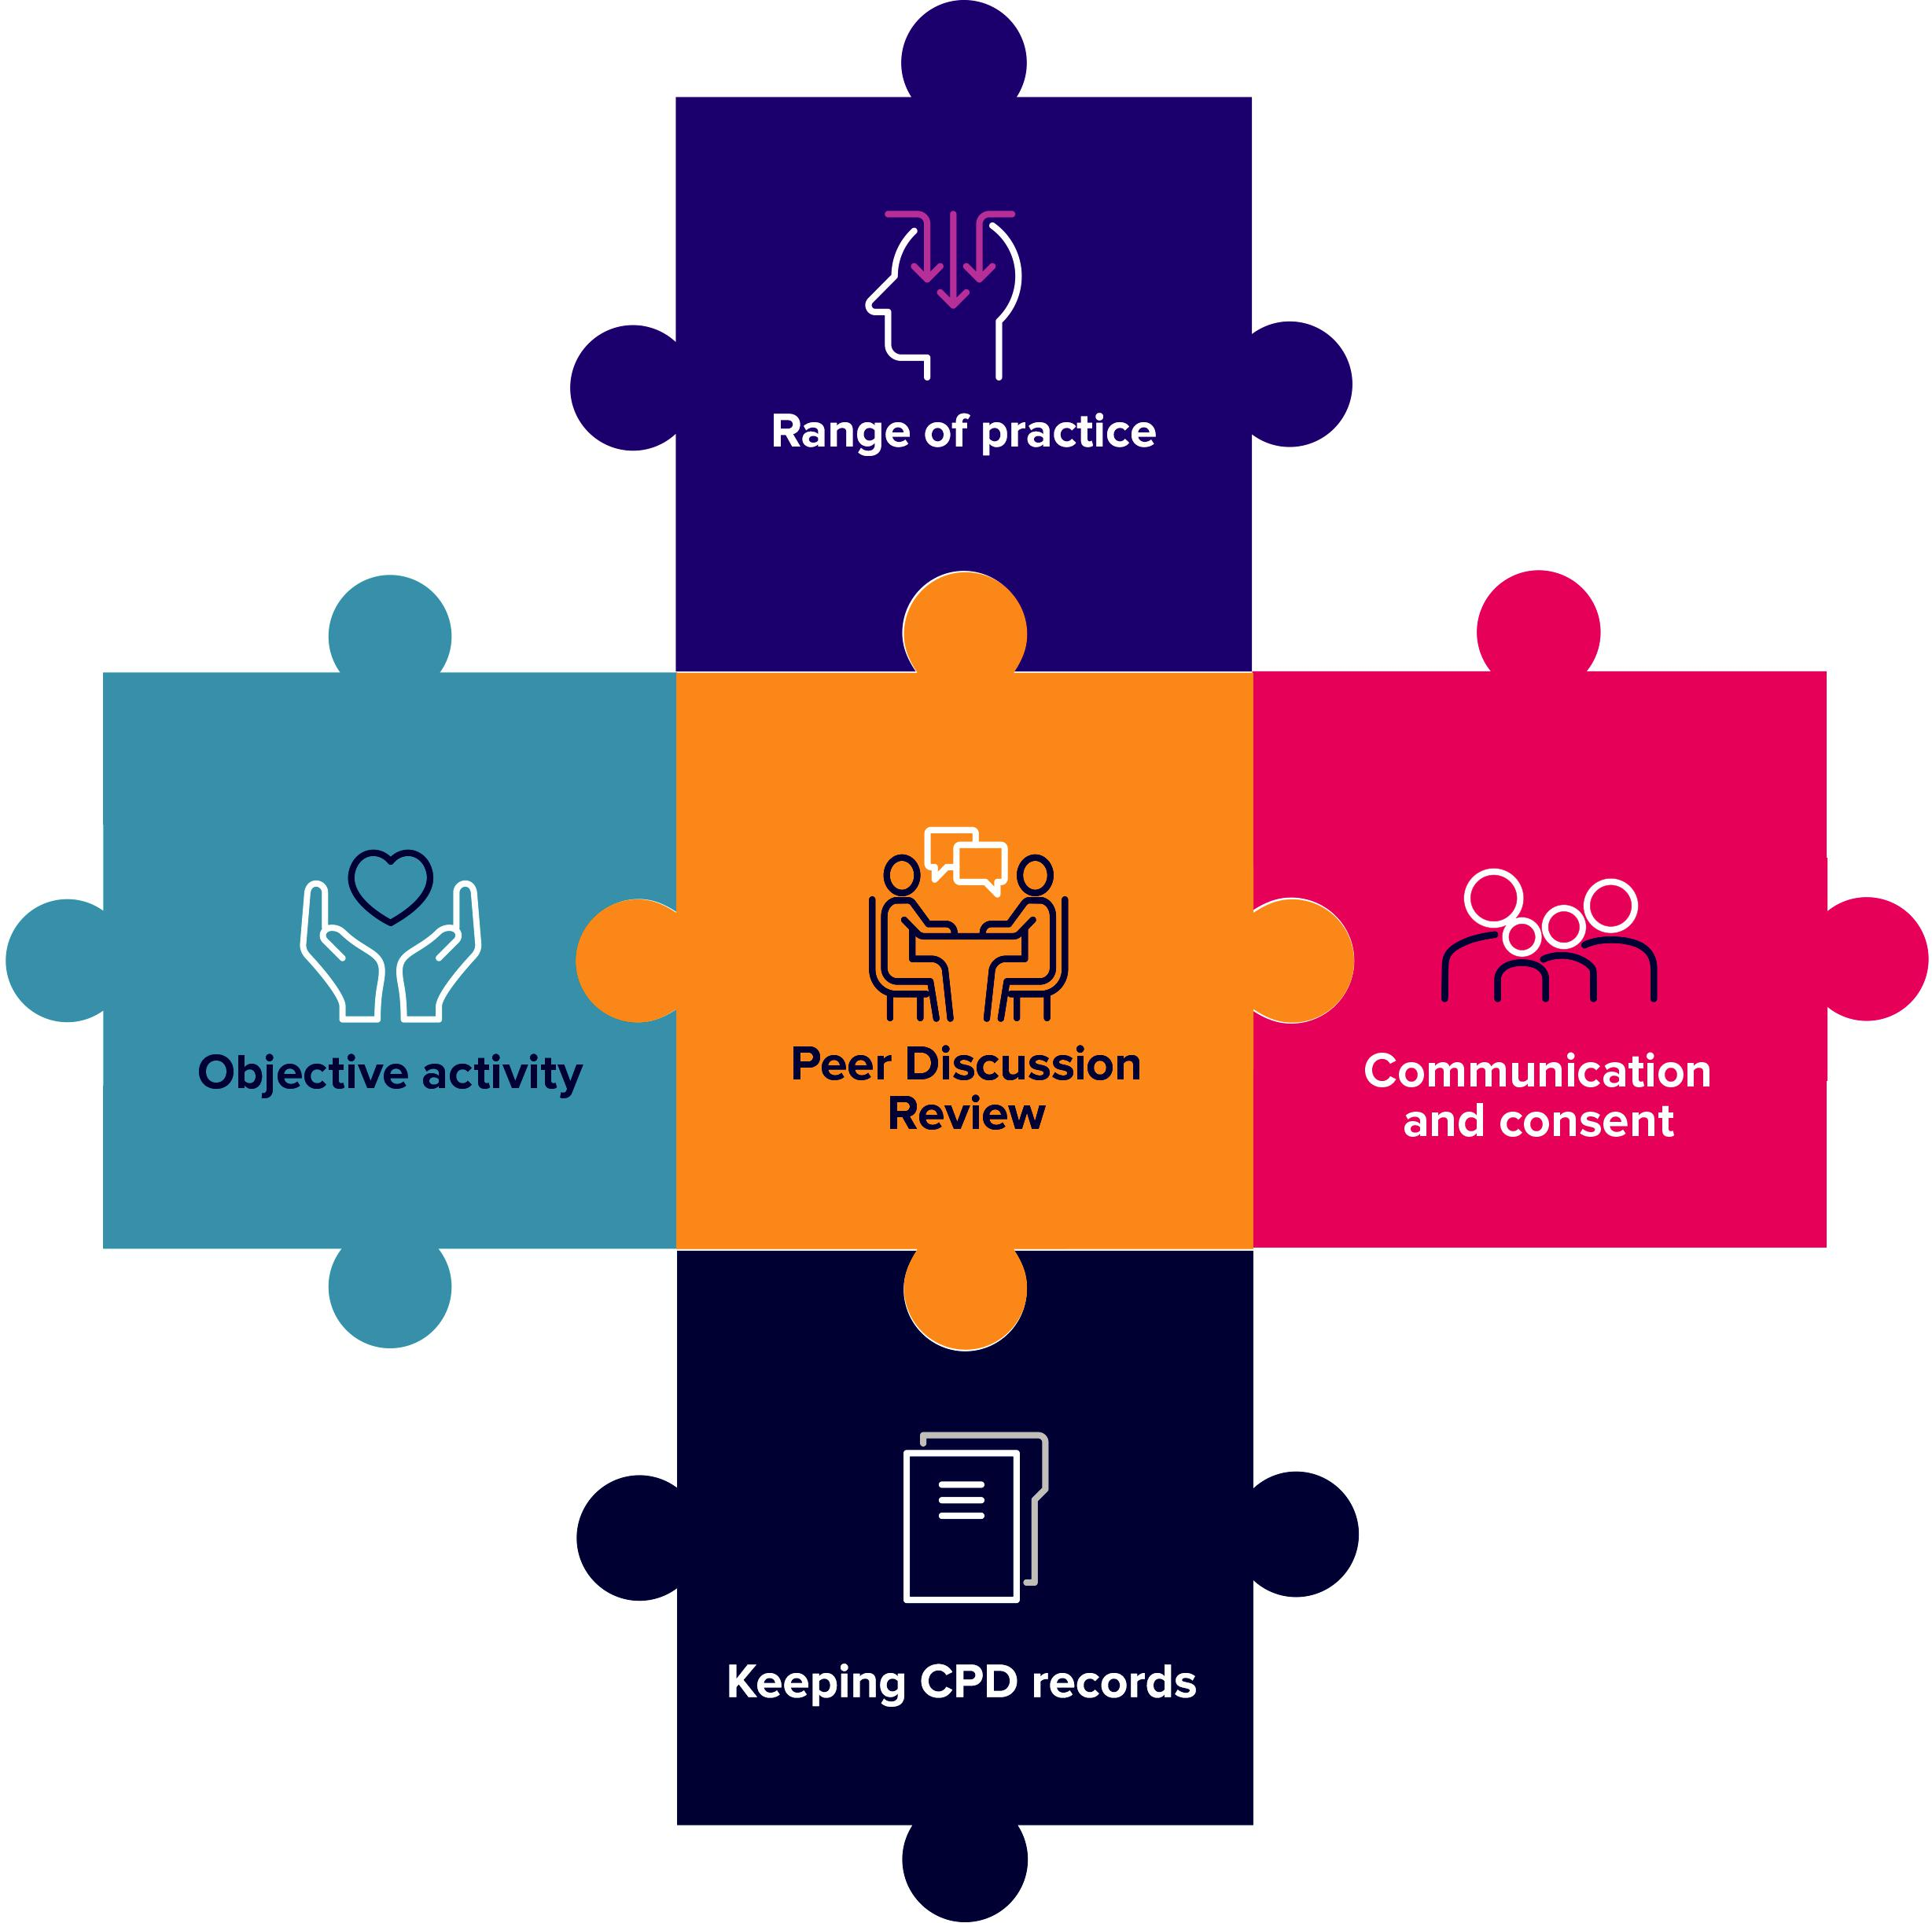

4

Workbook: Keeping CPD records

Range of practice: the four Osteopathic Practice Standards themes and breadth of practice.

You should do CPD activities in all four themes of the Osteopathic Practice Standards:

A. Communication and patient partnership

B. Knowledge, skills and performance

C. Safety and quality in practice

- Professionalism

Your CPD should also cover the breadth of your professional practice, which may include the clinical, education, research or management aspects of your roles.

Objective activity

Your CPD needs to include at least one objective activity that informs your practice and your CPD. An objective activity is where you seek external objective feedback about your practice and then analyse and reflect on this to show how it has informed your practice or CPD. This activity might include: case-based discussion, patient feedback, peer observation, clinical audit or a peer observation. See page 20 for further information.

Communication and consent

You need to do at least one CPD activity in the area of communication and consent. This should include reviewing the relevant guidance in the Osteopathic Practice Standards and showing how this has informed your learning and how it has been applied in practice. Doing an activity in the area of communication and consent will help you to demonstrate how your CPD benefits patients.

Keeping CPD records

You need to keep a record of your CPD that shows you have completed a three-year cycle of 90 hours. This must include a minimum of 45 hours of ‘learning with others’ and include all the required elements of the scheme. This workbook gives more guidance on keeping CPD records.

Peer Discussion Review

You need to complete a structured conversation towards the end of your three-year cycle with an osteopath or other health professional to confirm that you have completed all the scheme’s elements.

5

Workbook: Keeping CPD records

What is CPD?

The definition of continuing professional development (CPD) is very broad and can include any activity that maintains, enhances and develops osteopathic professional practice.

CPD can include any learning undertaken by an osteopath, for example:

- discussion of CPD and practice with a colleague

- courses, seminars or practical sessions

- e-learning

- reading, research or individual study

- Peer Discussion Review

- mentoring

- any other activities that can advance practice.

Doing CPD is an ongoing aspect of professional practice. Standard B3 of the Osteopathic Practice Standards (2018) states that osteopaths ‘must keep … professional knowledge and skills up to date’. To achieve this, osteopaths must be professionally engaged, undertaking professional development activities and keeping up to date with factors relevant to ongoing practice, including in relation to the wider healthcare environment.

For CPD to count as ‘learning with others’, it must also involve interaction with others to inform your learning – which means you will be both giving and receiving information. This can be carried out with osteopaths, other healthcare practitioners or other professionals.

You should reflect on the CPD you do and you must keep a record of it.

6

Workbook: Keeping CPD records

What is professional practice?

Professional practice can include clinical work (including safeguarding), education, research or management responsibilities. Over the course of a CPD cycle, CPD should reflect the breadth of an individual’s practice. So, for example, an osteopath who only undertakes clinical work and holds no management or teaching responsibilities might confine all their CPD to clinical work. However, an osteopath who undertakes one day a week in education, should undertake an appropriate portion of their CPD in the area of education or teaching practice. Osteopaths with research or management responsibilities should be able to demonstrate balanced CPD in these areas.

Learning points:

- The definition of CPD is very broad and includes any learning or activities that advance practice.

- Professional practice can include clinical work, education, research or management responsibilities.

- CPD should be reflected on and recorded.

7

Workbook: Keeping CPD records

Recording your CPD activity

You need to keep a record of your CPD activities. Each year

you will be required to complete an annual renewal of registration form and, as part of this, you need to make a declaration about the CPD activities you have done in that particular year of your three-year cycle.

Unlike the previous CPD scheme, you no longer need to submit a CPD annual summary form. So the main difference is that rather than submitting full details to the GOsC each year, your records will now help you carry out a Peer Discussion Review with a colleague towards the end of your three-year cycle.

This means that you now have flexibility in the way that you record your CPD. If, for example, you are registered as another health professional as well as an osteopath, perhaps you are also a doctor or a nurse, you may record CPD to inform NHS appraisals or other CPD records. You can now use these other records to also help demonstrate your osteopathic CPD – but make sure the relevance to osteopathic practice is also recorded.

We outline some options for how to record your CPD in this workbook, but the method you choose to maintain your record will be your choice. The important thing is that your record provides sufficient information to summarise effectively what CPD you’ve undertaken, how you have met the key elements of the scheme and how this has enhanced your work as an osteopath. This can then be discussed in your Peer Discussion Review.

Learning points:

- You must retain a record of your CPD, but how you do this is up to you.

- You must have a record of all the CPD you claim but it doesn’t need to be lengthy or detailed. See examples in this workbook.

8

Workbook: Keeping CPD records

Options for recording your CPD

We know that osteopaths reflect on practice regularly, but to convert these day-to-day reflections into claimable CPD, these reflections need to be written down and recorded. These records can also be useful to continue to inform your practice and your CPD, and may also help to demonstrate both how your practice has evolved over time and your commitment to learning.

There are various options for you to choose from as to how you maintain a record of your activities and reflections, and much of the decision will come down to your personal preference. We look at some options below.

Recording on the o zone: online CPD Diary

Many of you will have been using the CPD annual summary form as your method of recording your CPD activities. It looks like this:
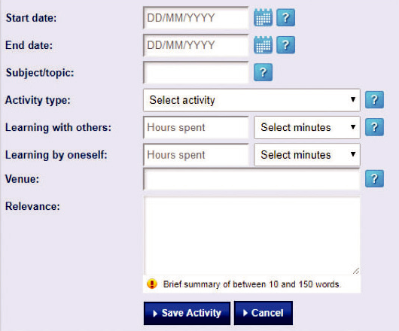

With the introduction of the new scheme, the purpose of the record has changed. Whereas an annual summary form was used to submit details of CPD activities to the GOsC, under the new scheme, unless you are one of the few asked to supply records and evidence of CPD, you no longer need to provide this detailed annual summary.

However, you might choose to continue keeping your records in the o zone, making use of your personal online CPD Diary. The CPD Diary has been developed to help you keep track of your CPD (but if you do this, remember to continue to keep hold of any supplementary materials too, for example notes or certificates). The online CPD Diary is optional, you have the flexibility to use other methods if you wish, and we explore these other options in this guide too.

9

Workbook: Keeping CPD records

CPD templates

We have included two templates towards the end of this workbook (see pages 14 to 19)

which you might find helpful:

- CPD activity record template

- CPD record summary template.

These are offered as examples. Feel free to adapt these or use something else if that works for you.

The CPD activity record template could be used in situations where you want to record a specific activity, for example attending a course or lecture, an informal discussion with a colleague, or an encounter with a patient which you find challenging. You can see an example of a completed CPD activity record on pages 14-15.

Remember that a brief summary of the key points, the key impact these points have had and any learning or actions you have identified will be sufficient for you to ultimately talk this through with a colleague when you come to do a Peer Discussion Review.

Learning points:

- Records of CPD should include a brief summary of the key points, the impact they have had and any further learning or actions you have identified to help you show your peer that you have engaged with the scheme.

Your own electronic records

You can use Word, Pages, Google Docs or whatever platform you’re familiar with or that works best for you. Remember to back up electronic records so that they can be accessed even if your computer is lost or damaged.

It’s perfectly possible to create your own online portfolio folder using templates as suggested above and storing these in a folder which can be shared with a peer or colleague. You can create shared folders in platforms such as Dropbox (dropbox.com/ register) or Google Drive (google.com/drive).

As well as your records of activities, it’s possible to scan evidence, such as certificates or notes using a smartphone app and store these in the folder too.

10

Workbook: Keeping CPD records

An eportfolio platform

There are several portfolio platforms available which individuals can sign up to, for example:

- PebblePad (pebblepad.co.uk)

- Folio Spaces (foliospaces.org)

- Padlet (padlet.com)

- Mahara (mahara.org).

Some of these might incur a fee and some might be free, so it’s worth exploring what might work for you if an eportfolio suits your needs. Some osteopaths will like the opportunity that an eportfolio provides to plan and reflect on activities and maintain evidence of these in one place, with the ability to share this with others.

Paper records

You might want simply to keep paper records of your activities and evidence. This is possible, although it might be more challenging to share for example with a colleague for a peer review, but this can still be done easily enough. Again, it’s always worth keeping copies in case they get lost or damaged.

11

Workbook: Keeping CPD records

Linking to the four themes
of the Osteopathic Practice Standards

The CPD scheme requires osteopaths to undertake activities across the four themes of the OPS – communication and patient partnership, knowledge skills and performance, safety and quality in practice and professionalism.

So, with every CPD activity you do, remember to take the opportunity to think about which themes of the Osteopathic Practice Standards (OPS) you have covered. Doing this will provide good evidence that you have covered the four themes across the three-year cycle.

Some, if not most, of the activities you do might cover more than one of the themes. There is no requirement as to how much time should be spent on each theme, and you don’t need to allocate the number of minutes spent on each theme in an activity which might encompass more than one of the themes.

The example given in the CPD activity record template on pages 14-15 indicates how a CPD event or activity might relate to each of the OPS themes. Thinking about and recording activities in this way is straightforward and means that over a three-year cycle, it should be manageable to accumulate sufficient evidence to demonstrate that CPD has been undertaken across each theme.

Remember, this is about linking to the themes of the OPS, not each individual standard.

Many CPD providers will indicate on their certificates and in the information they provide which OPS themes have been covered in their events.

Learning points:

- Many CPD activities will cover more than one theme of the OPS. You don’t need to cover all the standards in any particular theme.

12

Workbook: Keeping CPD records

Keeping records to help you
prepare for a Peer Discussion Review

You might find it helpful to highlight the CPD activities you have done that meet the key requirements of the CPD scheme to help you demonstrate that you have met them all. You can do this highlighting in whichever format works for you. Take a look at the Peer Discussion Review form so you can see what will be expected at that discussion.

Remember you will need:

- CPD records referring to the four themes of the OPS and the breadth of your professional practice, which may include the clinical, education, research or management aspects of your roles.

- CPD records of at least one objective activity (this might be a case-based discussion, patient feedback, clinical audit or a peer observation).

- CPD records covering communication and consent (this can be a part of another activity or it can be a separate activity in its own right).

It can also be useful to complete a draft Peer Discussion Review form before your Peer Discussion Review, and to carry out informal reviews with your peer earlier in your cycle, so you can share feedback and get support. This will also help you check that you can demonstrate how you have met the requirements of the scheme and how you might want to refer to the relevant aspects of your record to do this.

Further information about the Peer Discussion Review can be found in the Peer

Discussion Review Guidance available at: cpd.osteopathy.org.uk/pdr-guidance.

13

Workbook: Keeping CPD records

Completed example of a CPD activity record template

This is an example of a completed activity record, and could be adapted to suit a range of circumstances and activities.

Activity: Lecture/workshop and subsequent study | Date: 9.1.19

Subject: Review of orthopaedic testing of the shoulder and upper limb and an overview of current surgical interventions for common orthopaedic conditions.

Learning with others: 2 | Learning by oneself: 2

Location: The Anywhere Hotel, and subsequently my home.

Relevance to practice

What was the activity?

This was a lecture and workshop from two local orthopaedic surgeons who presented on common conditions of the shoulder and upper limb, clinical testing of these and how they might be addressed surgically. Subsequently, I reviewed the anatomy of these areas using my anatomy app and reviewed further orthopaedic testing.

What was the impact/significance of the activity?

This was a helpful overview and revision of orthopaedic testing of the shoulder and upper limb. It’s now some years since I studied this formally, and it was good to see the tests carried out by another professional, and their interpretation of these. It was useful, too, to hear how surgical interventions have developed over the past 10 years, and the relative risks and benefits of these from a surgeon’s perspective. During the workshop element there was a chance to discuss clinical cases with other professionals (GPs and physios, as well as osteopaths), and it was reassuring to hear how others approach patients with these conditions and manage the uncertainty within clinical practice.

How has/will the activity contribute to your practice?

Having been inspired by the presentation, I further reviewed the anatomy of the shoulder and upper limb, researched orthopaedic conditions, looking at a number of patient information resources available online, for example: www.ouh.nhs.uk/shoulderandelbow/information/documents/JRFinal2010poster.pdf and https://modalitypartnership.nhs.uk/self-help/conditions/articles/shoulderpain/treatment This has ensured that I am able to discuss treatment options fully with patients and ensured that the advice I give is consistent with current thinking. It has also helped me to appreciate where my own interventions fit within the broader choices available to patients.

14

Workbook: Keeping CPD records

Which themes of the Osteopathic Practice Standards have you considered in relation to the case/activity?

A. Communication and patient partnership | The activities have enhanced my ability to talk
For example; communication skills, values, | to patients more knowledgably about treatment
consent, capacity, supporting patients in caring for | options, which has helped me gain informed
themselves | consent for osteopathic intervention.
B. Knowledge, skills and performance
Anything which enhances the knowledge and | It has been helpful to review my knowledge in
skills you need to work as an osteopath, reflective | this area.
practice, acting on feedback
C. Safety and quality in practice | Useful to see how other professions approach
Evaluation and diagnosis, some aspects of | orthopaedic testing and views on the reliability of
communication, record keeping, safeguarding | certain tests.
D. Professionalism | I gained a greater understanding of the approach
Understanding contributions of other healthcare
 | of other healthcare professionals to the types
professionals, analysis of data and production
 | of patients that I see in practice and how a
of reports, equality and diversity, confidentiality,
 | multidisciplinary approach can be utilised in many
managing complaints, supporting colleagues, health
 | cases for the benefit of the patient.
and safety, maintaining boundaries with patients

Any additional thoughts or comments?

15

Workbook: Keeping CPD records

Completed example of a CPD record summary

Activity | Date | Hours | Hours | Evaluation and impact on practice. | OPS
Subject, type, |  | claimed | claimed |  | themes
venue (if |  | Learning | Learning
appropriate) |  | by oneself | with others
Subject: | 16.01.19 |  | 2.5 | This comprised: | A, B, C
Communication |  |  |  | • a presentation on some current
and consent |  |  |  | research around communication
Type: Regional |  |  |  | and the impact of effective
group meeting |  |  |  | communication on clinical
Venue: Hilton |  |  |  | outcomes
Hotel, Anytown |  |  |  | • an overview of the Montgomery
 |  |  |  | judgment and the relevance
 |  |  |  | of this in relation to consent in
 |  |  |  | osteopathic practice
 |  |  |  | • a case-based discussion in
 |  |  |  | small groups to consider a case
 |  |  |  | where a patient felt that their
 |  |  |  | expectations had not been met.
 |  |  |  | It was helpful to hear about current
 |  |  |  | thinking in this area, and to consider
 |  |  |  | the effect language can have on
 |  |  |  | the clinical outcome of patients.
 |  |  |  | Useful, also, to hear the views of
 |  |  |  | colleagues on the case discussed,
 |  |  |  | and how the issues raised may have
 |  |  |  | been more effectively dealt with.
 |  |  |  | I have reflected since on my own
 |  |  |  | communication skills and reviewed
 |  |  |  | my use of some medical terms with
 |  |  |  | patients which some may find off-
 |  |  |  | putting. Also considered how best to
 |  |  |  | explore with patient values and what
 |  |  |  | matters to them.
Subject: Common | 22.2.19 | 1 | 1.5 | This was a presentation from a local | A, B, C, D
neurological |  |  |  | neurologist on common neurological
conditions |  |  |  | conditions, the assessment and
Type: Lecture/ |  |  |  | screening of these, and medical
presentation |  |  |  | interventions. It was useful and
Venue: Anytown |  |  |  | relevant to review such conditions,
Hospital |  |  |  | and to better understand their
 |  |  |  | medical management and referral
 |  |  |  | processes. This has helped me
 |  |  |  | in discussing treatment options
 |  |  |  | with patients and in understanding
 |  |  |  | how osteopathy can help
 |  |  |  | alongside medical approaches to
 |  |  |  | management.

16

Workbook: Keeping CPD records

Subject: | 17.03.19 | 1 |  | I saw a patient with | B, C
Spondylolisthesis |  |  |  | spondylolisthesis, and took the
Type: Personal |  |  |  | opportunity afterwards to review
research |  |  |  | the anatomy of this and its clinical
 |  |  |  | management. I looked at the
 |  |  |  | information that the NHS provide
 |  |  |  | to patients regarding this condition,
 |  |  |  | and also at a website compiled by a
 |  |  |  | university in Belgium:
 |  |  |  | nhs.uk/conditions/spondylolisthesis
 |  |  |  | physio-pedia.com/Spondylolisthesis
Subject: Peer | 18.04.19 |  | 2.5 | I undertook a peer observation | A, B, C, D
observation |  |  |  | activity with my colleague David
Type: Observation |  |  |  | O’Path. Today, David observed
with a colleague |  |  |  | me with a new patient and then
Venue: My practice |  |  |  | a continuing one, and we met
 |  |  |  | afterwards to discuss what went
 |  |  |  | well, and where I might consider
 |  |  |  | improving aspects of my practice.
Subject: Somatic | 15.5.19 | 1 |  | This relates to an IJOM research | A, B, C
dysfunction |  |  |  | paper – ‘Somatic Dysfunction – an
Type: Research |  |  |  | osteopathic conundrum’, by Gary
paper |  |  |  | Fryer (International Journal of
 |  |  |  | Osteopathic Medicine, Volume 22,
 |  |  |  | December 2016, Pages 52-63)
 |  |  |  | • This was an interesting read
 |  |  |  | which reviews some basic
 |  |  |  | osteopathic concepts of
 |  |  |  | dysfunction in the light of
 |  |  |  | evidence, and explores more
 |  |  |  | plausible conceptual models.
 |  |  |  | It covers, also, some language
 |  |  |  | issues, and how diagnosis is
 |  |  |  | communicated to patients.

17

Workbook: Keeping CPD records

CPD activity record template

Activity: Date:

Subject:

Learning with others: | Learning by oneself:

Location:

Relevance to practice

What was the activity?

What was the impact/significance of the activity?

How has/will the activity contribute to your practice?

Which themes of the Osteopathic Practice Standards have you considered in relation to the case/activity?

- Communication and patient partnership

For example; communication skills, values, consent, capacity, supporting patients in caring for themselves

- Knowledge, skills and performance

Anything which enhances the knowledge and skills you need to work as an osteopath, reflective practice, acting on feedback

- Safety and quality in practice

Evaluation and diagnosis, some aspects of communication, record keeping, safeguarding

- Professionalism

Understanding contributions of other healthcare professionals, analysis of data and production of reports, equality and diversity, confidentiality, managing complaints, supporting colleagues, health and safety, maintaining boundaries with patients

Any additional thoughts or comments?

18

Workbook: Keeping CPD records

CPD record summary template

Activity | Date | Hours | Hours | Evaluation and impact on practice. | OPS
Subject, type, |  | claimed | claimed |  | themes
venue (if |  | Learning | Learning
appropriate) |  | by oneself | with others
Subject:
Type:
Venue:
Subject:
Type:
Venue:
Subject:
Type:
Venue:
Subject:
Type:
Venue:
Subject:
Type:
Venue:
Subject:
Type:
Venue:
Subject:
Type:
Venue:
Subject:
Type:
Venue:
Subject:
Type:
Venue:
Subject:
Type:
Venue:
Subject:
Type:
Venue:
Subject:
Type:
Venue:

19

Workbook: Keeping CPD records

Further information

Read the Osteopathic Practice Standards online: standards.osteopathy.org.uk

The o zone: members.osteopathy.org.uk/home

The CPD microsite: cpd.osteopathy.org.uk

There are a range of other workbooks available on our CPD microsite which cover various aspects of the CPD scheme. They have been designed to help you to plan your CPD and support you in meeting the requirements of the scheme.

The full range of workbooks are available at: cpd.osteopathy.org.uk/workbooks

Titles include:

•

•

•

•

•

Patient feedback

Keeping CPD records

Communication and consent

Case-based discussion

Peer observation

If you have any queries about this workbook or CPD in general, please feel free to get in touch:

Tel: +44 (0) 20 7357 6655

Email: newcpd@osteopathy.org.uk

20

