Workbook

Planning your CPD Workbook

Workbook: Planning your CPD

Contents

Introduction | 3
The features of the CPD scheme | 4
What is CPD? | 6
What is professional practice? | 7
Why plan your CPD? | 8
Unplanned or opportunistic learning | 9
Planning your CPD to meet the requirements of the CPD scheme | 10
Planning your CPD across the four themes of the OPS | 11
Development plan template | 14
- Year 1 CPD cycle | 14
- Year 2 CPD cycle | 15
- Year 3 CPD cycle | 16
Completed example of development plan template | 17
- Year 1 CPD cycle | 18
- Year 2 CPD cycle | 19
- Year 3 CPD cycle | 21

This workbook is published by the General Osteopathic Council (GOsC).
We welcome your comments and feedback to help us improve this workbook. ₂ Please send any comments and/or suggestions to: newcpd@osteopathy.org.uk.

The GOsC is a charity registered in England and Wales (1172749). | 30/11/18

Workbook: Planning your CPD

Introduction

This workbook has been prepared to support osteopaths in planning their Continuing Professional Development (CPD) as part of the GOsC CPD scheme. You will find learning Points throughout to help summarise the advice.

3

Workbook: Planning your CPD

The features
of the CPD scheme
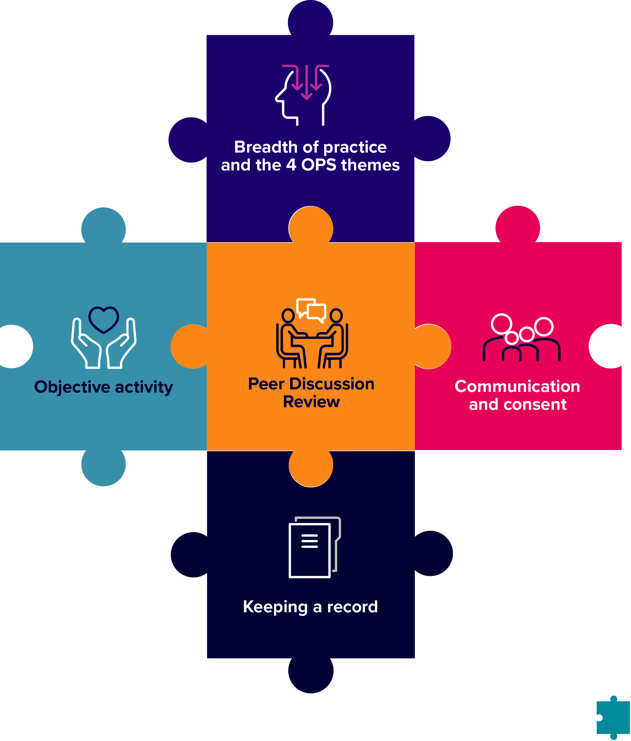

4

Workbook: Planning your CPD

Range of practice: the four OPS themes and breadth of practice

You should do CPD activities in all four themes of the OPS:

A. Communication and patient partnership

B. Knowledge, skills and performance

C. Safety and quality in practice

- Professionalism

Your CPD should also cover the breadth of your professional practice, which may include your clinical, education, research or management aspects of your roles.

Objective activity

Your CPD needs to include at least one objective activity that informs your practice and your CPD. An objective activity is where you seek external objective feedback then analyse and reflect on this to show how it has informed your practice. This activity might include: case-based discussion, patient feedback, peer observation or a clinical audit. See page 13 for useful resources.

Communication and consent

You need to do at least one CPD activity in the area of communication and consent. This should include reviewing the relevant guidance in the Osteopathic Practice Standards and showing how this has informed your learning and how it has been applied in practice. Doing an activity in the area of communication and consent will help you to demonstrate how your CPD benefits patients.

Keeping CPD records

You need to keep a record of your CPD that shows you have completed a three-year cycle of 90 hours. This must include a minimum of 45 hours of ‘learning with others’ and include all the required elements of the scheme. See page 13 for useful resources.

Peer Discussion Review

You need to hold a structured conversation towards the end of the three-year cycle with an osteopath or other health professional to confirm that you have completed all the scheme’s elements.

5

Workbook: Planning your CPD

What is CPD?

The definition of CPD is very broad and can include any activity that maintains, enhances and develops osteopathic professional practice. CPD can include any learning undertaken by an osteopath, for example:

- discussion of CPD and practice with a colleague

- courses, seminars or practical sessions

- e-learning

- reading, research or individual study

- Peer Discussion Review

- mentoring

- any other activities that can advance practice.

Doing CPD is an ongoing aspect of professional practice. Standard B3 of the Osteopathic Practice Standards (2018) states that osteopaths ‘must keep... professional knowledge and skills up to date’. To achieve this, osteopaths must be professionally engaged, undertaking professional development activities and keeping up to date with factors relevant to ongoing practice including in relation to the wider healthcare environment.

For CPD to count as ‘learning with others’, it must also involve interaction with others to inform your learning – which means you will be both giving and receiving information. This can be carried out with osteopaths, other healthcare practitioners or professionals You should reflect on the CPD you do and you must keep a record of it.

6

Workbook: Planning your CPD

What is professional practice?

Professional practice can include clinical work (including safeguarding), education, research or management responsibilities. Over the course of a CPD cycle, CPD should reflect the breadth of an individual’s practice. So, for example, an individual who only undertakes clinical work and holds no management or teaching responsibilities might confine all their CPD to clinical work. However, an osteopath who undertakes one day a week in education, should undertake an appropriate portion of their CPD in the area of education or teaching practice. Osteopaths with research or management responsibilities should be able to demonstrate balanced CPD in these areas.

Learning points:

- The definition of CPD is very broad and can include:
  - any learning
  - any other activities that can advance practice.

- Professional practice can include clinical work, education, research or management responsibilities.

- CPD should be reflected on and recorded.

7

Workbook: Planning your CPD

Why plan your CPD?

There are many reasons why osteopaths undertake the CPD that they do – interest in a particular subject, availability, affordability and flexibility when trying to fit this in with busy work and other demands.

It can help to have a plan, though, and to give some thought to what areas of CPD you wish to focus on during a particular timeframe. This can help you to feel confident about meeting the requirements of the CPD scheme. Planning your development proactively, rather than responding to events that happen to crop up from time to time, might also help you to identify different, more relevant or cheaper ways of meeting your CPD objectives. It could provide an opportunity for you to identify other people who are interested in the same areas or activities as you, so you might be able to work together. Planning your CPD can help to show your peer reviewer that you are engaging with the CPD scheme at the earliest opportunity.

A development plan template is included on page 14 of this workbook. The template provides a suggested format which you can adapt according to your needs. Essentially, though, these are some useful steps to take:

- Identify one or more learning needs

- Think about how you will you go about addressing the need

- Decide what (if any) resources you will require

- Think about how you will evaluate whether the learning need has been addressed

- Decide when you want to have completed the relevant CPD

Identifying your learning needs can be an ongoing process, and undertaking one activity might lead you to further activities as you reflect on what you have learned. You could decide to have one overarching plan to address these, or several plans, for example related to different areas of practice.

You will find a completed example of the template on page 17 of this workbook to give you an idea of what it could look like when someone has worked through it.

Whether or not you plan your CPD in this way is up to you, but you might find it helps to think through what you’ll aim to do and when, so that you can balance your activities evenly through the three-year cycle.

Learning points:

Planning your CPD can have a number of advantages including:

- being relevant to your particular interests and practice

- availability and flexibility

- affordability

- planning can give you time to explore different, helpful ways of undertaking CPD and can avoid the stress of responding to CPD events that crop up.

8

Workbook: Planning your CPD

Unplanned or opportunistic learning

Not all CPD activities are planned in advance. You might encounter a patient with an unusual medical condition which merits further research, for example, and this might prompt you to reflect on your communication approaches. If you work in education, perhaps a student asks a question which prompts you to talk to colleagues or carry out further research. However such opportunities arise, recording them in some way and considering their impact on your work as an osteopath, will mean they can be claimed as CPD.

Learning points:

- Unplanned CPD is valuable too.

- If you undertake unplanned CPD, do take time to record it so that it can count towards your CPD requirement.

9

Workbook: Planning your CPD

Planning your CPD to meet the requirements of the CPD scheme

These next sections can help you to plan your CPD to meet the requirements of the new CPD scheme.

There is flexibility within the new CPD scheme to spread the 90-hour requirement in a way that suits you. There may be some years when you do fewer CPD activities and then make up for this in the following year. That said, we would certainly recommend that you aim to carry out, reflect on and record at least 30 hours of CPD each year across the cycle. You should find this a reasonable and readily achievable amount.

Taking this approach will also help you to meet Standard B3 of the Osteopathic Practice Standards (2018): ‘You must keep your professional knowledge and skills up to date’ and avoids leaving the bulk of activities until the final year, which might be hard to manage. You’ll also need sufficient time within the final year to complete your Peer Discussion Review, and make sure you’ve met all the requirements of the scheme by the end of the cycle.

When planning your CPD remember to think about these requirements:

- 90 hours of CPD from the date that you enter your three-year CPD cycle. At least half of this must comprise ‘learning with others’.

- CPD activities must cover the range of your practice and the four themes of the Osteopathic Practice Standards (OPS). These are: Communication and patient partnership; Knowledge, skills and performance; Safety and quality in practice; and Professionalism.

- an objective activity must be carried out at least once within the three-year cycle.

- CPD must benefit patients and include an activity in the area of communication and consent at least once in the three-year cycle.

- A Peer Discussion Review must be completed towards the end of the cycle.

Learning points:

- Planning CPD across the three-year cycle helps you to show you are meeting your professional obligation to keep your knowledge and skills up to date and avoids leaving the bulk of activities until the final year, which then might be hard to manage.

- Discussing your CPD and practice with a peer can count as CPD. This can be done throughout the CPD cycle but your Peer Discussion Review should be completed before the end of Year 3 of the CPD cycle.

10

Workbook: Planning your CPD

Planning your CPD across the four themes of the OPS

The CPD scheme requires osteopaths to undertake activities across the four themes of the OPS. Some activities you do might in themselves cover more than one of the themes. Remember, there is no requirement as to how much time should be spent on each theme, and you don’t need to allocate the number of minutes spent on each in an activity which might encompass more than one of the themes. The broad areas of the OPS themes and what relevant CPD might look like are shown in the table below:

Theme of the | Areas include | Relevant CPD activities may cover:
OPS
Communication | Listening, respecting | • | Communicating with patients – different
and patient | patient’s concerns and |  | questions and approaches to identify patient
partnership | preferences, dignity | • | ideas, concerns and expectations
 | and modesty, effective |  | Exploring non-verbal communication
 | communication, providing | • | mechanisms
 | information, consent, |  | Ways of communicating benefits and risks of
 | patient partnership | • | treatment options to particular patients
 |  |  | Ways of supporting patients to make decisions
 |  |  | about treatment
Knowledge, | Having sufficient | • | Reflection on current knowledge and skills
skills and | knowledge and skills, |  | and learning new knowledge and skills
performance | working within training |  | including techniques (for patient feedback,
 | and competence, keeping |  | any reflection on the results of the feedback,
 | up to date, analysing and |  | for example, re-reading aspects of the OPS,
 | reflecting on information |  | reading around communication and consent
 | to enhance patient care | • | will cover this theme.)
 |  |  | Analysing feedback about your practice and
 |  |  | implementing improvements
Safety and | Case history taking and | • | Case history taking and developing a clear
quality in | record keeping, patient | • | narrative for treatment options
practice | evaluation, management, |  | Learning knowledge and skills about
 | safeguarding, wider role in |  | vulnerable patients, including safeguarding or
 | enhancing patients’ health | • | how to report female genital mutilation
 | and wellbeing |  | Signposting patients to resources about diet,
 |  | • | exercise, and smoking cessation
 |  |  | All of these areas could feature as part of your
 |  | • | patient feedback
 |  |  | Health and safety issues
 |  | • | Data analysis and report writing

11

Workbook: Planning your CPD

Theme of the | Areas include | Relevant CPD activities may cover:
OPS
Professionalism | Ethics, integrity, honesty, | • | Enhancing your understanding of the
 | duty of candour, |  | contributions of other healthcare professionals
 | confidentiality, working | • | to patient care
 | with others, complying |  | Establishing clear boundaries with patients
 | with regulatory | • | (through case studies or group discussions)
 | requirements |  | Equality and diversity issues
 |  | • | Confidentiality and data protection (eg GDPR)
 |  | • Keeping up to date with legal requirements on
 |  |  | advertising your practice
 |  | • Supporting colleagues to enhance patient
 |  |  | care (eg mentoring activities)

Many activities which osteopaths already undertake will relate to these themes, without any particular extra CPD being required. It’s not necessary to link to individual standards either, but it’s worth familiarising yourself with these and seeing where there might be gaps.

Some osteopaths have reported being unsure how to carry out activities relating to ‘Professionalism’. This is a diverse theme, and relates to a broad range of professional skills and behaviours. Considering the management of confidentiality, for example, professional boundaries or ethical behaviour both fall within this theme. These areas might be covered in a case-based discussion with colleagues, for example, as well as by undertaking more formal CPD activities.

Learning point:

Review the themes of the OPS and the table above to help you to identify that the CPD you are already doing covers the four themes, or to help you identify new, interesting areas of CPD that

could support your practice.

12

Workbook: Planning your CPD

There are a range of other workbooks available on our CPD microsite which cover various aspects of the CPD scheme. They have been designed to help you to plan your CPD and support you in meeting the requirements of the scheme.

The full range of workbooks are available at: cpd.osteopathy.org.uk/workbooks

Titles include:

• Patient feedback:

• Keeping records

• Communication and consent

• Case-based discussion

• Peer Observation

If you have any queries about this workbook or CPD in general, please feel free to get in touch:

Tel: +44 (0) 20 7357 6655

Email: newcpd@osteopathy.org.uk

13

Workbook: Planning your CPD

Development plan template

Development Plan

Name:

Covering the |  | To:
period from:

Year 1 CPD cycle

Ask: Where do I want to be by the end of this period? What do I want to be doing? Which aspects of the CPD scheme requirements might I meet – for example, I could undertake an objective activity.

What is my | What will I do to | What resources | What will be my | Target dates
learning/ | achieve this? | or support will I | success criteria? | for review and
development |  | need? |  | completion
need?

14

Workbook: Planning your CPD

Year 2 CPD cycle

Ask: Where do I want to be by the end of this period? What do I want to be doing? Which aspects of the CPD scheme requirements might I meet – for example, I could undertake an objective activity.

What is my | What will I do to | What resources | What will be my | Target dates
learning/ | achieve this? | or support will I | success criteria? | for review and
development |  | need? |  | completion
need?

15

Workbook: Planning your CPD

Year 3 CPD cycle

Ask: Where do I want to be by the end of this period? What do I want to be doing? Which aspects of the CPD scheme requirements might I meet – for example, I could undertake an objective activity.

What is my | What will I do to | What resources | What will be my | Target dates
learning/ | achieve this? | or support will I | success criteria? | for review and
development |  | need? |  | completion
need?

16

Workbook: Planning your CPD

Completed example
of development plan template

This is an example of what a development plan might look like when someone has completed it. It sets out plans to do activities over a three-year CPD cycle. It isn’t intended to be prescriptive at all, but illustrates how you might plan activities over the cycle to make sure you meet the requirements of the scheme. You can still do additional CPD as the opportunity arises.

As with other templates, you can adapt this to suit your needs, but you might find it helpful to use the structure suggested here to help you consider activities. For example, considering success criteria helps you to take things a step beyond ‘attending an event’, and helps you to think what you actually want to get out of doing the activity.

17

Workbook: Planning your CPD

Development Plan

Name: Annie Osteopath

Covering the | 1 March 2019 | To: | 28 February 2022
period from:

Year 1 CPD cycle

Ask: Where do I want to be by the end of this period? What do I want to be doing? Which aspects of the CPD scheme requirements might I meet – for example, I could undertake an objective activity.

What is my | What will I do to | What resources | What will be my | Target dates
learning/ | achieve this? | or support will I | success criteria? | for review and
development |  | need? |  | completion
need?
To seek feedback | Undertake a | Need to find or | Generating | September 2019
on my practice | questionnaire | adapt a suitable | sufficient | and February
from patients | survey of patients | questionnaire | feedback over a | 2020
 |  |  | defined period
 |  | Check resources | to enable me to
 |  | on cpd. | reflect on this
 |  | osteopathy.org.uk | and to consider
 |  | Talk to colleagues | the impact on my
 |  | who have done | practice
 |  | this already
To ensure that CPD | Consider each | OPS: I will put | Generate sense | September 2019
reflects breadth of | recorded activity | standards. | of how my CPD
my practice and | against the OPS | osteopathy.org.uk | reflects the OPS
the OPS themes | themes | onto home screen | themes, and use
 |  | of my phone so I | this to further plan
 |  | can access it any | activities for next
 |  | time | year.
Improve my | Undertake | Journal access via | Completion of | February 2020
understanding | specific CPD | o zone | all activities and
of management | event |  | to be able to
of patients with |  | Purchase book on | consider how I
chronic pain. | Read around the | chronic pain | might enhance
 | subject (source |  | my management
 | recent journal | Discuss cases | of patients with
 | articles) | with colleagues | chronic pain
 |  |  | and implement
 | Discuss cases |  | changes.
 | with colleagues at
 | local group
Identify a peer to | Discuss with |  | Agreeing to work | December 2019
discuss CPD issues | colleagues at |  | with someone
with and who will | local group.
carry out my Peer
Discussion Review
in Year 3 of the
cycle and seek
their agreement to |  |  |  | 18
working with me

Workbook: Planning your CPD

Year 2 CPD cycle

Ask: Where do I want to be by the end of this period? What do I want to be doing? Which aspects of the CPD scheme requirements might I meet – for example, I could undertake an objective activity.

What is my | What will I do to | What resources | What will be my | Target dates
learning/ | achieve this? | or support will I | success criteria? | for review and
development |  | need? |  | completion
need?
Undertake CPD in | Attend specific | Access to journals | Completion of | September 2020
communication and | CPD event in this | which I can get via | planned activities,
consent | subject | the o zone | enabling me to
 |  | Local group | reflect on my
 | Consider recent | meetings | practice and
 | journal articles |  | consider how
 |  |  | this might be
 | Discuss case |  | enhanced as a
 | scenarios with |  | result.
 | colleagues
Focus on some | Boundaries – | Access to GOsC | Completion of | September 2020
key aspects of | read around the | CPD site,o zone | planned activities
professionalism | subject – consider | and online | and reflection on
theme of the OPS | resources provided | Osteopathic | practice.
 | on CPD website | Practice
 |  | Standards:
 |  | standards.
 |  | osteopathy.org.
 |  | uk
Boundaries with | Case-based | Attend local group | Completion of | February 2021
patients | discussions with | meetings | planned activities
 | colleagues |  | and reflection on
 |  |  | practice.
Data protection | Data protection | iO website | Completion of | February 2021
 | – review data | ICO website | planned activities
 | storage and |  | and reflection
 | policies to ensure |  | on practice.
 | best practice and |  | Implement any
 | GDPR compliance. |  | indicated changes
 | Review iO |  | to processes.
 | resources and ICO |  | Recruit a suitable
 | website. |  | associate and
 |  |  | devise and

19

Workbook: Planning your CPD

Year 2 CPD cycle

What is my | What will I do to | What resources | What will be my | Target dates
learning/ | achieve this? | or support will I | success criteria? | for review and
development |  | need? |  | completion
need?
Supporting | Supporting | Access mentoring | Recruit a suitable | February 2021
colleagues | colleagues – As | support guidance | associate and
 | I plan to take on | on iO website | devise and
 | an associate this | Attend group | implement a
 | year, I am keen | meetings | mentoring plan.
 | to devise an
 | effective mentoring
 | programme to
 | support their
 | development
 | and ensure they
 | have the support
 | they need at this
 | early stage in their
 | career. I will talk to
 | colleagues to see
 | what they do in
 | their practices, and
 | review iO guidance
 | on mentoring.

20

Workbook: Planning your CPD

Year 3 CPD cycle

Ask: Where do I want to be by the end of this period? What do I want to be doing? Which aspects of the CPD scheme requirements might I meet – for example, I could undertake an objective activity.

What is my | What will I do to | What resources | What will be my | Target dates
learning/ | achieve this? | or support will I | success criteria? | for review and
development |  | need? |  | completion
need?
Enhance my | Undertake specific | Access to CPD | Completing | December 2021
knowledge and | CPD event in this | event | activities and
skill in rehabilitation | area. |  | being able to
techniques |  | Attend local group | confidently
 | Discuss | meetings | include enhanced
 | approaches with |  | rehab and
 | colleagues | Access research | exercise advice in
 |  | journals on | the management
 | Research journal | o zone. | of patents.
 | articles to review
 | latest thinking.
Review | Consider how |  | To develop | January 2022
development | my practice is |  | a broad
needs leading in to | developing, and |  | development to
the next three year | reflect on the |  | discuss during my
CPD cycle. | current cycle to |  | Peer Discussion
 | consider where |  | Review.
 | there may be gaps
 | in learning and
 | areas where I may
 | wish to develop
 | my skills and
 | knowledge further.
Peer Discussion | Arrange Peer | PDR guidance | Complete Peer | November 2021
Review | Discussion Review | and resources on | Discussion | and
 | with colleague to | GOsC CPD site | Review and get | January 2022
 | demonstrate how | cpd.osteopathy. | sign off by my
 | I’ve met the CPD | org.uk | peer.
 | requirements over
 | the past three
 | years and prepare
 | a draft peer review
 | so that I can work
 | out if I have met the
 | requirements.

21

