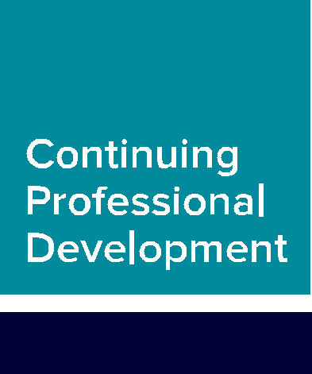

Workbook

Communication and consent Workbook
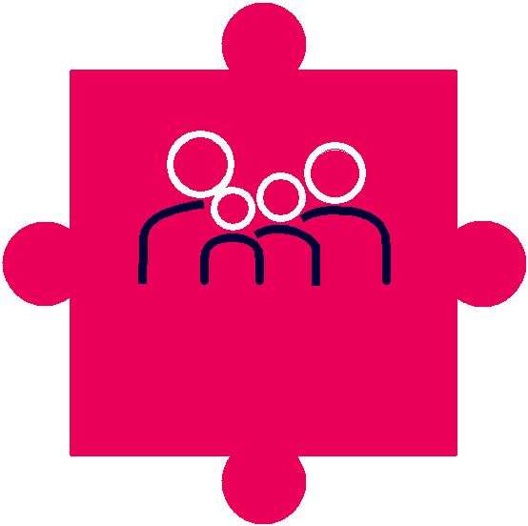

Communication
and consent

Workbook: Communication and consent

Contents

Introduction | 3
The features of the CPD scheme | 4
What is CPD? | 6
What is professional practice?
Communicating with patients | 8
What is the communication and
consent CPD requirement? | 10
Meeting the communication and
consent requirement | 11
Linking to the four themes of the
Osteopathic Practice Standards | 14
Useful communication and consent
resources | 15
Further information | 17

This workbook is published by the General Osteopathic Council (GOsC).

We welcome your comments and feedback to help us improve this workbook.

Please send any comments and/or suggestions to: newcpd@osteopathy.org.uk.

The GOsC is a charity registered in England and Wales (1172749). | 19/11/2019

Workbook: Communication and consent

Introduction

This workbook has been prepared to help osteopaths think about how they can meet the communication and consent requirement of the GOsC’s CPD scheme.

Osteopaths need to undertake at least one CPD activity relating to communication and consent during their three-year CPD cycle. Doing an activity that includes communication and consent will help you to demonstrate how your CPD benefits patients.

You will find learning points throughout to help summarise the advice.

3

Workbook: Communication and consent

The features
of the CPD scheme
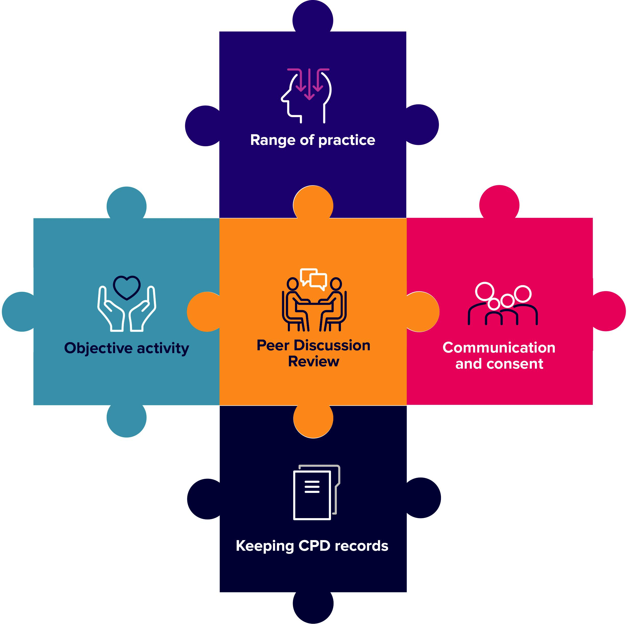

4

Workbook: Communication and consent

Range of practice: the four Osteopathic Practice Standards themes and breadth of practice.

You should do CPD activities in all four themes of the Osteopathic Practice Standards:

A. Communication and patient partnership

B. Knowledge, skills and performance

C. Safety and quality in practice

- Professionalism

Your CPD should also cover the breadth of your professional practice, which may include the clinical, education, research or management aspects of your role(s).

Objective activity

Your CPD needs to include at least one objective activity that informs your practice and your CPD. An objective activity is where you seek external objective feedback about your practice and then analyse and reflect on this to show how it has informed your practice or CPD. This activity might include: case-based discussion, patient feedback, peer observation or a clinical audit. See page 17 for further information.

Communication and consent

You need to do at least one CPD activity in the area of communication and consent. This should include reviewing the relevant guidance in the Osteopathic Practice Standards and showing how this has informed your learning and how it has been applied in practice. Doing an activity in the area of communication and consent will help you to demonstrate how your CPD benefits patients. This workbook has been prepared to help osteopaths think about how they can meet the communication and consent requirement of the GOsC’s CPD scheme.

Keeping CPD records

You need to keep a record of your CPD that shows you have completed a three-year cycle of a minimum of 90 hours. This must include a minimum of 45 hours of ‘learning with others’ and include all the required elements of the scheme.

Peer Discussion Review

You need to complete a Peer Discussion Review towards the end of your three-year cycle. A Peer Discussion Review is a structured conversation with an osteopath or other health professional in which you confirm, and discuss how, you have completed all the elements of the scheme.

5

Workbook: Communication and consent

What is CPD?

The definition of continuing professional development (CPD) is very broad and can include any activity that maintains, enhances and develops osteopathic professional practice.

CPD can include any learning undertaken by an osteopath, for example:

- discussion of CPD and practice with a colleague

- courses, seminars or practical sessions

- e-learning

- reading, research or individual study

- Peer Discussion Review

- mentoring

- any other activities that can advance practice.

Doing CPD is an ongoing aspect of professional practice (see What is professional practice? on page 7). According to the Osteopathic Practice Standards (2019):

Theme B: Knowledge, skills and performance

B3: You must keep your professional knowledge and skills up to date.

To achieve this, osteopaths must be professionally engaged, undertaking professional development activities and keeping up to date with factors relevant to ongoing practice, including in relation to the wider healthcare environment.

For CPD to count as ‘learning with others’, it must also involve interaction with others to inform your learning – which means you will be both giving and receiving information. This can be carried out with osteopaths, other healthcare practitioners or other professionals.

You should reflect on the CPD you do, and you must keep a record of any activity that you claim towards your CPD requirement.

6

Workbook: Communication and consent

What is professional practice?

Professional practice can include clinical work (including safeguarding), education, research or management responsibilities (including leadership). Over the course of a CPD cycle, CPD should reflect the breadth of an individual’s practice. For example, an osteopath who only undertakes clinical work and holds no management or teaching responsibilities might confine all their CPD to clinical work. However, an osteopath who undertakes one day a week in education, should do an appropriate portion of their CPD in the area of education or teaching practice. Osteopaths with research or management responsibilities should be able to demonstrate balanced CPD in these areas.

Learning points:

- The definition of CPD is very broad and includes any learning or activities that advance practice.

- Professional practice can include clinical work, education, research or management responsibilities.

- CPD should be reflected on and recorded.

7

Workbook: Communication and consent

Communicating with patients

Communication is central to relating effectively to patients and also a core element of the Osteopathic Practice Standards (OPS). Research commissioned by the GOsC has provided insight into the expectations of patients in relation to communication and consent.

The Public Perceptions Study, conducted by YouGov in 2018 (see: osteopathy.org. uk/public-perceptions-study) indicates that the following factors are important in establishing patients’ confidence in an osteopath:

•

•

•

•

•

•

•

gives good advice

listens to the patient

explains diagnosis clearly

treats the patient with dignity

involves the patient in decisions around their care

puts them at ease

asks for consent before examination or treatment.

Learning point:

- Good communication is central to patients’ expectations of osteopathic care.

The Montgomery Judgment (2015)

The Supreme Court ruling on the case of Montgomery v Lanarkshire Health Board was instrumental in confirming that ‘informed consent’ is part of UK law, reinforcing what is already a key part of the standards of all health professionals including osteopaths.

It acknowledges that patients are not passive recipients of treatments, but are active, self-determining partners in the process. Rather than just thinking in terms of the percentage chance of an adverse event occurring, practitioners need to consider the significance of the risk of treatment options for any individual patient.

This means there cannot be a standard formula or form of words that works for every patient. The focus should be on having a dialogue with the patient, finding out what is important to them, and tailoring your explanation of the treatment options accordingly.

8

Workbook: Communication and consent

For more details on the judgment see:

- Supreme Court website: www.supremecourt.uk/cases/docs/ uksc-2013-0136-judgment.pdf

- BBC website: bbc.co.uk/news/uk-scotland-glasgow-west-31831591

- GOsC CPD microsite: cpd.osteopathy.org.uk/learn-from-others/thought-pieces/ the-law-on-consent-has-changed-whats-new

Learning point:

- Effective dialogue is at the heart of patient partnership and shared decision making.

Patient concerns and complaints

Issues around communication tend to feature prominently in concerns and complaints raised about osteopaths.

The GOsC, the Institute of Osteopathy, and the providers of osteopathic indemnity insurance have been working together since 2013 to collect data from patients on their reported concerns, with the aim of better understanding the nature and frequency of concerns raised about osteopaths and osteopathic services.

Not all of these concerns are subsequently dealt with by the GOsC, but they do provide a useful insight into the issues patients worry about in relation to osteopathic practice. They can also be useful in helping osteopaths and others to reflect.

The data the organisations collect is pooled annually and independently analysed by the National Council for Osteopathic Research (NCOR).

The outcomes of this initiative inform osteopathic education and training, and help to shape targeted information and guidance for osteopaths, patients and educators. They are also useful to providers, and others, in helping them to consider how they can support osteopaths to continually enhance communication and avoid miscommunications. You can find out more and read the reports on the GOsC website (see: osteopathy.org.uk/concerns-raised-about-osteopaths).

Learning point:

- Communication and consent issues feature as a significant proportion of concerns raised about osteopaths.

9

Workbook: Communication and consent

What is the communication and consent CPD requirement?

According to the CPD guidance, osteopaths must demonstrate that they have sought to ensure that CPD activities benefit patients, undertaking at least one CPD activity focused on communication and consent.

This means the osteopath needs to be able to show:

- They have undertaken CPD activity relating to communication and consent with patients.

- They have reviewed the guidance in the Osteopathic Practice Standards – particularly the section on Communication and patient partnership.

•

•

That these activities have informed their learning and have been applied in practice.

That these activities have been recorded.

There isn’t a minimum number of CPD hours that must be spent on communication and consent, however three hours of activity over your three-year cycle is likely to be sufficient to meet this requirement.

Many of the CPD activities you undertake will include an element of communication and consent, even if this isn’t their primary focus. Your aim should be to ensure that the CPD you have done on communication and consent has informed your learning and practice.

Learning point:

- A communication and consent activity should include reviewing the OPS and the relevant Standards, considering how this has enhanced learning and its impact on practice, and this should be recorded.

10

Workbook: Communication and consent

Meeting the communication and consent requirement

There are a wide variety of ways in which you can meet the communication and consent requirement of the CPD scheme. We look at some suggestions below.

Read the Osteopathic Practice Standards

A key part of the communication and consent requirement is to read Theme A: Communication and patient partnership in the Osteopathic Practice Standards and think about how this relates to your practice. The Osteopathic Practice Standards are available at: standards.osteopathy.org.uk

Case studies

Case studies or scenarios can be an excellent way to consider aspects of your clinical encounters, including communication and consent issues and thinking about the application of the Osteopathic Practice Standards to practice. This could range from anonymised cases from your practice which you discuss with colleagues, to fictional examples covering challenging clinical situations. For more information on this approach, see the Case-based Discussion Workbook: cpd.osteopathy.org.uk/ resources/case-based-discussion-workbook

The table on the following page shows the ways in which case-based discussion may touch on communication and consent.

11

Workbook: Communication and consent

OPS theme | Areas include | Relevant CPD activities may cover:
A | Listening, respecting | • | communicating with patients – different
Communication | patient’s concerns and |  | questions and approaches to identify patient ideas,
and patient | preferences, dignity | • | concerns and expectations
partnership | and modesty, effective |  | exploring non-verbal communication mechanisms
 | communication, providing | • | communicating benefits and risks of treatment options
 | information, consent, | • | to particular patients
 | patient partnership |  | supporting patients to make decisions about treatment
B | Having sufficient working | • | reflecting on current knowledge and skills and learning
Knowledge, skills | within training and |  | new knowledge and skills including techniques (for
and performance | competence, keeping up |  | patient feedback, any reflection on the results of the
 | to date, analysing and |  | feedback, for example, re-reading aspects of the OPS,
 | reflecting on information |  | reading around communication and consent will cover
 | to enhance patient care |  | this theme)
 |  | • analysing feedback about your practice and
 |  | • | implementing improvements
 |  |  | analysing data and report writing
C | Case history taking and | • | taking a case history and developing a clear narrative
Safety and quality | record keeping, patient | • | for treatment options
in practice | evaluation, management, |  | learning knowledge and skills about vulnerable
 | safeguarding, wider role |  | patients, including safeguarding or how to report female
 | in enhancing patients’ | • | genital mutilation
 | health and wellbeing |  | signposting patients to resources about diet, exercise,
 |  |  | and smoking cessation
 |  | • dealing with health and safety issues
D | Ethics, integrity, honesty, | • | enhancing your understanding of the contributions
Professionalism | duty of candour, | • | of other healthcare professionals to patient care
 | confidentiality, working |  | establishing clear boundaries with patients (through
 | with others, complying | • | case studies or group discussions)
 | with regulatory |  | data analysis and report writing
 | requirements | • | reviewing equality and diversity issues
 |  | • considering confidentiality and data protection
 |  | • | (eg GDPR)
 |  |  | keeping up to date with legal requirements on
 |  | • | advertising your practice
 |  |  | analysing feedback about your practice and
 |  | • | implementing improvements
 |  |  | supporting colleagues to enhance patient care (eg
 |  |  | mentoring activities)

Our CPD microsite also contains some case scenarios that you could use to support the implications for communication and consent. See for example: cpd.osteopathy.org. uk/communication-and-consent-kent

12

Workbook: Communication and consent

CPD events

Many CPD providers will offer specific events aimed at communication and consent issues which will enable you to meet this requirement.

CPD events may contain aspects that relate to communication and/or consent even if they are focused on learning new techniques or treatments. For example, a presentation on surgical approaches to the shoulder might give you the opportunity to reflect on how you discuss treatment options, and the risks and benefits of these with patients, in order to support their decision making.

Recording how your learning has enhanced your communication with patients, means that you can use this towards the CPD scheme’s communication and consent requirement.

Group discussions

Group discussions can take place in a variety of settings, for example within a regional group, practice meetings or other get-togethers with colleagues whether face-to-face or online. The discussions are particularly useful if they involve reviewing and discussing the Osteopathic Practice Standards.

Reflections on practice

Osteopaths report that they regularly reflect on their clinical practice, but don’t always record this as a CPD activity. If a clinical encounter, for example, causes you to reflect on your communication with patients and as a result impacts on your practice, then make sure to record this activity as this can count towards your CPD.

Objective activities

Another requirement of the CPD scheme is to demonstrate that an objective activity has contributed to your practice. This is an activity which provides you with some form of external feedback on your practice. Examples include case-based discussion, patient feedback, peer observation and clinical audit. Many of these activities will provide you with feedback on aspects of your practice directly related to communication and consent, and may therefore contribute to both CPD requirements.

We have produced a range of workbooks focused on many of the objective activities which you can read on our dedicated CPD microsite, see: cpd.osteopathy.org.uk/ workbooks

Learning point:

- You can choose how you do CPD in communication and consent and it can be undertaken in a range of different ways

– either by yourself or with others.

13

Workbook: Communication and consent

Linking to the four themes of the Osteopathic Practice Standards

The Osteopathic Practice Standards (OPS) are available at: standards. osteopathy.org.uk. There are Standards within each of the four themes of the OPS which may relate to communication and consent, so one CPD activity may relate to more than one theme of the OPS (see table below).

A. Communication and patient partnership

A1. You must listen to patients and respect their individuality, concerns and preferences. You must be polite and considerate with patients and treat them with dignity and courtesy.

A2. You must work in partnership with patients, adapting your communication approach to take into account their particular needs, and supporting patients in expressing to you what is important to them.

A3. You must give patients the information they want or need to know in a way they can understand.

A4. You must receive valid consent for all aspects of examination and treatment and record this as appropriate.

A5. You must support patients in caring for themselves to improve and maintain their own health and wellbeing.

A6. You must respect your patients’ dignity and modesty.

A7. You must make sure your beliefs and values do not prejudice your patients’ care.

B. Knowledge, skills and performance

B1. You must have and be able to apply sufficient and appropriate knowledge and skills to support your work as an osteopath.

B2 You must recognise and work within the limits of your training and competence.

C. Safety and quality in practice

C1. You must be able to conduct an osteopathic patient evaluation and deliver safe, competent and appropriate osteopathic care to your patients.

C6. You must be aware of your wider role as a healthcare professional to contribute to enhancing the health and wellbeing of your patients.

D. Professionalism

D2. You must establish and maintain clear professional boundaries with patients, and must not abuse your professional standing and the position of trust which you have as an osteopath.

D3. You must be open and honest with patients, fulfilling your duty of candour.

D4. You must have a policy in place by which you manage patient complaints, and respond quickly and appropriately to any that arise.

Learning point:

- A communication and consent activity may relate to more
than one theme of the OPS.

14

Workbook: Communication and consent

Useful communication
and consent resources

If you would like to do some further reading on the subject of communication and consent, there is a wealth of material available. We have outlined a small selection below.

Patient stories

Reading stories in which real patients tell their stories about what is important to them, can be a useful resource for reflecting on your practice. In turn this may help you to consider how you relate to patients and help patients to articulate what is important to them and help them to live well in their environment.

Patient stories can also help us to reflect on how patients interact with other health professionals and the implications for our own practice and learning.

See for example: www.england.nhs.uk/personal-health-budgets/phbs-in-action/ patient-stories/declans-story or http://sussexmskpartnershipeast.co.uk/about/how-we-are-doing

National Council for Osteopathic Research

The National Council for Osteopathic Research has produced useful resources on the communication of benefit and risk, as well as risk and patient incidents, see: www.ncor. org.uk/practitioners/practitioner-information-communicating-benefit-and-risk-in-osteopathy/communicating-benefit-and-risk-in-osteopathy

Reviewing the resources on the NCOR website can help you to meet the communication and consent requirement. You can also discuss these resources with a colleague and use any learning to reflect on your own practice.

GOsC ‘Obtaining consent: Patient’s capacity to give consent’ guidance

Standard A4 of the Osteopathic Practice Standards requires an osteopath to have their patient’s valid consent before they examine or treat the patient. For the consent to be valid it must be given by a patient who has the capacity to consent.

This guidance is a useful resource which expands on the guidance on consent in the OPS, particularly in relation to capacity and the different requirements across the UK. See: osteopathy.org.uk/standards/guidance-for-osteopaths/consent

Journals

A range of journals is available free for osteopaths via the Research journals section of the o zone including The International Journal of Osteopathic Medicine.

Below are sources of research on communication issues and the impact of
communication in practice. Reading a paper, reflecting on it and discussing it with
colleagues can provide effective CPD in this area. | 15

Workbook: Communication and consent

The following are just a few examples of research articles which are available to osteopaths via the o zone, just log in to read them:

Tyreman S, Evidence, alternative facts and narrative: A personal reflection on person-centred care and the role of stories in healthcare, International Journal of
Osteopathic Medicine (2018) 28, 1-3.

Thomson et al, Osteopaths professional views, identities and conceptions – A qualitative grounded theory study, International Journal of Osteopathic Medicine
(2014) 17, 146-159.

Darlow, B, Beliefs about back pain: The confluence of client, clinician and community, International Journal of Osteopathic Medicine (2016) 20, 53-61.

Pincus, et al: Cognitive and affective reassurance and patient outcomes in primary

care: A systematic review, PAIN 154 (2013) 2407-2416.

Thomson and Collyer; ‘Talking a different language’ – A qualitative study on low back pain patients’ interpretation of the language used by student osteopaths,
International Journal of Osteopathic Medicine 24 (2017).

Reflecting on and recording CPD in communication and consent

You can record CPD in your online CPD Diary, which is available on the o zone, or in any other way you wish. Records should include:

•

•

•

A brief summary of key aspects of the activity

How the learning has impacted your practice

Any future learning or actions you have identified

The Keeping CPD Records workbook has some further information about recording CPD, see: cpd.osteopathy.org.uk/resources/keeping-records-workbook/

16

Workbook: Communication and consent

Further information

Read the Osteopathic Practice Standards online: standards.osteopathy.org.uk

The CPD microsite: cpd.osteopathy.org.uk

There is a range of workbooks available on our CPD microsite which cover various aspects of the CPD scheme. They have been designed to help you to plan your CPD and support you in meeting the requirements of the scheme.

The full range of workbooks is available at: cpd.osteopathy.org.uk/workbooks

Titles include:

•

•

•

•

•

Keeping CPD records

Patient feedback

Case-based discussion

Peer observation

Planning your CPD

If you have any queries about this workbook or CPD in general, please feel free to get in touch.

Contact us
newcpd@osteopathy.org.uk

+44 (0)20 7357 6655

17

