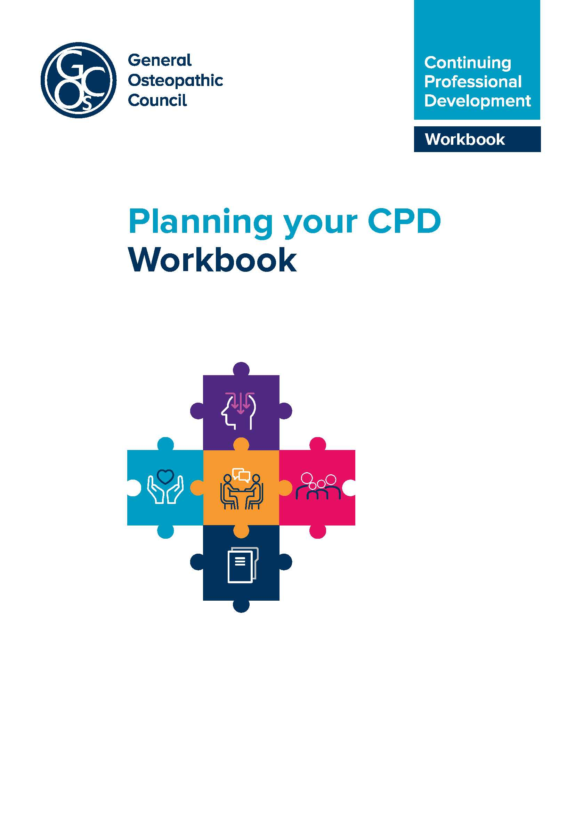

Introduction to planning
This workbook has been prepared to support osteopaths in planning their CPD.
What constitutes CPD?
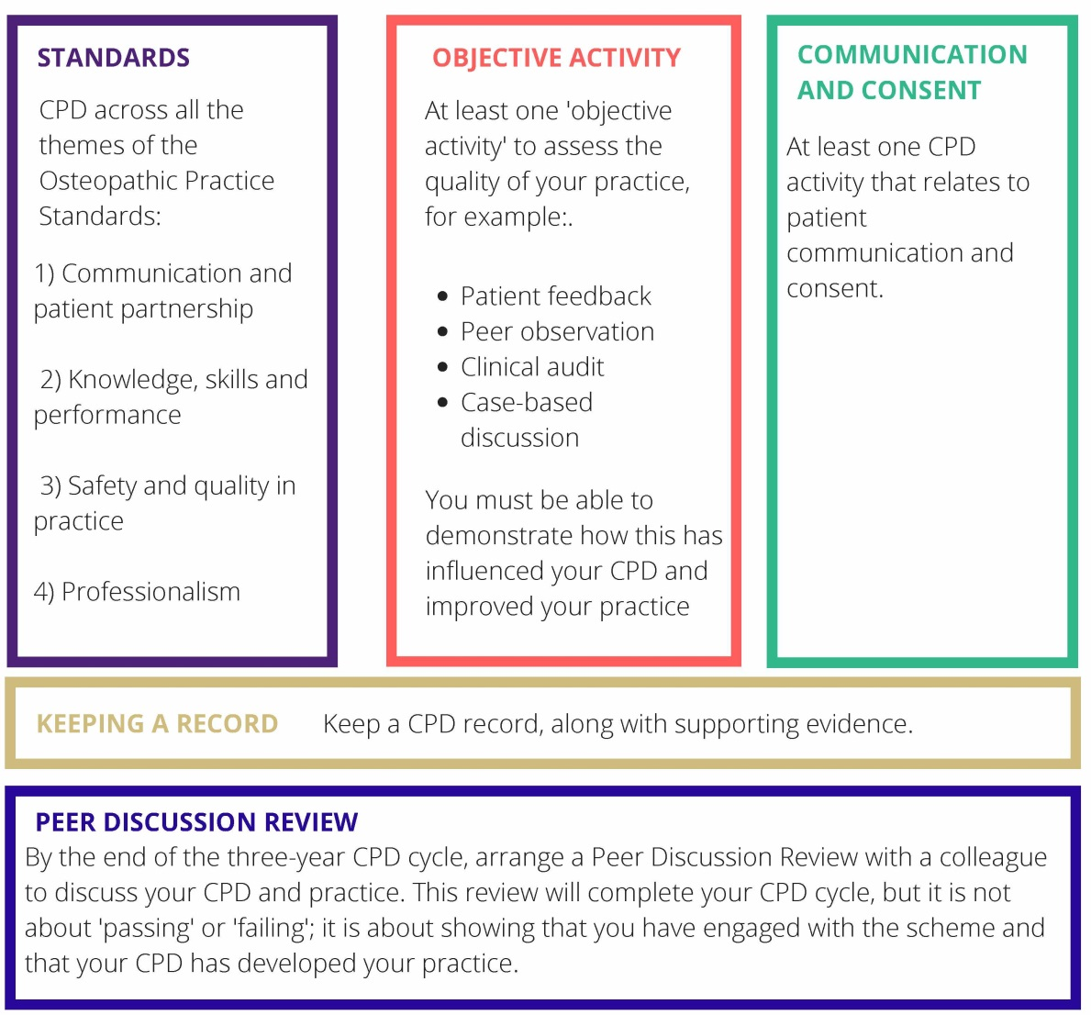
The definition of CPD is very broad and can include any activity that maintains, enhances and develops osteopathic professional practice. CPD includes any learning undertaken by an osteopath, for example, discussion of CPD and practice with a colleague, courses, seminars, practical sessions, elearning, reading, research, individual study, Peer Discussion Review, mentoring and any other activities that can advance practice.
Undertaking CPD is an on-going aspect of professional practice. Standard B3 of the Osteopathic Practice Standards (2018) states that osteopaths ‘must keep professional knowledge and skills up to date’. To achieve this, osteopaths must be professionally engaged, undertaking professional development activities and keeping up to date with factors relevant to on-going practice (including the wider healthcare environment).
Learning point:
Regular learning and reflection should be a feature of CPD.

CPD learning with others additionally must involve interaction (both giving and receiving information to inform learning) with osteopaths, healthcare practitioners
or other professionals. CPD must be reflected on and recorded by the osteopath within their CPD folder. The CPD website cpd.osteopathy.org.uk provides a range of examples and templates that can be used for this.
What is professional practice?
Professional practice can include clinical work, education, research or management responsibilities. Over the course of a CPD cycle, CPD should be appropriately balanced across the whole of an individual’s practice. For example, an individual who only undertakes clinical work and holds no management or teaching responsibilities might confine all their CPD to clinical work. However, an osteopath who undertakes one day a week in education should undertake an appropriate portion of their CPD in the area of education or teaching practice, in addition to their CPD in clinical practice. Osteopaths with research or management responsibilities should be able to demonstrate balanced CPD in these areas.
Learning points:
The definition of CPD is very broad and can include any learning and any other activities that can advance practice. Professional practice can include clinical work education, research or management responsibilities. CPD should be reflected on
and recorded.
Planning your CPD
There are many reasons why osteopaths undertake the CPD that they do – interest in a particular subject of course, but also availability, affordability and flexibility, when trying to fit this in with busy work and other demands. It does help to have a plan, though, and to give some thought to what areas of CPD you wish to focus on during a particular timeframe. This enables you to plan your development proactively, rather than just responding to whatever events crop up from time to time. A development plan template is included in the Annex. This is a suggested format which you can adapt according to your needs. Essentially, though, the key questions to consider are:
- what is your learning need?
- how will you go about addressing this?
- what resources will you need to do this (if any)?
- how will you evaluate whether the learning need has been addressed?
- what’s the timeframe for completing the CPD?
Identifying your learning needs can be an on-going process, and undertaking one activity might lead to further ones as you reflect on what has been learned. You could have one overarching plan to address these, or several plans, for example, related to different areas of practice. Whether you plan CPD in this way is up to you, but you may find it helps to think through what you’ll aim to do and when, so that you balance your activities evenly through the three-year cycle.
Learning point:
Planning CPD can have a number of advantages including: being relevant to your particular interests and practice, availability, affordability and flexibility. Planning can give you time to explore different, helpful ways of undertaking CPD and can avoid the stress of responding to CPD events that crop up.
We have also included a completed example of the template in the Annex.
Unplanned or opportunistic learning
Not all CPD activities are planned in advance. You may encounter a patient with an unusual medical condition which merits further research, for example, which causes you to reflect on your communication approaches. If you work in education, perhaps a student asks a question which prompts you to talk to colleagues or carry out further research. However such opportunities arise, recording them in some way and considering their impact on your work as an osteopath, will mean they can be claimed as CPD.
Learning point:
Unplanned CPD is valuable too. If you undertake unplanned CPD, do take time to record it so that it can count towards your CPD requirement.
The impact of the new CPD scheme on your CPD planning
There are additional elements to the new CPD scheme:
- From the date that you enter your first three-year CPD cycle, there will be a requirement of 90 hours of CPD. At least half of this must comprise ‘learning with others’.
- A requirement to ensure that CPD activities cover the range of your practice and the four themes of the Osteopathic Practice Standards (OPS). These are: communication and patient partnership, knowledge, skills and performance, safety and quality in practice and professionalism.
- The requirement for an objective activity to be carried out at least once within the three-year cycle.
- The requirement to undertake activity in the area of communication and consent at least once in the three-year cycle.
- A peer discussion review towards the end of the cycle
Planning your CPD across the themes of the OPS:
- The new CPD scheme requires osteopaths to undertake activities across the four themes of the OPS. There is no absolute requirement as to the hours spent on each theme, however, and it is not necessary to allocate minutes spent on each in an activity which might encompass more than one of the themes. The broad areas of the OPS themes are shown in the table below:
Theme of the OPS | Areas include | Relevant CPD activities may cover:
Communication and patient partnership | Listening, respecting patient’s concerns and preferences, dignity and modesty, effective communication, providing information, consent, patient partnership. | - communicating with patients – different questions and approaches to identify patient ideas, concerns and expectations  - exploring non-verbal communication mechanisms  - ways of communicating benefits and risks of treatment options to particular patients  - ways of supporting patients to make decisions about treatment.
Knowledge, skills and performance | Having sufficient knowledge and skills, working within training and competence, keeping up to date, analysing and reflecting on information to enhance patient care. | - reflection on current knowledge and skills and learning new knowledge and skills including techniques (for patient feedback, any reflection on the results of the feedback, for example, re-reading aspects of the OPS, reading around communication and consent will cover this theme)  - analysing feedback about your practice and implementing improvements.
Safety and quality in practice | Case history taking and record keeping, patient evaluation, management, safeguarding, wider role in enhancing patients’ health and well being. | - case history taking and developing a clear narrative for treatment options  - learning knowledge and skills about vulnerable patients, including safeguarding or how to report female genital mutilation  - signposting patients to resources about diet, exercise, and smoking cessation  - all of these areas could feature as part of your patient feedback.  - health and safety issues  - data analysis and report writing.
Professionalism | Ethics, integrity, honesty, duty of candour, confidentiality, working with others, complying with regulatory requirements. | • enhancing your understanding of the contributions of other healthcare professionals to patient care  • establishing clear boundaries with patients (through case studies or group discussions)  • equality and diversity issues  • confidentiality and data protection  (eg GDPR)  • keeping up to date with legal requirements on advertising your practice  • supporting colleagues to enhance patient care (eg mentoring activities)

Many activities which osteopaths already undertake will relate to these themes, without any particular extra CPD being required. It’s not necessary to map to individual standards either, but it’s worth familiarising yourself with these and seeing where there might be gaps. Some have reported being unsure how to carry out activities relating to ‘Professionalism’. This is actually a very diverse theme, and relates to a broad range of professional skills and behaviours. Considering the management of confidentiality, for example, professional boundaries or ethical behaviour, all fall within this theme. These areas might be covered in a case-based discussion with colleagues, for example, as well as by undertaking more formal CPD activities.
Learning point:
Reviewing the themes of the OPS and the table above can help to identify that the CPD you are already doing covers the four themes, or can identify new interesting areas of CPD that could support your practice.
Planning across the three year cycle
There is flexibility within the new CPD scheme to spread the 90 hour requirement in a way that suits you. There may be some years when you undertake fewer CPD activities and then make up for this in the following year. That said, we would certainly recommend that a starting point to planning would be to aim to carry out 30 hours of CPD each year across the cycle. This is a reasonable and readily achievable amount and avoids leaving the bulk of activities until the final year, which then might be hard to manage. You’ll also need sufficient time within the final year to complete the Peer Discussion Review, and ensure that you’ve the requirements by the end of the cycle.
Learning point:
Planning CPD across the three-year cycle helps you to show that you are meeting your professional obligation to keep your knowledge and skills up to date and avoids leaving the bulk of activities until the final year, which then might be hard to manage.

Learning point:
Remember discussing your CPD and practice with your peer can count as CPD. This can be done throughout the CPD cycle but should be completed before the end of Year 3 of the CPD cycle.

- Development plan template
- Completed example of development plan template

- Development plan template
Development Plan
NAME:
COVERING THE PERIOD FROM: |  | TO:

Year 1 CPD cycle
(Where do I want to be by the end of this period? What do I want to be doing? Which aspects of the CPD scheme requirements might I meet – for example, undertake an objective activity)
What is my learning/  development need? | What will I do to achieve this? | What resources or support will I need? | What will my success criteria be? | Target dates for review and completion

Year 2 CPD cycle
What is my learning/  development need? | What will I do to achieve this? | What resources or support will I need? | What will my success criteria be? | Target dates for review and completion

Year 3 CPD cycle
What is my learning/  development need? | What will I do to achieve this? | What resources or support will I need? | What will my success criteria be? | Target dates for review and completion

- Completed example of development plan template
This is an example of what a development plan might look like to set out activities over a three year CPD cycle. It isn’t intended to be prescriptive at all, but illustrates how you might plan activities over the cycle to ensure that you meet the requirements of the scheme. It shouldn’t stop additional CPD being incorporated as opportunities arise. As with other templates, you can adapt this to suit your needs, though it can help to consider activities in the structure suggested. For example, considering success criteria helps you to take things a step further than just ‘attending an event’, and helps you to think what you actually want from the activity.
Development Plan
NAME: Annie Osteopath
COVERING THE PERIOD FROM: | 1 March 2019 | TO: | 28 February 2022

Year 1 CPD cycle
(Where do I want to be by the end of this period? What do I want to be doing? Which aspects of the CPD scheme requirements might I meet – for example, undertake an objective activity)
What is my learning/  development need? | What will I do to achieve this? | What resources or support will I need? | What will my success criteria be? | Target dates for review and completion
To seek feedback on my practice from patients. | Undertake a questionnaire survey of patients | Need to find or adapt a suitable questionnaire.  Check resources on GOsC CPD site.  Talk to colleagues who have done this already. | Generating sufficient feedback over a defined period to enable me to reflect on this, consider the impact on my practice. | February 2020
To ensure that CPD reflects breadth of my practice and the OPS themes. | Consider each recorded activity against the OPS themes. | OPS. | Generate sense of how my CPD reflects the OPS themes, and use this to further plan activities for next year. | February 2020

Improve my understanding of management of patients with chronic pain. | Undertake specific CPD event.  Read around the subject (source Recent journal articles).  Discuss cases with colleagues at local group. | Journal access via o zone.  Purchase book on chronic pain.  Discuss cases with colleagues. | Completion of all activities and to be able to consider how I might enhance my management of patients with chronic pain and implement changes. | February 2020
Identify a peer to discuss CPD issues with and who will carry out my peer discussion review in Year 3 of the cycle. | Discuss with colleagues at local group. |  | Agreeing to work with someone. | February 2020

Year 2 CPD cycle
What is my learning/  development need? | What will I do to achieve this? | What resources or support will I need? | What will my success criteria be? | Target dates for review and completion
Undertake CPD in communication and consent. | Attend specific CPD event in this subject.  Consider recent journal articles.  Discuss case scenarios with colleagues. | Access to journals in  o zone.  Local group meetings. | Completion of planned activities, enabling me to reflect on my practice and consider how this might be enhanced as a result. | February 2021
Focus on some key aspects of professionalism theme of the OPS. | Boundaries – read around the subject – consider resources provided on CPD website. | Access to GOsC CPD site and o zone. | Completion of planned activities and reflection on practice. | February 2021
Boundaries with patients. | Case based discussions with colleagues. | Attend local group meetings. | Completion of planned activities and reflection on practice. | February 2021
Data protection. | Data protection – review data storage and policies to ensure best practice and GDPR compliance. Review iO resources and ICO website. | iO website.  ICO website. | Completion of planned activities and reflection on practice. Implement any indicated changes to processes. | February 2021
Supporting colleagues. | Supporting colleagues – As I plan to take on an associate this year, I am keen to devise an effective mentoring programme to support their development and ensure they have the support they need at this early stage in their career. I will talk to colleagues to see what they do in their practices, and review iO guidance on mentoring. | Access mentoring support guidance on iO website.  Attend group meetings. | Recruit a suitable associate and devise and implement a mentoring plan. | February 2021

Year 3 CPD cycle
What is my learning/  development need? | What will I do to achieve this? | What resources or support will I need? | What will my success criteria be? | Target dates for review and completion
Enhance my knowledge and skill in rehabilitation techniques | Undertake specific CPD event in this area.  Discuss approaches with colleagues  Research journal articles to review latest thinking. | Access to CPD event  Attend local group meetings  Access research journals on o zone. | Completing activities and being able to confidently include enhanced rehab and exercise advice in the management of patents. | December 2021
Review development needs leading in to the next three year CPD cycle. | Consider how my practice is developing, and reflect on the current cycle to consider where there may be gaps in learning and areas where I may wish to develop my skills and knowledge further. |  | To develop a broad development to discuss during my peer discussion review. | January 2022
Peer discussion review | Arrange peer discussion review with colleague to demonstrate how I’ve met the CPD requirements over the last three years. |  | Complete peer discussion review and get sign off by my peer. | January 2022

If you have any queries on the workbook or CPD in general, please feel free to get in touch:
General Osteopathic Council
Osteopathy House
176 Tower Bridge Road
London SE1 3LU

Email: newcpd@osteopathy.org.uk
osteopathy.org.uk
cpd.osteopathy.org.uk

The GOsC is a charity registered in England and Wales (1172749)

We welcome your comments and feedback. We are keen to hear your feedback to help us to improve this workbook. Please send any comments and/or suggestions to newcpd@osteopathy.org.uk

