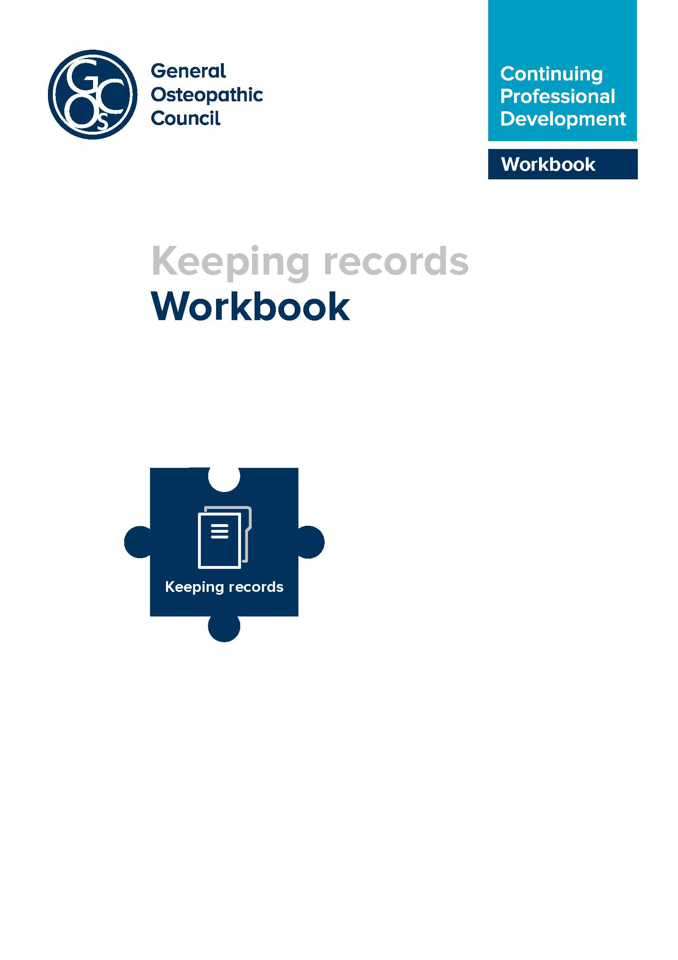
Introduction to keeping records
This workbook has been prepared to support osteopaths in keeping their CPD records.
The new CPD scheme
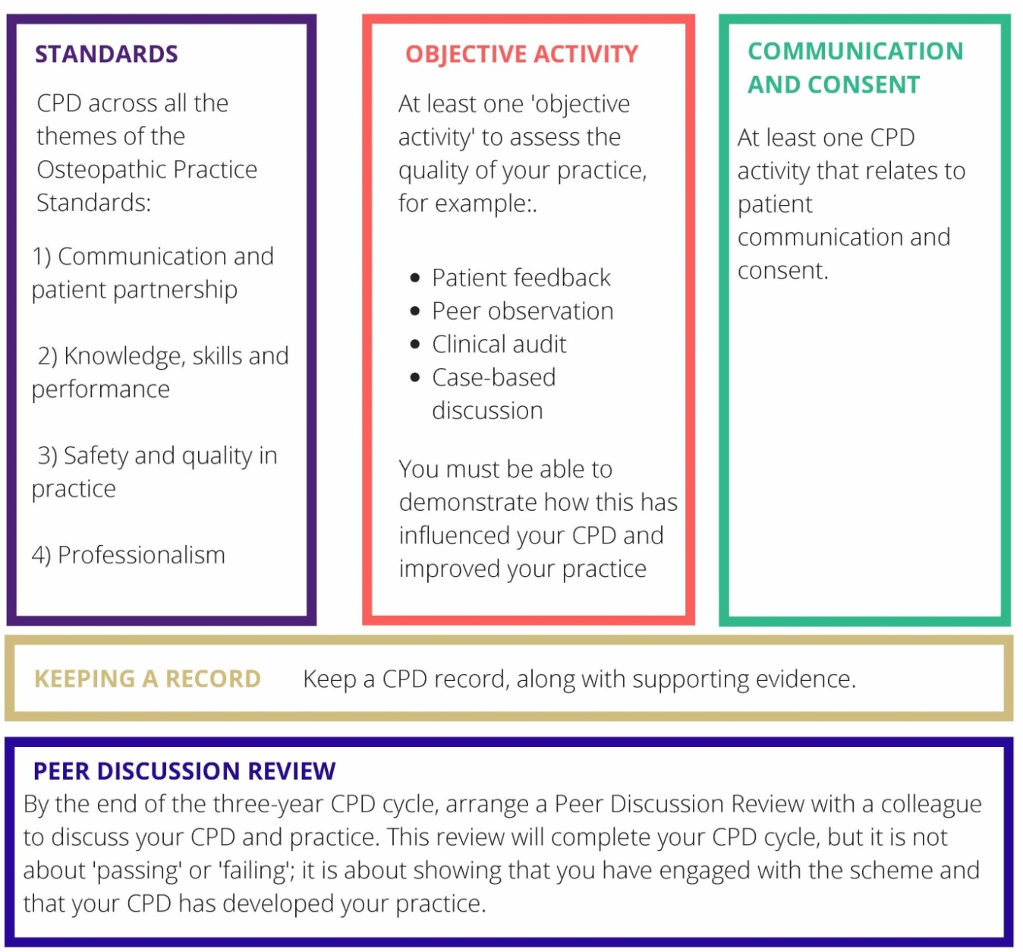
The new CPD scheme (from 1 October 2018) encompasses some changes and enhancements to the present system. In terms of the requirement to keep a record of your CPD activities, however, nothing has changed. The only difference is that rather than submitting full details to the GOsC annually, your records will support you in undergoing a peer discussion review with a colleague towards the end of your three year cycle. You might choose to keep your records in the o zone area in, the CPD Diary, as many osteopaths do now, but the new system will allow you the flexibility to use other methods if you wish and we will explore explore these in this guide. We outline some suggestions in this guide, but how you decide to maintain your record will be down to you. The important thing is that your record provides sufficient information to summarise effectively what CPD you’ve undertaken and how this has enhanced your work as an osteopath. This can then be discussed in your peer discussion review.
How to reflect on and record your CPD activity
You should already be used to recording your CPD activities. Many will currently use the CPD annual summary form as their record, (keeping certificates and notes in a CPD Record folder) which looks like this:
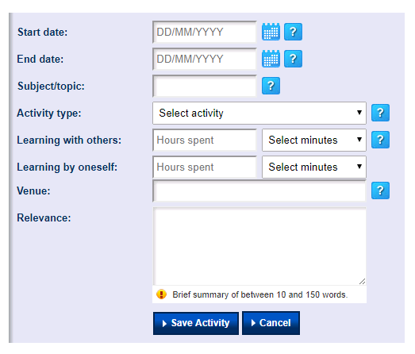

With the introduction of the new scheme, the purpose of the record will change. Currently, the annual summary form is used to submit details of CPD activities to the GOsC. In the future, (unless asked to supply records and evidence of CPD) this detailed annual summary will not be required. A modified version of the record form, a CPD diary, will be available for osteopaths to use to record activities if they wish but the aim of this will be for you to share your records with the person carrying out your peer discussion review, rather than with the GOsC.
Learning point
You must retain a record of your CPD to share with your peer under the new CPD cycle.
Other options for recording CPD
Templates:
Although a version of the CPD summary form will be available, as now, via the
o zone, the introduction of the new scheme means that you can also use other methods to record CPD activities.
We have included within the Annex
- CPD activity template
- CPD summary record template
These are offered as examples, and you do not have to use any of them. Feel free to adapt something that works for you.
The CPD activity template could be used in situations where you want to record an activity, for example, attending a course or lecture, an informal discussion with a colleague, or an encounter with a challenging patient. Don’t feel that you have to record pages of information. A brief summary of the key points, the key impact they had and any identified learning/action plans will be sufficient for you to ultimately talk this through with a colleague when you come to do a Peer Discussion Review.

CPD template example
For example, a completed activity record might look like this:
This is just an example of a completed activity record, and could be adapted to suit a range of circumstances and activities.
Activity: Lecture/workshop and subsequent study | Date: 9.1.17
Subject: Review of orthopaedic testing of the shoulder and upper limb and an overview of current surgical interventions for common orthopaedic conditions.
Learning with others: 2 | Learning by oneself: 2
Location: The Anywhere Hotel, and subsequently my home.
Relevance to practice
What was the activity?
This was a lecture and workshop from two local orthopaedic surgeons who presented on common conditions of the shoulder and upper limb, clinical testing of these and how they might be addressed surgically. Subsequently, I reviewed the anatomy and of these areas using my anatomy app, and reviewed further orthopaedic testing for these areas.
What was the impact/significance of the activity?
This was a helpful overview and revision of orthopaedic testing of the shoulder and upper limb. It’s now some years since I studied this formally, and it was good to see the tests carried out by another professional, and their interpretation of these. It was useful, too, to hear how surgical interventions have developed over the last ten years, and the relative risks and benefits of these from a surgeon’s perspective. During the workshop element, there was a chance to discuss clinical cases with other professionals (GPs and physios, as well as osteopaths), and it was reassuring to hear how others approach patients with these conditions, and manage the uncertainty within clinical practice.
How has/will the activity contribute to your practice?
Having been inspired by the presentation, I further reviewed the anatomy of the shoulder and upper limb, researched orthopaedic conditions, looking at a number of patient information resources available online, for example: ouh.nhs.uk/shoulderandelbow/information/
documents/JRFinal2010poster.pdf and modalitypartnership.nhs.uk/self-help/conditions/
articles/shoulderpain/treatment
This has ensured that I am able to discuss treatment options for fully with patients, and ensure that the advice that I give is consistent with current thinking. It has also helped me to appreciate where my own interventions fit within the broader choices available to patients.
Linking to OPS themes
Communication and patient partnership  (For example; communication skills, values, consent, capacity, supporting patients in caring for themselves) | The activities have enhanced my ability to talk to patients more knowledgably about treatment options, which has helped gain informed consent for osteopathic intervention.

Knowledge, skills and performance  (Anything which enhances the knowledge and skills you need to work as an osteopath, reflective practice, acting on feedback) | It has been helpful to review my knowledge in this area.
Safety and quality in practice  (Evaluation and diagnosis, some aspects of communication, record keeping, safeguarding) | Useful to see how other professions approach orthopaedic testing, and views on the reliability of certain tests.
Professionalism  (Understanding contributions of other healthcare professionals, analysis of data and production of reports, equality and diversity, confidentiality, managing complaints, supporting colleagues, health and safety, maintaining boundaries with patients) | I gained a greater understanding of the approach of other healthcare professionals to the types of patients that I see in practice, and how a multidisciplinary approach can be utilised in many cases for the benefit of the patient.
The CPD summary record template is another way of recording activities. You can use one table to chart these, along the lines of this example (also set out in the Annex):
Activity  Subject, type, venue  (if appropriate) | Date | Hours claimed  Learning by oneself | Hours claimed  Learning with others | Evaluation and impact on practice. | OPS themes
Subject: Communication and consent  Type: Regional group meeting  Venue: Hilton Hotel, Anytown | 16.01.18 |  | 2 | This comprised:  - a presentation on some current research around communication and the impact of effective communication on clinical outcomes  - an overview of the Montgomery judgment and the relevance of this in relation to consent in osteopathic practice  - a case based discussion in small groups to consider a case where a patient felt that their expectations had not been met.  It was helpful to hear about current thinking in this area, and to consider the effect language can have on the clinical outcome of patients. Useful, also, to hear the views of colleagues on the case discussed, and how the issues raised may have been more effectively dealt with. I have reflected since on my own communication skills, and reviewed my use of some medical terms with patients which some may find off-putting. Also considered how best to explore with patient values and what matters to them. | A, B, C
Subject: Common neurological conditions  Type: Lecture/presentation  Venue: Anytown Hospital | 22.2.18 |  | 1.5 | This was a presentation from a local neurologist on common neurological conditions, the assessment and screening of these, and medical interventions. It was useful and relevant to review such conditions, and to better understand their medical management and referral processes. This has helped me in discussing treatment options with patients and in understanding how osteopathy can help alongside medical approaches to management. | A, B, C, D
We know from feedback received that osteopaths say that they reflect on practice regularly. To convert these day to day reflections into claimable CPD, however, they need to be written down.

Keeping a record – other considerations
There are various options as to how you maintain a record of your activities, and much will come down to personal preference. These might include:
- The GOsC activity summary (as outlined above): This will feel familiar to those used to recording their CPD in this way.
- Your own electronic records: You can use Word, Pages, Google Docs or whatever platform you’re familiar with or works best for you. Remember to back up electronic records so that they can be accessed even if your computer is lost or damaged. It’s perfectly possible to create your own online portfolio folder using templates as suggested above, and storing these in a folder which can be shared with a peer or colleague. You can create shared folders in platforms such as Dropbox (dropbox.com/register) or Google Drive (google.com/drive). As well as your records of activities, it’s possible to scan evidence, such as certificates or notes using a smartphone app, and store these in the folder too.
- An eportfolio platform: There are a number of portfolio platforms available which individuals can sign-up to, for example:
- PebblePad (pebblepad.co.uk)
- Folio Spaces (foliospaces.org/)
- Padlet (padlet.com)
- Mahara (mahara.org).
Some of these may incur a fee and some may be free to sign up for, so it’s worth exploring what might work for you if an eportfolio suits your needs. Some will like the opportunity that an eportfolio provides to plan and reflect on activities and maintain evidence of these in one place, with the ability to share this with others.
- Paper records: It’s also possible, of course, to keep paper records of your activities and evidence. It may be more challenging to share with a colleague for a peer review, but can be done easily enough. Again, it’s worth always keeping copies in case the worst happens.
Linking to the themes of the Osteopathic Practice Standards (OPS)
The new CPD scheme requires osteopaths to undertake activities across the four themes of the OPS. There is no set requirement as to the hours spent on each theme, however, and it is not necessary to allocate minutes spent on each theme in an activity which might encompass more than one. The example given in the CPD template above indicates how a CPD event or activity might relate to each of the OPS themes. Thinking about and recording activities in this way is straightforward, and means that over a three-year cycle, sufficient evidence is easily accumulated to demonstrate that CPD has been undertaken across each theme. Remember, this is about linking to the themes of the OPS, not each individual standard.
Many CPD providers will already reflect on their certificates which OPS themes have been covered in their events.
You may find it helpful to highlight activities that demonstrate the key requirements of the CPD scheme in whatever format that works for you:
- CPD records referring to the four themes of the OPS
- CPD records of the objective activity (this might be a case-based discussion, patient feedback, clinical audit, peer observation)
- CPD records showing CPD in the area of communication and consent.
References and resources
Osteopathic Practice Standards: standards.osteopathy.org.uk
The o zone log in: members.osteopathy.org.uk/home
The dedicated CPD site: cpd.osteopathy.org.uk

- CPD activity template
- CPD summary sheet template (1) and completed example (2)

- CPD activity record template
Activity: | Date:
Subject:
Learning with others: | Learning by oneself:
Location
Relevance to practice
What was the activity?
What was the impact/significance of the activity?

How has/will the activity contribute to your practice?
Linking to OPS themes
Communication and patient partnership
(For example; communication skills, values, consent, capacity, supporting patients in caring for themselves)
Knowledge, skills and performance
(Anything which enhances the knowledge and skills you need to work as an osteopath, reflective practice, acting on feedback)
Safety and quality in practice
(Evaluation and diagnosis, some aspects of communication, record keeping, safeguarding)
Professionalism
(Understanding contributions of other healthcare professionals, analysis of data and production of reports, equality and diversity, confidentiality, managing complaints, supporting colleagues, health and safety, maintaining boundaries with patients)
- Which themes of the Osteopathic Practice Standards have you considered in relation to the case considered?
Communication and patient partnership | Knowledge, skills and performance | Safety and quality in practice | Professionalism
- Any additional thoughts or comments?

Annex B (1) CPD record summary template
Activity  Subject, type, venue (if appropriate) | Date | Hours claimed  Learning by oneself | Hours claimed  Learning with others | Evaluation and impact on practice. | OPS themes
Subject:
Type:
Venue:
Subject:
Type:
Venue:
Subject:
Type:
Venue:
Subject:
Type:
Venue:
Subject:
Type:
Venue:
Subject:
Type:
Venue:
Subject:
Type:
Venue:

Annex B (2) Example CPD record summary
Activity  Subject, type, venue  (if appropriate) | Date | Hours claimed  Learning by oneself | Hours claimed  Learning with others | Evaluation and impact on practice. | OPS themes
Subject: Communication and consent  Type: Regional group meeting  Venue: Hilton Hotel, Anytown | 16.01.18 |  | 2 | This comprised:  - a presentation on some current research around communication and the impact of effective communication on clinical outcomes  - an overview of the Montgomery judgment and the relevance of this in relation to consent in osteopathic practice  - a case based discussion in small groups to consider a case where a patient felt that their expectations had not been met.  It was helpful to hear about current thinking in this area, and to consider the effect language can have on the clinical outcome of patients. Useful, also, to hear the views of colleagues on the case discussed, and how the issues raised may have been more effectively dealt with. I have reflected since on my own communication skills, and reviewed my use of some medical terms with patients which some may find off-putting. Also considered how best to explore with patient values and what matters to them. | A, B, C
Subject: Common neurological conditions  Type: Lecture/presentation  Venue: Anytown Hospital | 22.2.18 |  | 1.5 | This was a presentation from a local neurologist on common neurological conditions, the assessment and screening of these, and medical interventions. It was useful and relevant to review such conditions, and to better understand their medical management and referral processes. This has helped me in discussing treatment options with patients and in understanding how osteopathy can help alongside medical approaches to management. | A, B, C, D

Subject: Spondylolisthesis  Type: Personal research | 17.03.18 | 1 |  | I saw a patient with spondylolisthesis, and took the opportunity afterwards to review the anatomy of these and their clinical management. I looked at the information that the NHS provide to patients regarding this condition, and also at a website compiled by a university in Belgium:  nhs.uk/conditions/spondylolisthesis/  physio-pedia.com/Spondylolisthesis | B, C
Subject: Peer observation  Type: Observation with a colleague  Venue: My practice | 18.04.18 |  | 2.5 | I undertook a peer observation activity with my colleague David O’Path. Today, David observed me with a new patient and then a continuing one, and we met afterwards to discuss what went well, and where I might consider improving aspects of my practice. (see Peer Observation evaluation form for full details) | A, B, C, D
Subject: Somatic dysfunction  Type: Research paper | 15.5.18 | 1 |  | - This relates to an IJOM research paper – ‘Somatic Dysfunction – an osteopathic conundrum’, by Gary Fryer (International Journal of Osteopathic Medicine,  - Volume 22, December 2016, Pages 52-63)  - This was an interesting read which reviews some basic osteopathic concepts of dysfunction in the light of evidence, and explores more plausible conceptual models. It covers, also, some language issues, and how diagnosis is communicated to patients. | A, B, C

If you have any queries on the workbook or CPD in general, please feel free to get in touch:
General Osteopathic Council
Osteopathy House
176 Tower Bridge Road
London SE1 3LU

Email: newcpd@osteopathy.org.uk
osteopathy.org.uk
cpd.osteopathy.org.uk

The GOsC is a charity registered in England and Wales (1172749)

We welcome your comments and feedback. We are keen to hear your feedback to help us to improve this workbook. Please send any comments and/or suggestions to newcpd@osteopathy.org.uk

