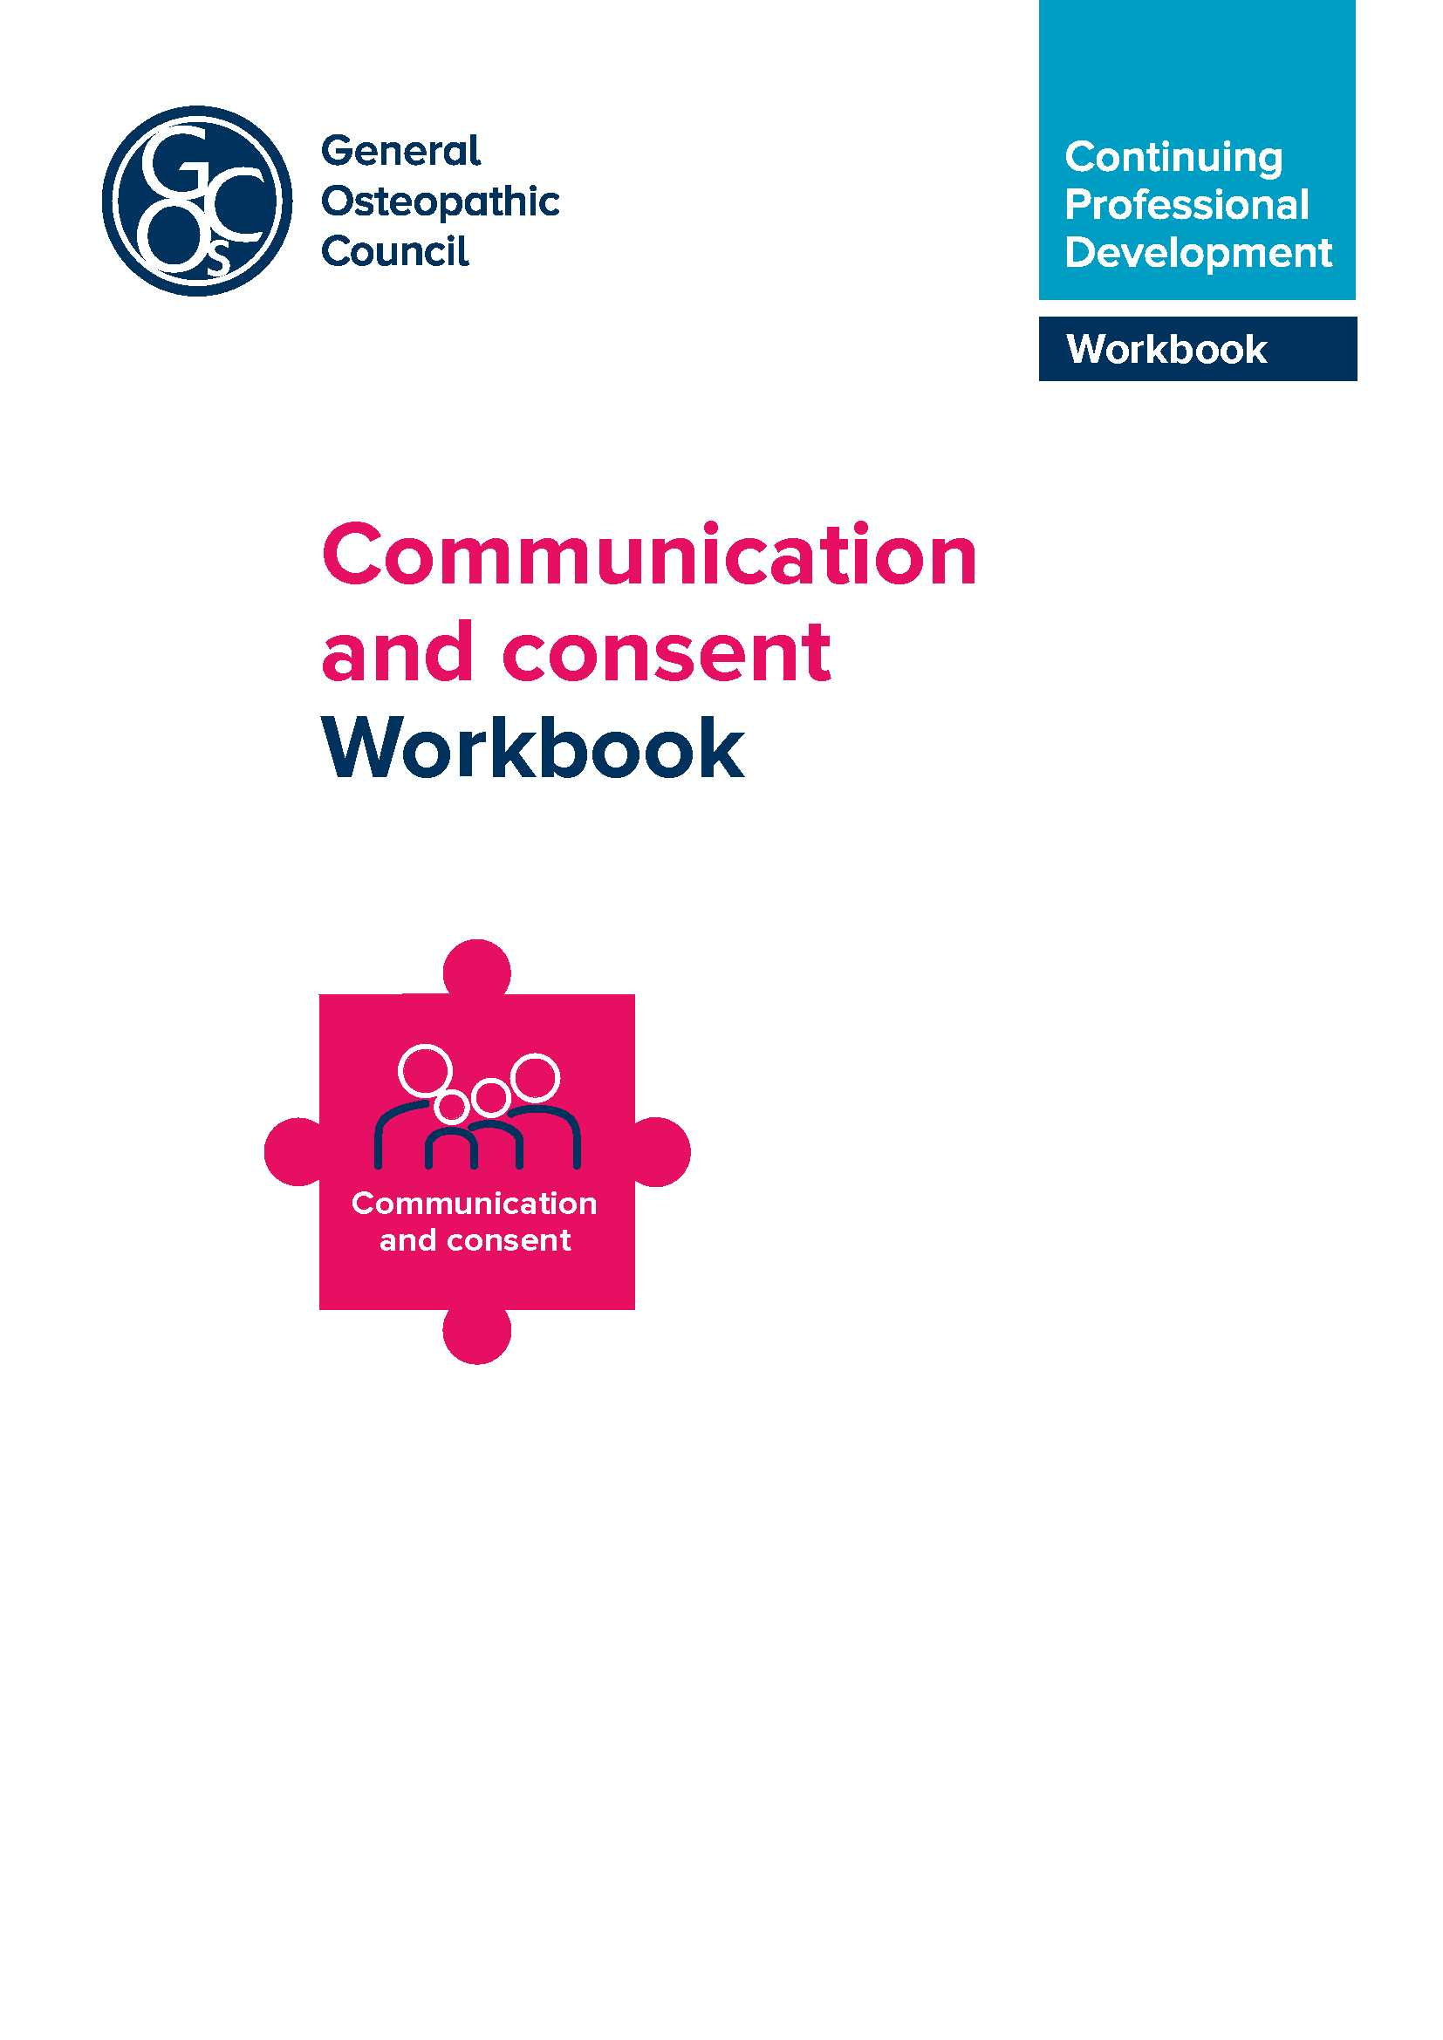

Introduction to communication and consent
This resource has been prepared to support osteopaths in fulfilling the requirement of the new CPD scheme that osteopaths undertake at least one CPD activity relating to communication and consent during their three-year CPD cycle.
It explains why communication and consent is important and what this means. It also deals with some of the frequently asked questions around this element of the scheme, and offers suggestions as to how it might be met.
The new CPD scheme
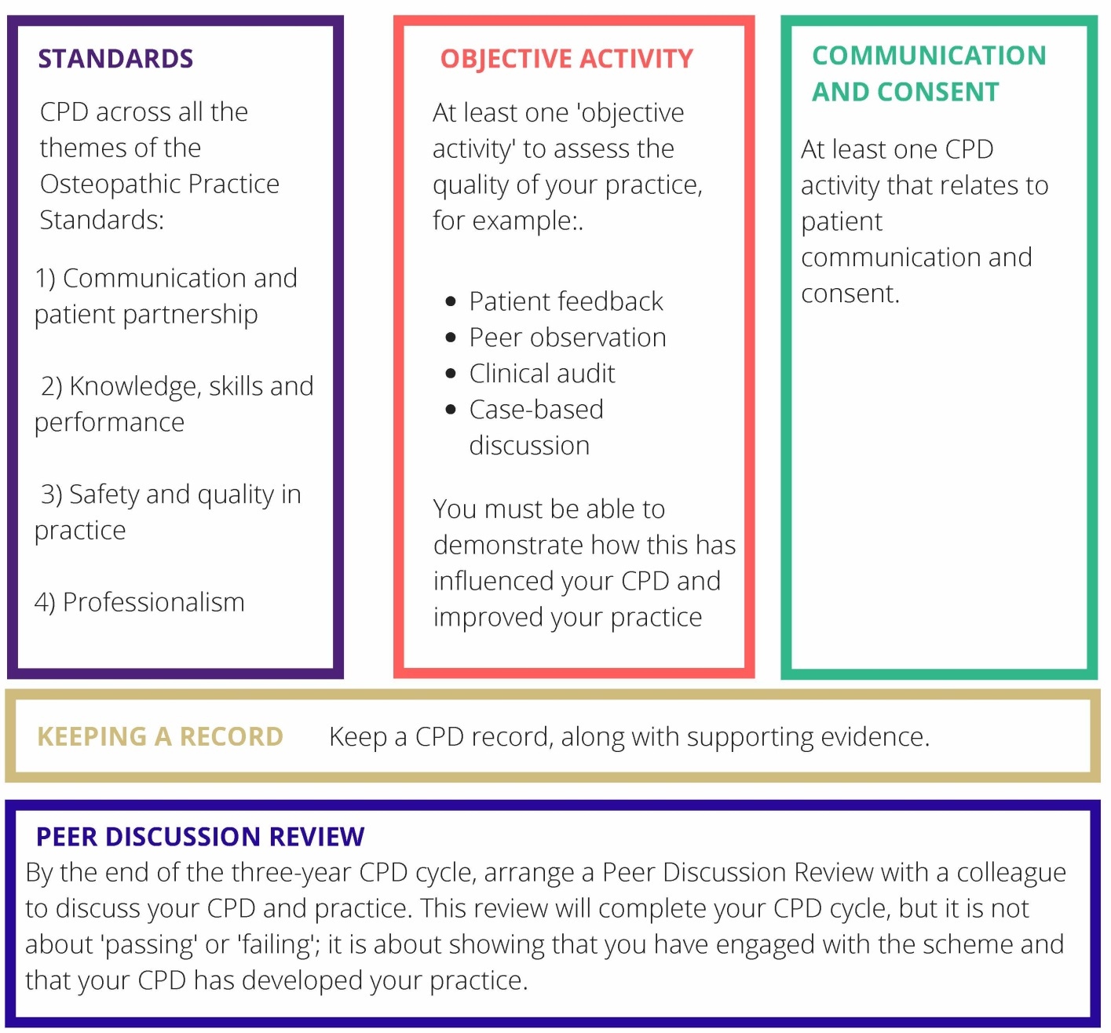
What exactly is the requirement that I have to meet?
The communication and consent requirement is outlined in the CPD Guidance within Standard 3 and also in the Peer Discussion Review Guidance
CPD Standard 3 outlines that: osteopaths demonstrate that they have sought to ensure that CPD activities benefit patients (every three years undertaking a CPD activity in communication and consent).
Guidance:
This Standard is met by the osteopath being able to show:
- they have undertaken CPD activity relating to communication and consent
with patients
- they have reviewed the guidance in the Osteopathic Practice Standards (OPS)
- that this has informed their learning and has been applied in practice.
(We recommend around three hours of CPD to be spent on communication and consent but this is not essential. The important outcome is that the osteopath has undertaken CPD which has informed practice.)
This Standard may be met by an osteopath who has undertaken less than three hours of relevant CPD, but is able to show that this activity has informed their learning and practice.
This Standard is not met if the osteopath is unable to show that they have undertaken an activity relating to communication and consent.
How much CPD relating to communication and consent will be required? The number of hours required to fulfil this CPD standard is not stipulated. It is suggested that a minimum of around three hours over a three-year cycle should be enough to meet the requirement in this respect; however, it’s more about the outcomes than the hours.
Will I have to keep repeating the same activity every CPD cycle? No – there are many different ways of meeting this requirement without having to repeat exactly the same activity each CPD cycle. It may be a specific event, or activity, or a number of events that, over time, enable you to easily demonstrate that this requirement has been met. Some examples are given in this guide.
Learning point
A communication and consent activity should include reviewing the relevant OPS, considering how this has enhanced learning and its impact on practice, and this should be recorded.

Why is communication and consent a mandatory element of the new CPD scheme?
Communication is a central element of relating to patients and also a central element of the OPS.
The table below indicates some of the standards relating to communication. Standards from all four themes can be relevant to communication and consent in the context of an osteopathic consultation.
So an activity in communication and consent can also show that you have considered all themes of the OPS.
Communication and patient partnership
A1. You must listen to patients and respect their individuality, concerns and preferences. You must be polite and considerate with patients, and treat them with dignity and courtesy.
A2. You must work in partnership with patients, adapting your communication approach to take into account their particular needs, and supporting patients in expressing to you what is important to them.
A3. You must give patients the information they want or need to know in a way they can understand.
A4. You must receive valid consent for all aspects of examination and treatment and record this as appropriate.
A5. You must support patients in caring for themselves to improve and maintain their own health and wellbeing.
A6. You must respect your patients’ dignity and modesty.
A7. You must make sure your beliefs and values do not prejudice your patients’ care.
Knowledge, skills and performance
B1. You must have and be able to apply sufficient and appropriate knowledge and skills to support your work as an osteopath
B4. You must recognise and work within the limits of your training and competence.
Safety and quality in practice
C1. You must be able to conduct an osteopathic patient evaluation and deliver safe, competent and appropriate osteopathic care to your patients.
C6. You must be aware of your wider role as a healthcare professional to contribute to enhancing the health and wellbeing of your patients.
Professionalism
D2. You must establish and maintain clear professional boundaries with patients, and must not abuse your professional standing and the position of trust which you have as an osteopath.
D3. You must be open and honest with patients, fulfilling your duty of candour.
D4. You must have a policy in place by which you manage patient complaints, and respond quickly and appropriately to any which arise.

Learning point: a communication and consent activity might also help to show CPD in each of the four themes of the OPS.
Concerns and complaints
Communication issues feature heavily in complaints and concerns raised about osteopaths.
The GOsC, the Institute of Osteopathy and the providers of osteopathic indemnity insurance have been undertaking a collaborative data collection initiative since 2013, with the aim of better understanding the nature and frequency of concerns raised about osteopaths and osteopathic services.
The participating organisations have developed a common system for classifying concerns, and apply this classification routinely in their case management. The organisations’ aggregate figures are pooled annually and independently analysed by the National Council for Osteopathic Research (NCOR).
Data collected under this initiative are being used to inform osteopathic education and training, and to shape targeted information and guidance for osteopaths, patients and educators. You can see the reports on the GOsC website.
The following is a summary of concerns raised from 2013-2016. As can be seen, the majority are within the categories of conduct or clinical care. There was a massive increase in complaints raised around misleading advertising/websites from three in 2013 to 175 in 2016, largely due to one particular pressure group, but setting these aside, those relating to conduct make up 40-50% of concerns.

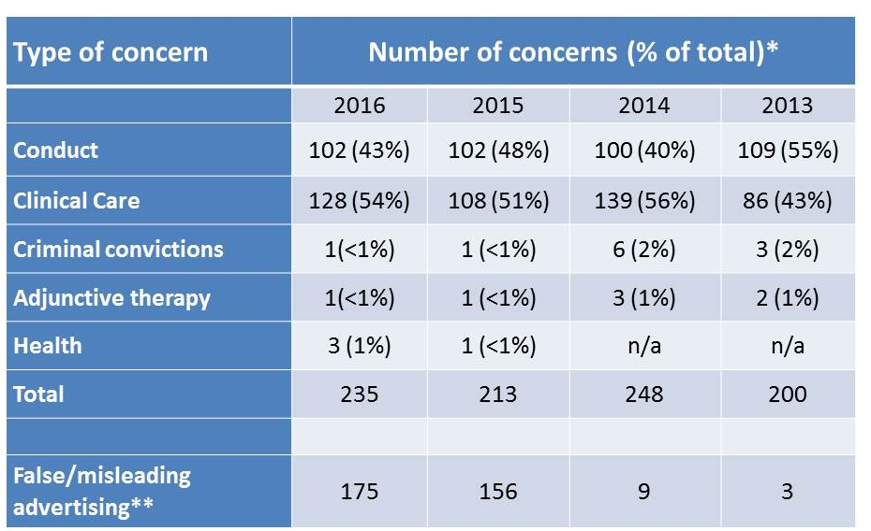
Of those, we can see in 2016, some 18% related to a failure to communicate effectively, and 18% communicating inappropriately. These numbers have steadily risen since 2013. 13% related to a failure to obtain valid consent/a lack of shared decision making with the patient. Numbers in this category had been dropping but rose again last year.
Learning point
Communication and consent issues feature as a significant proportion of concerns raised by patients about osteopaths.
Patient expectations
Research commissioned by the GOsC has demonstrated the expectations of patients in the area of communication and consent. For example, see a public perception study; conducted by YouGov in 2018 which highlights what the public consider are important in establishing confidence in an osteopath:
- gives good advice
- really listens to the patient
- explains diagnosis clearly
- treats the patient with dignity
- involves the patient in decisions around their care
- puts them at ease
- asks for consent before examination or treatment.
Learning point:
Good communication is at the centre of patients’ expectations of osteopathic care.

The Montgomery Judgment (2015)
This was a significant judgment made by the Supreme Court in 2015, which effectively changed the law relating to consent. The full details of the judgment can be found on the Supreme Court website. The BBC news website provides a summary of the case. The case is instrumental in confirming the fact that ‘informed consent’ is now part of English law.
It acknowledges the understanding that patients are not passive recipients of treatments, but are active, self-determining partners in the process. Rather than just thinking in terms of the percentage chance of an adverse events occurring, practitioners need to consider the significance of the risk of treatment options for any individual patient.
This means that there cannot be a standard formula or form of words that works for every patient. It is more about having a dialogue with the patient, finding out what is important to them, and tailoring your explanation of the treatment options accordingly.
Learning point
There is no standard formula for communicating with patients. Dialogue is important, finding out what is important to your patients and tailoring your explanation of the treatment options accordingly.
The case also illustrates how the context of communication and consent issues in healthcare may change over time, and is not fixed.

How can I do CPD in communication and consent?
CPD relating to communication and consent can be very varied, formal or informal, planned or unplanned with others, by yourself, in a course or not in a course. The following are suggestions which might help to identify ways in which this requirement can be met.
Case studies
Case studies or scenarios can be can be excellent ways of considering aspects of clinical encounters, including communication and consent issues. These could be anonymised cases from your practice which you discuss with colleagues, or fictional examples covering challenging clinical situations. For more information on this approach, see our case based discussion workbookcpd.osteopathy.org.uk/resource/case-based-discussion-workbook/
Specific CPD events
Many CPD providers will offer specific events aimed at communication and consent issues which will enable an osteopath to meet this requirement. It’s worth pointing out though, that many other CPD events might contain aspects that relate to communication. For example, a presentation on, say, surgical approaches to the shoulder may cause you to reflect on how you discuss these with patients and outline treatment options with them. Recording this fact will enable you to claim the activity towards this particular CPD requirement.
Group discussions
These could be regional groups, practice meetings or other get-togethers with colleagues, particularly if it involves reviewing and discussing the OPS for example.
Reflections on practice
Osteopaths report how they constantly reflect on practice, but don’t always record this fact. If a clinical encounter, for example, causes you to reflect on your communication with patients and as a result impacts on your practice in some way, then record this and use the experience towards meeting this CPD requirement.
Objective activities
Another requirement of the CPD scheme is that an objective activity has contributed to your practice. This is an activity which provides you with some form of objective feedback on your practice, and could include, for example, patient feedback, peer observation, clinical audit or case based discussion. Many of these will provide feedback on aspects of your practice directly related to communication and consent, and may therefore contribute to both CPD requirements.
Learning point
You can choose how you do CPD in communication and consent and it can be undertaken in a range of different ways – either by yourself or with others.

National Council for Osteopathic Research
The NCOR website has a range of really useful information around the communication of benefit and risk, and risk and patient incidents.
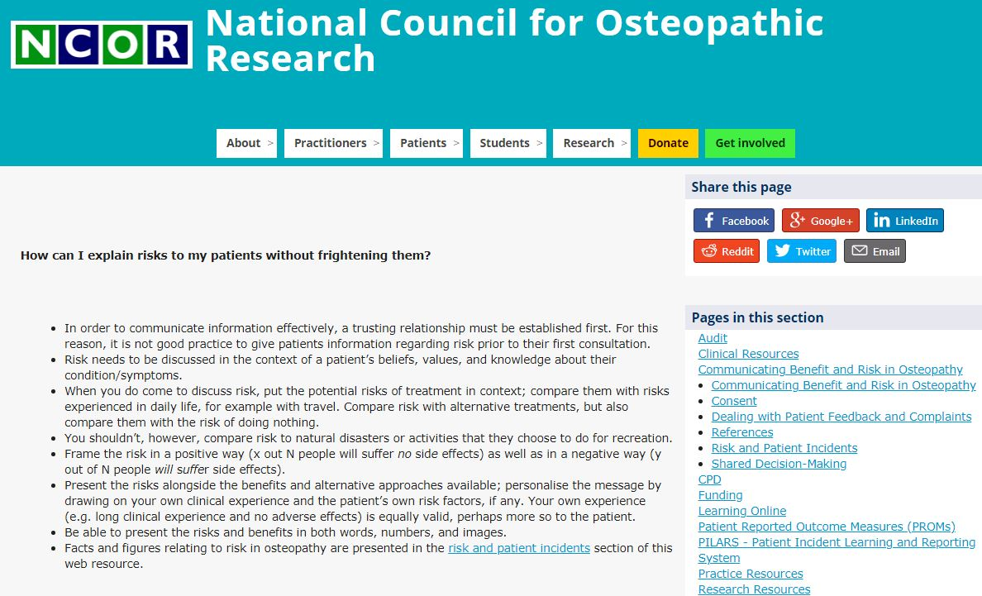
Journal articles
As well as The International Journal of Osteopathic Medicine, a range of journals are available free to osteopaths via the o zone area of the GOsC website.

These are excellent sources of research on communication issues and the impact of communication in practice. Reading a paper, reflecting on it and discussing it with colleagues can provide effective CPD in this area. The following are just a few examples of research articles which are available to osteopaths via the o zone.
- Thomson et al, Osteopaths professional views, identities and conceptions IJOM, (2014) 17, 146-159.
This is a qualitative study that raises questions around how osteopaths’ own beliefs and theories of practice impact on their communication with patients.
- Darlow, B, Beliefs about back pain: The confluence of client, clinician and community, International Journal of Osteopathic Medicine (2016) 20, 53-61.
This is an interesting paper, and a neat synthesis of work in this area. As well as looking at patient beliefs and the impact of these on presentations, it explores how practitioners’ beliefs impact on outcomes, and the type of language which can support or alleviate unhelpful patient beliefs.
- Pincus, et al: Cognitive and affective reassurance and patient outcomes in primary care: A systematic review, Pain 154 (2013) 2407-2416.
This paper by Tamar Pincus and others including Steve Vogel of the UCO, examines in more detail the components of effective reassurance. It’s interesting to see the differences between affective reassurance and cognitive reassurance and their affect on outcomes.
- Thomson and Collyer ‘Talking a different language’ – A qualitative study on low back pain patients’ interpretation of the language used by student osteopaths (International Journal of Osteopathic Medicine 24 (2017).
This is another interesting study touching on the area of language and communication. Patients were interviewed to explore their feelings about language used during consultations.
Blogs:
Blogs by osteopaths and others can be useful sources of information and discussion. For example, this by Dr Oliver Thomson (author of some of the papers mentioned above): droliverthomson.com/words-matter
And Osteofm, written by osteopath, Penny Sawell: osteofm.com/2017/06/28/
bite-size-ijom-words-the-most-powerful-drugs-used-by-mankind

If you have any queries on the workbook or CPD in general, please feel free to get in touch:
General Osteopathic Council
Osteopathy House
176 Tower Bridge Road
London SE1 3LU

Email: newcpd@osteopathy.org.uk
osteopathy.org.uk
cpd.osteopathy.org.uk

The GOsC is a charity registered in England and Wales (1172749)

We welcome your comments and feedback. We are keen to hear your feedback to help us to improve this workbook. Please send any comments and/or suggestions to newcpd@osteopathy.org.uk

Available at: standards.osteopathy.org.uk.
osteopathy.org.uk/news-and-resources/document-library/research-and-surveys/types-of-concerns-raised-about-osteopaths-and-services.
osteopathy.org.uk/news-and-resources/research-surveys/gosc-research/public-and-patient-perceptions.
supremecourt.uk/decided-cases/docs/UKSC_2013_0136_Judgment.pdf.
bbc.co.uk/news/uk-scotland-glasgow-west-31831591.
ncor.org.uk.
ncor.org.uk/practitioners/practitioner-information-communicating-benefit-and-risk-in-osteopathy/communicating-benefit-and-risk-in-osteopathy.
ncor.org.uk/practitioners/practitioner-information-communicating-benefit-and-risk-in-osteopathy/risk-and-patient-incidents.
members.osteopathy.org.uk/news-and-resources/research/research-journals.
sciencedirect.com/science/article/pii/S1746068913001715.
sciencedirect.com/science/article/pii/S1746068916000067.
www.sciencedirect.com/science/article/pii/S0304395913003874.
www.sciencedirect.com/science/article/pii/S174606891630044X.

